**DESIGNED BY:**

* **ANUJA SATAPATHY (L3733)**
* **DEBASHIS PRADHAN (L3721)**
* **KANNU CHARAN KAR (L3686)**
* **SANJANA SETHI (L3734)**
* **SUJATA ORAM (L3724)**

**UNDER THE GUIDENCE OF:**

**Mr. KISHAN SHARMA**

**CONTENTS**

* **ACKNOWLEDGEMENT**
* **CERTIFICATE**
* **INTRODUCTION**
* **TECHNOLOIES USED**
* **FLOW CHART DIAGRAM**
* **SOURCE CODE**
* **WEBPAGE OUTPUT SCREENSHOT**
* **CONCLUSION**
* **BIBLIOGRAPHY**

**ACKNOWLEDGEMENT**

First of all, we would like to mention the contribution of Seenet consultancy services Pvt. Ltd. for the development and application domain.

We respect and thank to Mr. Kishan Sharma sir for providing us an opportunity to do the project work in SeeNet and giving us all support and guidance, which made us complete the project duty.

We would like to thank each member of our group for their participation, support and guidance which helped us in completing our project work successfully.

**CERTIFICATE**

This to certify the following students:-

* **ANUJA SATAPATHY (L3733)**
* **DEBASHIS PRADHAN (L3721)**
* **KANNU CHARAN KAR (L3686)**
* **SANJANA SETHI (L3734)**
* **SUJATA ORAM (L3724)**

Of **SeeNet computer Institute** has complete the Web designing project, titled with “**ONLINE E SPORTS SITE** ” during the academic year 2022-2023 towards partial fulfillment to credit for the computer science project evolution of HTML & CSS at **SeeNet Consultancy Services Pvt. Ltd., STPI Complex Rourkela-769002.**

They have submitted satisfactory report, as complied in the following pages, under professional supervision.

**(Student’s Project Co-ordinate)**

**See Net Consultancy Services Pvt. Ltd.**

**INTRODUCTION**

This project **online E-Sprots Site** has been developed on HTML and CSS. We develop html projects with source code who one to us html projects to learn.

The main objects of developing this project was to create a static website for the Sport, from which user can get the complete details of the matches upcoming matches ,Latest News about sports and much more.

This project is in HTML & CSS so it’s a static website and does not perform any type of dynamic data base operations.

**Pages of the project online E-Sports sites:**

* **Home page:** This page contains the basic information about the E-sport site like we have linked home page to all other web pages, and we can go directly by click to them navigation menu.
* **Game Page:** This page contains all type of Games & that can be download.
* **Tournament page:** This page contains all type of tournament games through which we can book slot and play all type of tournaments.
* **Review page:** This page shows the customer reviews and rating of our website.
* **Live page:** This page shows the live streaming of tournament & games.
* **About Us page:** This page shows the information about our online E-sport site.
* **Shop page:** This page cointains product &accessories releted to games which can be bought by user .
* **Contact us :** Here queries can be raised related games, tournament & website.
* **Join :** This page help Us to join the tournament.
* **Register :** This page contain the details that can be filled by new user to play upcoming games and tournament.
* **Login:** Here user can log in & logout his/her account.
* **Notification :** it notify players about event upadate and other free rewards.
* **Profile :** A user profile contains information of an user.
* **Cart**: It helps customers to select or store items before buying them.
* **Info:** its contains the information about the reward policy and overview of the website.

**TECHNOLOGIES USED**

We have developed this project using the below technology:-

* HTML: Page layout has been designed in HTML.
* VS Code: Used for Coding
* Java script : used for designing and animation.
* CSS: CSS has been used for the designing part.
* Font awesome used for buttons and icons.
* W3 schools: used for Shadow, Animation effect.

**FLOW CHART**

**Welcome to online site:**

Home

Review

About

Home

Games

Tournament

Shop

Notification

Profile

Info

Contact Us

Cart

Join

Search Box

Register

Login

Play

Fortnite

Pubg

Takken 7

Free fire

Call of duty

Minecraft

Roket leagve

GAMES

Fall Guy

Morden welfare

Dragon ball

Rainbows seige

State survival

Apex legenp

Dota 2

Over watch

Play wow

Valorent

Counters trikes

Gta v

Fifa footbal

Class royal

Tournament

Courage fall guys

Booking

Bgmi

Among us

Minecraft

Free fire

Pubg

Valorant

Fall guys

trailer

Shop

ASUS ROG 2

Gaming ki yroard

Cap

Buy now

Ps5 controller

Headphone

Ergonomic chair

Gaming mouse

Review

Customer Review

Carrymimati

Jhonathon

Mortal

Live

Live chart

Watch live Match

Our Servies

Our Story

Our purpose

About Us

Notification

Gmail inbox

User

User profile/linkdin

Cart

Payment Succesful

Billing Address/

Payment

Buy Now

Same as shop

Info

Eligibilily

Overview

Rewards policy

Contact Us

Continue

Send

Contact us

Join

Join Button

Join From

How to join

Rules and regulation

Google

Search

Register

Success

Register Button

Register Form

Login

Login Button

Login Form

**Source Code**

**Home.html**

<!DOCTYPE html>

<html lang="en">

<head>

    <title>Homepage</title>

    <link rel="stylesheet" href="CSS/home.css">

    <link rel="stylesheet" href="https://cdnjs.cloudflare.com/ajax/libs/font-awesome/6.4.0/css/all.min.css">

    <link rel="stylesheet" href="https://cdnjs.cloudflare.com/ajax/libs/font-awesome/6.4.2/css/all.min.css" integrity="sha512-z3gLpd7yknf1YoNbCzqRKc4qyor8gaKU1qmn+CShxbuBusANI9QpRohGBreCFkKxLhei6S9CQXFEbbKuqLg0DA==" crossorigin="anonymous" referrerpolicy="no-referrer" />

    <link rel="preconnect" href="https://fonts.googleapis.com">

    <link rel="preconnect" href="https://fonts.gstatic.com" crossorigin>

    <link href="https://fonts.googleapis.com/css2?family=Lato&family=Tektur:wght@500&display=swap" rel="stylesheet">

</head>

<body>

    <div class="box1">

        <div class="logo">

            <img src="Images/Logo.jpg" width="250px" height="70px">

         </div>

    <div class="box2">

        <a href="HTML/contact.html"><button id="btn1">CONTACT US</button>&nbsp;</a>

        <a href="HTML/join.html"><button id="btn2">JOIN</button></a>

    </div>

    <div class="box3">

        <div class="search">

            <input type="text" placeholder="&nbsp;&nbsp;&nbsp; Search here" size="44px">

        </div>

        <a href="https://www.google.com">

            <i class="fa-solid fa-magnifying-glass" style="color: #ffffff;" id="icon1"></i>

        </a>

    </div>

    <div class="box4">

        <button id="btn3"><a href="HTML/Register.html">REGISTER</a></button>&nbsp;

        <button id="btn4"><a href="HTML/login.html">LOGIN</a> </button>

    </div>

    </div>

    <div class="box5">

        <nav>

            <a href="#">Home</a>

            <a href="HTML/games.html">Games</a>

            <a href="HTML/Tournament (2).html">Tournament</a>

            <a href="HTML/review.html">Review</a>

            <a href="HTML/live.html">Live</a>

            <a href="HTML/Aboutus.html">About Us</a>

            <a href="HTML/Shop.html">Shop</a>

            <div class="animation start-home"></div>

        </nav>

    </div>

    <div class="line1"> E&nbsp; N&nbsp;J&nbsp;O&nbsp;Y&nbsp;&nbsp; T&nbsp;H&nbsp;E &nbsp;&nbsp;G&nbsp;A&nbsp;M&nbsp;E&nbsp;S</div>

    <div class="line2">

        Epic Games Made For <br> True Gamers!

    </div>

    <div id="btn5">

        <a href="Images/video/ Call_of_Duty__Modern_Warfare_II_Worldwide_Reveal_Trailer(720p).mp4"><button> P&nbsp;L&nbsp;A&nbsp;Y</button></a>

    </div>

    <div class="i1">

        <img src="Images/bag1.png">

    </div>

    <div class="i2">

        <img src="Images/bag.png">

    </div>

    <div class="box6">

        <a href="HTML/notification.html"><i class="fa-solid fa-envelope fa-2xl" id="icon2"></i></a>

        <a href="HTML/profile.html"><i class="fa-solid fa-user fa-2xl" id="icon3"></i></a>

        <a href="HTML/cart.html"> <i class="fa-solid fa-cart-shopping fa-2xl" id="icon4"></i></a>

        <a href="HTML/info.html"><i class="fa-solid fa-circle-info" style="color: #ffffff;"id="icon5"></i></a>

    </div>

    <div class="box7">

        <div class="i3">

            <img src="Images/cocacola.png">

        </div>

        <div class="i4">

            <img src="Images/addidas.png">

        </div>

        <div class="i5">

            <img src="Images/hp.png">

        </div>

        <div class="i6">

            <img src="Images/alienware (1).png">

        </div>

        <div class="i7">

            <img src="Images/redbull (1).png">

        </div>

        <div class="i8">

            <img src="Images/bmw.png">

        </div>

        <div class="i9">

            <img src="Images/ryzen.png">

        </div>

        <div class="i10">

            <img src="Images/airtel (1).png">

        </div>

    </div>

    <div class="box8">

        <div class="line3">Follow Us</div>

        <div class="main">

            <!-- Facebook Icon -->

            <div class="icon fb">

                <a href="https://www.facebook.com"><i class="fa-brands fa-facebook-f"></i>

                <span>Facebook</span></a>

            </div>

            <!-- GitHub Icon -->

            <div class="icon inst">

                <a href="https://www.instagram.com"><i class="fa-brands fa-instagram"></i>

                <span>Instagram</span></a>

                </div>

            <!-- YouTube Icon -->

            <div class="icon yt">

                <a href="https://youtube.com/@gaming"><i class="fa-brands fa-youtube"></i>

                <span>YouTube</span></a>

            </div>

            <!-- Twitter Icon -->

            <div class="icon twt">

                <a href="https://twitter.com"><i class="fa-brands fa-twitter"></i>

                <span>Twitter</span></a>

            </div>

        </div>

        <div class="boxin1">

            <div class="r1">Resources</div>

            Support-A-Creator <br>

            Distribute on Epic Games <br>

            Careers <br>

            Company <br>

        </div>

        <div class="boxin2">

            Fan Art Policy <br>

            UX Research <br>

            Store EULA <br>

            </div>

        <div class="boxin3">

            Online Services <br>

            Community Rules <br>

            Epic Newsroom <br>

        </div>

        <table class="made">

        <tr>

            <td id="m1">Made by Unreal Tournament</td>

        </tr>

        <tr>

            <td>Battle Breakers</td>

            <td>Robo Recall</td>

        </tr>

        <tr>

            <td>fortnite</td>

            <td>Infinity Blade</td>

        </tr>

        </table>

        <p id="p1">© 2023, Unreal Tournament, Inc. All rights reserved. Epic, Epic Games, the Epic Games logo, Fortnite,<br>

            the Fortnite logo, Unreal, Unreal Engine, the Unreal Engine logo, Unreal Tournament, and the Unreal Tournament logo are <br>

            trademarks or registered trademarks of Epic Games, Inc. in the United States of America and elsewhere. <br>

            Other brands or product names are the trademarks of their respective owners.   <br><br>

            Terms of Service  &nbsp;&nbsp;&nbsp;&nbsp;&nbsp;&nbsp;&nbsp;&nbsp;

            Privacy PolicyStore &nbsp;&nbsp;&nbsp;&nbsp;&nbsp;&nbsp;&nbsp;&nbsp; Refund Policy</p>

        </div>

    </div>

</body>

</html>

**Home .css**

body

{

    background-image: url(../Images/background.jpg);

    background-size: cover;

    color: white;

    margin: 0px;

    padding: 0px;

    height: 1250px;

}

.box1

{

    background-color: black;

    border-radius: 1px;

    display: inline-block;

    height: 115px;

    width: 1348px;

}

.logo

{

    border: 2px solid black;

    display: inline-block;

    position: absolute;

    left: 0px;

    top: 0px;

}

.box2

{

    border: 2px solid black;

    display: inline-block;

    position: absolute;

    width: 250px;

    height: 40px;

    left: 365px;

    top: 10px;

}

#btn1

{

    background-color: rgb(11, 104, 170);

    color: white;

    width: 120px;

    height: 42px;

    font-size: 16px;

    border-radius: 9px;

    font-weight: bold;

    font-family: 'Lato', sans-serif;

    border: none;

}

#btn2

{

    background-color: rgb(11, 104, 170);

    color: white;

    width: 120px;

    height: 42px;

    font-size: 16px;

    border-radius: 9px;

    font-weight: bold;

    font-family: 'Lato', sans-serif;

    border: none;

}

.box2 #btn1:hover

{

    border: 2px solid black;

    color: white;

    text-decoration: none;

    cursor: pointer;

    font-size: 13px;

}

#btn1 a

{

    text-decoration: none;

    color: white;

}

.box2 #btn2:hover

{

    border: 2px solid black;

    color: white;

    cursor: pointer;

    font-size: 13px;

}

#btn2 a

{

    text-decoration: none;

    color: white;

}

.box3

{

    border: 2px solid black;

    display: inline-block;

    width: 440px;

    height: 50px;

    position: absolute;

    left: 630px;

    top: 10px;

}

.box3 .search input

{

    font-size: 15px;

    height: 30px;

    display: inline-block;

    position: absolute;

    left: 8px;

    top: 2px;

    border-radius: 20px;

}

.box3 #icon1

{

    font-size: 26px;

    position: absolute;

    right: 5px;

    top: 5px;

}

.box4

{

    border: 2px solid black;

    display: inline-block;

    position: absolute;

    width: 250px;

    height: 40px;

    right: 10px;

    top: 10px;

}

.box4 #btn3

{

    background-color: rgb(11, 104, 170);

    color: white;

    width: 120px;

    height: 42px;

    font-size: 16px;

    border-radius: 9px;

    font-weight: bold;

    font-family: 'Lato', sans-serif;

    border: none;

}

.box4 #btn4

{

    background-color: rgb(11, 104, 170);

    color: white;

    width: 120px;

    height: 42px;

    font-size: 16px;

    border-radius: 9px;

    font-weight: bold;

    font-family: 'Lato', sans-serif;

    border: none;

}

#btn3:hover

{

    border: 2px solid black;

    color: white;

    cursor: pointer;

    font-size: 13px;

}

#btn3 a

{

    text-decoration: none;

    color: white;

}

#btn4:hover

{

    border: 2px solid black;

    color: white;

    cursor: pointer;

    font-size: 13px;

}

#btn4 a

{

    text-decoration: none;

    color: white;

}

.box5 nav

{

    border: 1px solid black;

    position: absolute;

    top: 70px;

    width: 1105px;

    height: 43px;

    border-radius: 8px;

    font-size: 0;

    box-shadow: 0 2px 3px 0 rgba(0, 0, 0,.1);

}

.box5 nav a

{

    font-family: 'Lato', sans-serif;

    position: absolute;

    top: 5px;

    font-size: 15px;

    text-transform: uppercase;

    color: white;

    font-weight: bold;

    text-decoration: none;

    line-height: 32px;

    position: relative;

    z-index: 1;

    display: inline-block;

    text-align: center;

}

nav .animation

{

    position: absolute;

    height: 100%;

    top: 0;

    z-index: 0;

    background: purple;

    width: 150px;

    border-radius: 8px;

}

a:nth-child(1)

{

    width: 150px;

}

nav .start-home,a:nth-child(1):hover~.animation

{

    width: 150px;

    left: 0px;

}

a:nth-child(2)

{

    width: 150px;

}

nav .start-games,a:nth-child(2):hover~.animation

{

    width: 150px;

    left: 152px;

}

a:nth-child(3)

{

    width: 150px;

}

nav .start-tournament,a:nth-child(3):hover~.animation

{

    width: 150px;

    left: 303px;

}

a:nth-child(4)

{

    width: 150px;

}

nav .start-live,a:nth-child(4):hover~.animation

{

    width: 150px;

    left: 450px;

}

a:nth-child(5)

{

    width: 150px;

}

nav .start-news,a:nth-child(5):hover~.animation

{

    width: 150px;

    left: 598px;

}

a:nth-child(6)

{

    width: 150px;

}

nav .start-aboutus,a:nth-child(6):hover~.animation

{

    width: 150px;

    left: 753px;

}

a:nth-child(7)

{

    width: 150px;

}

nav .start-shop,a:nth-child(7):hover~.animation

{

    width: 150px;

    left: 903px;

}

.line1

{

    text-align: center;

    position: absolute;

    top: 145px;

    left: 580px;

    font-family: 'Tektur', cursive;

}

.line2

{

    font-size: 42px;

    text-align: center;

    position: absolute;

    top: 175px;

    font-family: 'Tektur', cursive;

    left: 465px;

}

#btn5 a button

{

    background-color: rgb(131, 31, 170);

    text-align: center;

    position: absolute;

    left: 610px;

    top: 300px;

    height: 40px;

    width: 150px;

    color: white;

    border: none;

    font-size: 20px;

    font-family: 'Tektur', cursive;

    box-shadow: 0 0 5px cyan,  0 0 5px cyan, 0 0 5px cyan, 0 0 5px cyan;

}

#btn5 :hover

{

    font-size: 16px;

    background-color: rgb(105, 24, 138);

    cursor: pointer;

    background: linear-gradient(45deg,#2a09e9,#eb0cf3,#2a09e9);

}

#btn5 a

{

    text-decoration: none;

    color: white;

}

.i1 img

{

    width: 1300px;

    height: 315px;

    position: absolute;

    top: 347px;

    left: 20px;

}

.i2 img

{

    display: inline-block;

    width: 610px;

    height: 292px;

    position: absolute;

    top: 370px;

    left: 370px;

}

.i2:hover.i2 img

{

    cursor: pointer;

    transition: all 0.25s ease-in-out;

    transform: scale(1.3);

}

.box6

{

    border: 2px solid black;

    display: inline-block;

    width: 210px;

    height: 39px;

    position: absolute;

    right: 10px;

    top: 70px;

}

.box6  a #icon2

{

    font-size: 27px;

    position: absolute;

    right: 170px;

    top: 22px;

    color: white;

}

a #icon2:hover

{

    color: yellow;

    font-size: 30px;

    cursor: pointer;

}

.box6 a #icon3

{

    font-size: 26px;

    position: absolute;

    right: 120px;

    top: 20px;

    color: white;

}

a #icon3:hover

{

    color: rgb(67, 67, 245);

    font-size: 30px;

    cursor: pointer;

}

.box6 a #icon4

{

    font-size: 26px;

    position: absolute;

    right: 70px;

    top: 20px;

    color: white;

}

a #icon4:hover

{

    color: lime;

    font-size: 30px;

    cursor: pointer;

}

.box6 a #icon5

{

    font-size: 30px;

    position: absolute;

    right: 10px;

    top: 7px;

    color: white;

}

#icon5:hover

{

    font-size: 32px;

    cursor: pointer;

    background-color: #1A6ED8;

    border-radius: 50%;

}

.box7

{

    display: inline-block;

    width: 1348px;

    height: 150px;

    position: absolute;

    top: 670px;

    background-color: rgb(97, 92, 92);

}

.i3 img

{

    display: inline-block;

    width: 120px;

    height: 110px;

    position: absolute;

    top: 19px;

    left: 25px;

}

.i4 img

{

    display: inline-block;

    width: 160px;

    height: 100px;

    position: absolute;

    top: 19px;

    left: 170px;

    filter: invert(100%);

}

.i5 img

{

    display: inline-block;

    width: 122px;

    height: 120px;

    position: absolute;

    top: 16px;

    left: 360px;

}

.i6 img

{

    display: inline-block;

    width: 120px;

    height: 127px;

    position: absolute;

    top:12px;

    left: 520px;

}

.i7 img

{

    display: inline-block;

    width: 190px;

    height: 130px;

    position: absolute;

    top: 19px;

    right: 485px;

}

.i8 img

{

    display: inline-block;

    width: 130px;

    height: 120px;

    position: absolute;

    top: 15px;

    right: 345px;

}

.i9 img

{

    display: inline-block;

    width: 120px;

    height: 110px;

    position: absolute;

    top: 19px;

   right: 187px;

}

.i10 img

{

    display: inline-block;

    width: 120px;

    height: 110px;

    position: absolute;

    top: 19px;

    right: 30px;

}

.box8

{

    display: inline-block;

    width: 1348px;

    height: 120px;

    position: absolute;

    top: 810px;

    background-color:rgb(97, 92, 92);

}

.line3

{

    font-size: 30px;

    font-weight: bold;

    text-align: center;

    text-decoration: underline;

    font-family: 'Lato', sans-serif;

    padding-bottom: 5px;

}

.main

{

    width: 100%;

    display: flex;

    align-items: center;

    justify-content: center;

}

.icon

{

    width: 50px;

    height: 50px;

    border-radius: 100px;

    background: #fff;

    margin: 10px;

    text-align: center;

    font-size: 20px;

    line-height: 50px;

    font-family: sans-serif;

    overflow: hidden;

    transition: all .3s ease-out;

}

.icon:hover

{

    width: 150px;

    cursor: pointer;

    display: flex;

    align-items: center;

    justify-content: space-evenly;

    color: #fff;

}

.icon a

{

    text-decoration: none;

    color: white;

}

.icon:hover i

{

    color: #fff;

}

.icon .fa-facebook-f

{

    color: #1A6ED8;

}

.fb:hover

{

    background: #1A6ED8;

}

.icon .fa-twitter

{

    color: #1DA1F2;

}

.twt:hover

{

    background: #1DA1F2;

}

.icon .fa-instagram

{

    color: #ff1751;

}

.inst:hover

{

    background: #ff1751;

}

.icon .fa-youtube

{

    color: #FE0000;

}

.yt:hover

{

    background: #FE0000;

}

.boxin1

{

    border: 2px solid red;

    position: absolute;

    top: 120px;

    left: 30px;

    font-size: 19px;

    border: none;

    color: white;

}

.boxin2

{

    border: 2px solid red;

    position: absolute;

    top: 150px;

    left: 250px;

    font-size: 19px;

    border: none;

    color: white;

}

.boxin3

{

    border: 2px solid red;

    position: absolute;

    top: 150px;

    left: 410px;

    font-size: 19px;

    border: none;

    color: white;

}

.boxin1 .r1

{

    padding-bottom: 10px;

    color: #ffffff65;

}

.made

{

    margin-top: 130px;

    margin-left: 30px;

    font-size: 19px;

    color: white;

    padding-top: 20px;

}

.made #m1

{

    color: #ffffff65;

}

#p1

{

    position: absolute;

    left: 600px;

    top: 130px;

    color: white;

    font-size: 19px;

}

**Game.html**

<!DOCTYPE html>

<html lang="en">

<head>

    <title>Games</title>

    <link rel="stylesheet" href="../CSS/games.css">

</head>

<link rel="stylesheet" href="https://cdnjs.cloudflare.com/ajax/libs/font-awesome/6.4.0/css/all.min.css">

<body>

    <div class="box1">

        <div class="logo">

            <img src="../Images/Logo.jpg" width="250px" height="70px">

         </div>

    <div class="box2">

        <button id="btn1"><a href="contact.html">CONTACT US</a></button>&nbsp;

        <button id="btn2"><a href="join.html">JOIN</a></button>

    </div>

    <div class="box3">

        <div class="search">

            <input type="text" placeholder="&nbsp;&nbsp;&nbsp; Search here" size="44px">

        </div>

        <a href="https://www.google.com">

            <i class="fa-solid fa-magnifying-glass" style="color: #ffffff;" id="icon1"></i>

        </a>

    </div>

    <div class="box4">

        <button id="btn3"><a href="Register.html">REGISTER</a></button>&nbsp;

        <button id="btn4"><a href="login.html">LOGIN</a> </button>

    </div>

    </div>

    <div class="box5">

        <nav>

            <a href="../Home.html">Home</a>

            <a href="HTML/games.html">Games</a>

            <a href="../HTML/Tournament (2).html">Tournament</a>

            <a href="../HTML/review.html">Review</a>

            <a href="../HTML/live.html">Live</a>

            <a href="../HTML/live.html">About Us</a>

            <a href="../HTML/Shop.html">Shop</a>

            <div class="animation start-home"></div>

        </nav>

    </div>

    <div class="box6">

        <a href="notification.html"><i class="fa-solid fa-envelope fa-2xl" id="icon2"></i></a>

        <a href="profile.html"><i class="fa-solid fa-user fa-2xl" id="icon3"></i></a>

        <a href="cart.html"> <i class="fa-solid fa-cart-shopping fa-2xl" id="icon4"></i></a>

        <a href="info.html"><i class="fa-solid fa-circle-info fa-2xl" id="icon5"></i></a>

    </div>

     <div class="latest-games1">

        <h1>Games</h1>

        <div class="latest-container">

            <div class="latest-inside">

               <a href="../Images/video/Call_of_Duty__Modern_Warfare_II_Worldwide_Reveal_Trailer(720p).mp4"><img src="../IMAGES/call of duty.jfif" alt=""></a>

                <div class="heading1">

                    <h4>CALL OF DUTY</h4>

                    <p><span>&#9733;&#9733;&#9733;&#9733;&#9734; </span></p>

                    <h6>Action</h6>

                </div>

               <div class="btn7">

                   <a href="https://www.callofduty.com/hub">Play now</a>

               </div>

            </div>

            <div class="latest-inside">

               <a href="../Images/video/“Break_the_Curse!”_with_Jujutsu_Kaisen(720p).mp4"><img src="../IMAGES/fortnite-1920x1080-hd-cvavgntkwzkn72rg.jpg" alt=""></a>

                <div class="heading1">

                    <h4>FORTNITE</h4>

                    <p><span>&#9733;&#9733;&#9733;&#9733;&#9734; </span></p>

                    <h6>Action</h6>

                </div>

               <div class="btn7">

                   <a href="https://www.fortnite.com/">Play now</a>

               </div>

            </div>

            <div class="latest-inside">

                <a href="../Images//video/PUBG_Collaboration___Aston_Martin_Teaser(720p).mp4"><img src="../IMAGES/8.jpg" alt=""></a>

                <div class="heading1">

                    <h4>PUBG</h4>

                    <p><span>&#9733;&#9733;&#9733;&#9733;&#9734; </span></p>

                    <h6>Action</h6>

                </div>

               <div class="btn7">

                   <a href="https://www.battlegroundsmobileindia.com/">Play now</a>

               </div>

            </div>

            <div class="latest-inside">

               <a href="../Images//video/Tekken_7_%E2%80%93_Launch_Trailer___PS4(720p).mp4"> <img src="../IMAGES/group 1.jfif" alt=""></a>

                <div class="heading1">

                    <h4>TAKKEN 7</h4>

                    <p><span>&#9733;&#9733;&#9733;&#9733;&#9734; </span></p>

                    <h6>Action</h6>

                </div>

               <div class="btn7">

                   <a href="https://www.dota2.com/home">Play now</a>

               </div>

            </div>

            <div class="latest-inside">

                <a href="../Images/video/Free_Fire_Official_Trailer___Free_Fire_Official(720p).mp4"><img src="../IMAGES/Free-Fire-India-Today-League-Rs-35-Lakh-and-a-trip-to-.png" alt=""></a>

                <div class="heading1">

                    <h4>FREE FIRE</h4>

                    <p><span>&#9733;&#9733;&#9733;&#9733;&#9734; </span></p>

                    <h6>Action</h6>

                </div>

               <div class="btn7">

                   <a href="https://play.google.com/store/apps/details?id=com.dts.freefiremax&hl=en&gl=US">Play now</a>

               </div>

            </div>

        </div>

     </div>

    <div class="latest-games1">

        <h1></h1>

        <div class="latest-container">

            <div class="latest-inside">

                <img src="../IMAGES/AOC-Masters-–-Valorant-Enters-Grand-Finals-on-Dec-11-Epic-Esports-Event-Will-See-Teams-Pitting-Their-Skills-This-December.jpg" alt=""></a>

                <div class="heading1">

                    <h4>VALORENT</h4>

                    <p><span>&#9733;&#9733;&#9733;&#9733;&#9734; </span></p>

                    <h6>Action</h6>

                </div>

               <div class="btn7">

                   <a href="https://playvalorant.com/en-gb/">Play now</a>

               </div>

            </div>

            <div class="latest-inside">

               <a href="../Images/video/Counter_Strike_2_Leveling_Up_The_World_Trailer(720p).mp4"> <img src="../IMAGES/counter-strike-counter-strike-global-offensive-video-games-cs-wallpaper.jpg" alt=""></a>

                <div class="heading1">

                    <h4>COUNTERS TRIKES</h4>

                    <p><span>&#9733;&#9733;&#9733;&#9733;&#9734; </span></p>

                    <h6>Action</h6>

                </div>

               <div class="btn7">

                   <a href="https://store.steampowered.com/app/730/CounterStrike_Global_Offensive/">Play now</a>

               </div>

            </div>

            <div class="latest-inside">

                <a href="../Images/video/Grand_Theft_Auto_V_Trailer(720p).mp4"><img src="../IMAGES/rockstar-gta-grand-theft-auto-rockstar-games-wallpaper-preview.jpg" alt=""></a>

                <div class="heading1">

                    <h4>GTA V</h4>

                    <p><span>&#9733;&#9733;&#9733;&#9733;&#9734; </span></p>

                    <h6>Action</h6>

                </div>

               <div class="btn7">

                   <a href="https://www.rockstargames.com/gta-v">Play now</a>

               </div>

            </div>

            <div class="latest-inside">

                <a href="../Images//video/EA_SPORTS_FC_24___Official_Gameplay_Trailer(720p).mp4"><img src="../IMAGES/maxresdefault (1).jpg" alt=""></a>

                <div class="heading1">

                    <h4>FIFA FOOTBAL</h4>

                    <p><span>&#9733;&#9733;&#9733;&#9733;&#9734; </span></p>

                    <h6>Action</h6>

                </div>

               <div class="btn7">

                   <a href="https://play.google.com/store/apps/details?id=com.ea.gp.fifamobile&hl=en&gl=US">Play now</a>

               </div>

            </div>

            <div class="latest-inside">

               <a href="../Images/video/Minecraft_Trails___Tales_Update__Official_Launch_Trailer(720p).mp4"><img src="../IMAGES/maxresdefault (4).jpg" alt=""></a>

                <div class="heading1">

                    <h4>MINECRAFT</h4>

                    <p><span>&#9733;&#9733;&#9733;&#9733;&#9734; </span></p>

                    <h6>Action</h6>

                </div>

               <div class="btn7">

                   <a href="https://www.minecraft.net/en-us/store/minecraft-deluxe-collection-pc">Play now</a>

               </div>

            </div>

        </div>

    </div>

    <div class="latest-games1">

        <h1></h1>

        <div class="latest-container">

            <div class="latest-inside">

                <a href="../Images/video/Rocket_League_-_Official_4K_Cinematic_Free_To_Play_Trailer(720p).mp4"><img src="../IMAGES/roket.jpg" alt=""></a>

                <div class="heading1">

                    <h4>ROKET LEAGUE</h4>

                    <p><span>&#9733;&#9733;&#9733;&#9733;&#9734; </span></p>

                    <h6>Action</h6>

                </div>

               <div class="btn7">

                   <a href="https://www.rocketleague.com/">Play now</a>

               </div>

            </div>

            <div class="latest-inside">

                <a href="../Images/video/Fall_Guys_Warriors_of_Light_Announcement_Trailer(720p).mp4"><img src="../IMAGES/HD-wallpaper-poster-of-fall-guys.jpg" alt=""></a>

                <div class="heading1">

                    <h4>FALL GUY</h4>

                    <p><span>&#9733;&#9733;&#9733;&#9733;&#9734; </span></p>

                    <h6>Action</h6>

                </div>

               <div class="btn7">

                   <a href="https://www.fallguys.com/en-US">Play now</a>

               </div>

            </div>

            <div class="latest-inside">

                <a href="../Images/video/Modern_Warfare_III_is_Coming(720p).mp4"><img src="../IMAGES/desktop-wallpaper-call-of-duty-advanced-warfare-cod-aw.jpg" alt=""></a>

                <div class="heading1">

                    <h4>MORDEN WELFARE</h4>

                    <p><span>&#9733;&#9733;&#9733;&#9733;&#9734; </span></p>

                    <h6>Action</h6>

                </div>

               <div class="btn7">

                   <a href="https://www.callofduty.com/modernwarfare">Play now</a>

               </div>

            </div>

            <div class="latest-inside">

                <a href="../Images/video/映画『ドラゴンボール超　スーパーヒーロー』予告PART２（4.22）(720p).mp4"><img src="../IMAGES/DRAGON.png" alt=""></a>

                <div class="heading1">

                    <h4>DRAGON BALL</h4>

                    <p><span>&#9733;&#9733;&#9733;&#9733;&#9734; </span></p>

                    <h6>Action</h6>

                </div>

               <div class="btn7">

                   <a href="https://www.bandainamcoent.com/games/dragon-ball-xenoverse-2">Play now</a>

               </div>

            </div>

            <div class="latest-inside">

                <a href="../Images/video/Inside_Rainbow_Official_Trailer_–_Tom_Clancy's_Rainbow_Six_Siege(720p).mp4"><img src="../IMAGES/siege-logo.jpg" alt=""></a>

                <div class="heading1">

                    <h4>RAINBOWS SEIGE</h4>

                    <p><span>&#9733;&#9733;&#9733;&#9733;&#9734; </span></p>

                    <h6>Action</h6>

                </div>

               <div class="btn7">

                   <a href="https://www.ubisoft.com/en-gb/game/rainbow-six/siege">Play now</a>

               </div>

            </div>

        </div>

    </div>

    <div class="latest-games1">

        <h1></h1>

        <div class="latest-container">

            <div class="latest-inside">

                <img src="../IMAGES/STATE...jpg" alt=""></a>

                <div class="heading1">

                    <h4>STATE SURVIVAL</h4>

                    <p><span>&#9733;&#9733;&#9733;&#9733;&#9734; </span></p>

                    <h6>Action</h6>

                </div>

               <div class="btn7">

                   <a href="https://play.google.com/store/apps/details?id=com.kingsgroup.sos&hl=en&gl=US">Play now</a>

               </div>

            </div>

            <div class="latest-inside">

                <a href="../Images/video/Apex_Legends__Resurrection_Battle_Pass_Trailer(720p).mp4"><img src="../IMAGES/clickwallpapers.net-apex-legends-4k-free-download-wallpaper-img_3.jpg" alt=""></a>

                <div class="heading1">

                    <h4>APEX LEGEND</h4>

                    <p><span>&#9733;&#9733;&#9733;&#9733;&#9734; </span></p>

                    <h6>Action</h6>

                </div>

               <div class="btn7">

                   <a href="https://www.ea.com/games/apex-legends">Play now</a>

               </div>

            </div>

            <div class="latest-inside">

               <a href="../Images/video/Overwatch_2__Invasion___Official_Trailer___New_Support_Hero%2C_Flashpoint%2C_and_More(720p).mp4"></a> <img src="../IMAGES/OVER.jpg" alt=""></a>

                <div class="heading1">

                    <h4>OVER WATCH  </h4>

                    <p><span>&#9733;&#9733;&#9733;&#9733;&#9734; </span></p>

                    <h6>Action</h6>

                </div>

               <div class="btn7">

                   <a href="https://overwatch.blizzard.com/en-us/">Play now</a>

               </div>

            </div>

            <div class="latest-inside">

               <a href="../Images/video/The_International_Returns(1080p).mp4"></a> <img src="../IMAGES/DOTA...jfif" alt=""></a>

                <div class="heading1">

                    <h4>DOTA2</h4>

                    <p><span>&#9733;&#9733;&#9733;&#9733;&#9734; </span></p>

                    <h6>Action</h6>

                </div>

               <div class="btn7">

                   <a href="https://www.dota2.com/home">Play now</a>

               </div>

            </div>

            <div class="latest-inside">

                <a href="../Images/video/Clash_Royale_Official_Epic_Comeback_Trailer(720p).mp4"><img src="../IMAGES/CR_facebook_share_02.jpg" alt=""></a>

                <div class="heading1">

                    <h4>CLASS ROYAL</h4>

                    <p><span>&#9733;&#9733;&#9733;&#9733;&#9734; </span></p>

                    <h6>Action</h6>

                </div>

               <div class="btn7">

                   <a href="">Play now</a>

               </div>

            </div>

        </div>

    </div>

    <div class="box8">

        <div class="line3">Follow Us</div>

        <div class="main">

            <!-- Facebook Icon -->

            <div class="icon fb">

                <a href="https://www.facebook.com"><i class="fa-brands fa-facebook-f"></i>

                <span>Facebook</span></a>

            </div>

            <!-- GitHub Icon -->

            <div class="icon inst">

                <a href="https://www.instagram.com"><i class="fa-brands fa-instagram"></i>

                <span>Instagram</span></a>

                </div>

            <!-- YouTube Icon -->

            <div class="icon yt">

                <a href="https://youtube.com/@gaming"><i class="fa-brands fa-youtube"></i>

                <span>YouTube</span></a>

            </div>

            <!-- Twitter Icon -->

            <div class="icon twt">

                <a href="https://twitter.com"><i class="fa-brands fa-twitter"></i>

                <span>Twitter</span></a>

            </div>

        </div>

        <div class="boxin1">

            <div class="r1">Resources</div>

            Support-A-Creator <br>

            Distribute on Epic Games <br>

            Careers <br>

            Company <br>

        </div>

        <div class="boxin2">

            Fan Art Policy <br>

            UX Research <br>

            Store EULA <br>

            </div>

        <div class="boxin3">

            Online Services <br>

            Community Rules <br>

            Epic Newsroom <br>

        </div>

        <table class="made">

        <tr>

            <td id="m1">Made by Unreal Tournament</td>

        </tr>

        <tr>

            <td>Battle Breakers</td>

            <td>Robo Recall</td>

        </tr>

        <tr>

            <td>fortnite</td>

            <td>Infinity Blade</td>

        </tr>

        </table>

        <p id="p1">© 2023, Unreal Tournament, Inc. All rights reserved. Epic, Epic Games, the Epic Games logo, Fortnite,<br>

            the Fortnite logo, Unreal, Unreal Engine, the Unreal Engine logo, Unreal Tournament, and the Unreal Tournament logo are <br>

            trademarks or registered trademarks of Epic Games, Inc. in the United States of America and elsewhere. <br>

            Other brands or product names are the trademarks of their respective owners.   <br><br><br>

            Terms of Service  &nbsp;&nbsp;&nbsp;&nbsp;&nbsp;&nbsp;&nbsp;&nbsp;

            Privacy PolicyStore &nbsp;&nbsp;&nbsp;&nbsp;&nbsp;&nbsp;&nbsp;&nbsp; Refund Policy</p>

        </div>

    </div>

</body>

</html>

**Game.css**

body

{

    background-color: rgb(62, 63, 74);

    margin: 0px;

    padding: 0px;

    height:100vh ;

}

html

{

    scroll-behavior: smooth;

}

.box1

{

    background-color: black;

    border-radius: 1px;

    display: inline-block;

    height: 115px;

    width: 1348px;

}

.logo

{

    border: 2px solid black;

    display: inline-block;

    position: absolute;

    left: 0px;

    top: 0px;

}

.box2

{

    border: 2px solid black;

    display: inline-block;

    position: absolute;

    width: 250px;

    height: 40px;

    left: 365px;

    top: 10px;

}

#btn1

{

    background-color: rgb(11, 104, 170);

    color: white;

    width: 120px;

    height: 42px;

    font-size: 16px;

    border-radius: 9px;

    font-weight: bold;

    font-family: 'Lato', sans-serif;

    border: none;

}

#btn2

{

    background-color: rgb(11, 104, 170);

    color: white;

    width: 120px;

    height: 42px;

    font-size: 16px;

    border-radius: 9px;

    font-weight: bold;

    font-family: 'Lato', sans-serif;

    border: none;

}

.box2 #btn1:hover

{

    border: 2px solid black;

    color: white;

    text-decoration: none;

    cursor: pointer;

    font-size: 13px;

}

#btn1 a

{

    text-decoration: none;

    color: white;

}

.box2 #btn2:hover

{

    border: 2px solid black;

    color: white;

    cursor: pointer;

    font-size: 13px;

}

#btn2 a

{

    text-decoration: none;

    color: white;

}

.box3

{

    border: 2px solid black;

    display: inline-block;

    width: 440px;

    height: 50px;

    position: absolute;

    left: 630px;

    top: 10px;

}

.box3 .search input

{

    font-size: 15px;

    height: 30px;

    display: inline-block;

    position: absolute;

    left: 8px;

    top: 2px;

    border-radius: 20px;

}

.box3 #icon1

{

    font-size: 26px;

    position: absolute;

    right: 5px;

    top: 5px;

}

.box4

{

    border: 2px solid black;

    display: inline-block;

    position: absolute;

    width: 250px;

    height: 40px;

    right: 10px;

    top: 10px;

}

.box4 #btn3

{

    background-color: rgb(11, 104, 170);

    color: white;

    width: 120px;

    height: 42px;

    font-size: 16px;

    border-radius: 9px;

    font-weight: bold;

    font-family: 'Lato', sans-serif;

    border: none;

}

.box4 #btn4

{

    background-color: rgb(11, 104, 170);

    color: white;

    width: 120px;

    height: 42px;

    font-size: 16px;

    border-radius: 9px;

    font-weight: bold;

    font-family: 'Lato', sans-serif;

    border: none;

}

#btn3:hover

{

    border: 2px solid black;

    color: white;

    cursor: pointer;

    font-size: 13px;

}

#btn3 a

{

    text-decoration: none;

    color: white;

}

#btn4:hover

{

    border: 2px solid black;

    color: white;

    cursor: pointer;

    font-size: 13px;

}

#btn4 a

{

    text-decoration: none;

    color: white;

}

.box5 nav

{

    border: 1px solid black;

    position: absolute;

    top: 70px;

    width: 1105px;

    height: 43px;

    border-radius: 8px;

    font-size: 0;

    box-shadow: 0 2px 3px 0 rgba(0, 0, 0,.1);

}

.box5 nav a

{

    font-family: 'Lato', sans-serif;

    position: absolute;

    top: 5px;

    font-size: 15px;

    text-transform: uppercase;

    color: white;

    font-weight: bold;

    text-decoration: none;

    line-height: 32px;

    position: relative;

    z-index: 1;

    display: inline-block;

    text-align: center;

}

nav .animation

{

    position: absolute;

    height: 100%;

    top: 0;

    z-index: 0;

    background: purple;

    width: 150px;

    border-radius: 8px;

}

a:nth-child(1)

{

    width: 150px;

}

nav .start-home,a:nth-child(1):hover~.animation

{

    width: 150px;

    left: 0px;

}

a:nth-child(2)

{

    width: 150px;

}

nav .start-home,a:nth-child(2):hover~.animation

{

    width: 150px;

    left: 152px;

}

a:nth-child(3)

{

    width: 150px;

}

nav .start-tournament,a:nth-child(3):hover~.animation

{

    width: 150px;

    left: 303px;

}

a:nth-child(4)

{

    width: 150px;

}

nav .start-review,a:nth-child(4):hover~.animation

{

    width: 150px;

    left: 450px;

}

a:nth-child(5)

{

    width: 150px;

}

nav .start-live,a:nth-child(5):hover~.animation

{

    width: 150px;

    left: 598px;

}

a:nth-child(6)

{

    width: 150px;

}

nav .start-aboutus,a:nth-child(6):hover~.animation

{

    width: 150px;

    left: 753px;

}

a:nth-child(7)

{

    width: 150px;

}

nav .start-shop,a:nth-child(7):hover~.animation

{

    width: 150px;

    left: 903px;

}

.box6

{

    border: 2px solid black;

    display: inline-block;

    width: 210px;

    height: 39px;

    position: absolute;

    right: 10px;

    top: 70px;

}

.box6  a #icon2

{

    font-size: 27px;

    position: absolute;

    right: 170px;

    top: 22px;

    color: white;

}

a #icon2:hover

{

    color: yellow;

    font-size: 30px;

    cursor: pointer;

}

.box6 a #icon3

{

    font-size: 26px;

    position: absolute;

    right: 120px;

    top: 20px;

    color: white;

}

a #icon3:hover

{

    color: rgb(67, 67, 245);

    font-size: 30px;

    cursor: pointer;

}

.box6 a #icon4

{

    font-size: 26px;

    position: absolute;

    right: 70px;

    top: 20px;

    color: white;

}

a #icon4:hover

{

    color: lime;

    font-size: 30px;

    cursor: pointer;

}

.box6 a #icon5

{

    font-size: 32px;

    position: absolute;

    right: 10px;

    top: 20px;

    color: white;

}

a #icon5:hover

{

    color: blue;

    font-size: 32px;

    cursor: pointer;

}

html

{

    scroll-behavior: smooth;

}

.latest-container

{

    padding: 10px 10px;

}

.latest-container

{

    display: flex;

    margin-top: 0px;

    justify-content: space-between;

    align-items: center;

}

.latest-inside img

{

    height: 122px;

    cursor: pointer;

    padding: 4px;

    transition: all 50ms ease-in-out;

}

.latest-inside img:hover{

    transform: scale(1.2);

}

.heading1

{

    color: white;

    line-height: 1.5;

}

.heading1 h4

{

    font-size: 15px;

}

.heading1 h6

{

    font-size: 12px;

}

.btn7

{

    margin-top: -30px;

    margin-left: 150px;

}

.btn7 a

{

    font-size: 13px;

    text-decoration: none;

    background: rgb(7, 84, 185);

    padding: 7px 7px;

    border-radius: 10%;

    color: white;

}

.btn7 a:hover

{

    color:rgb(4, 4, 4);

    font-weight: bol;

    background-color:rgb(177, 116, 177);

}

.btn7 a:active

{

    font-weight: bold;

    background-color: whitesmoke;

}

.latest-games1 h1

{

    color: white;

    font-size: 35px;

    margin-left: 20px;

}

.box8

{

    display: inline-block;

    width: 1348px;

    height: 400px;

    position: absolute;

    top: 1505px;

    background-color: #191d21;

}

.line3

{

    font-size: 30px;

    font-weight: bold;

    text-align: center;

    text-decoration: underline;

    font-family: 'Lato', sans-serif;

    color: white;

}

.main

{

    width: 100%;

    display: flex;

    align-items: center;

    justify-content: center;

    height: 100PX;

}

.icon

{

    width: 50px;

    height: 50px;

    border-radius: 100px;

    background: #fff;

    margin: 10px;

    text-align: center;

    font-size: 20px;

    line-height: 50px;

    font-family: sans-serif;

    overflow: hidden;

    transition: all .3s ease-out;

}

.icon:hover

{

    width: 150px;

    cursor: pointer;

    display: flex;

    align-items: center;

    justify-content: space-evenly;

    color: #fff;

}

.icon a

{

    text-decoration: none;

    color: white;

}

.icon:hover i

{

    color: #fff;

}

.icon .fa-facebook-f

{

    color: #1A6ED8;

}

.fb:hover

{

    background: #1A6ED8;

}

.icon .fa-twitter

{

    color: #1DA1F2;

}

.twt:hover

{

    background: #1DA1F2;

}

.icon .fa-instagram

{

    color: #ff1751;

}

.inst:hover

{

    background: #ff1751;

}

.icon .fa-youtube

{

    color: #FE0000;

}

.yt:hover

{

    background: #FE0000;

}

.boxin1

{

    border: 2px solid red;

    position: absolute;

    top: 120px;

    left: 30px;

    font-size: 19px;

    border: none;

    color: white;

}

.boxin2

{

    border: 2px solid red;

    position: absolute;

    top: 150px;

    left: 250px;

    font-size: 19px;

    border: none;

    color: white;

}

.boxin3

{

    border: 2px solid red;

    position: absolute;

    top: 150px;

    left: 410px;

    font-size: 19px;

    border: none;

    color: white;

}

.boxin1 .r1

{

    padding-bottom: 10px;

    color: #ffffff65;

}

.made

{

    margin-top: 130px;

    margin-left: 30px;

    font-size: 19px;

    color: white;

    padding-top: 20px;

}

.made #m1

{

    color: #ffffff65;

}

#p1

{

    position: absolute;

    left: 600px;

    top: 130px;

    color: white;

    font-size: 19px;

}

h1

{

    margin-left: 50px;

}

**Tournament.html**

<!DOCTYPE html>

<html lang="en">

<head>

    <title>Tournament</title>

    <link rel="stylesheet" href="../CSS/Tournament (2).css">

</head>

<link rel="stylesheet" href="https://cdnjs.cloudflare.com/ajax/libs/font-awesome/6.4.0/css/all.min.css">

<body>

    <div class="box111">

        <div class="logo">

            <img src="../Images/Logo.jpg" width="250px" height="70px">

         </div>

    <div class="box222">

        <button id="btn1"><a href="contact.html">CONTACT US</a></button>&nbsp;

        <button id="btn2"><a href="join.html">JOIN</a></button>

    </div>

    <div class="box333">

        <div class="search">

            <input type="text" placeholder="&nbsp;&nbsp;&nbsp; Search here" size="44px">

        </div>

        <a href="https://www.google.com">

            <i class="fa-solid fa-magnifying-glass" style="color: #ffffff;" id="icon1"></i>

        </a>

    </div>

    <div class="box444">

        <button id="btn3"><a href="Register.html">REGISTER</a></button>&nbsp;

        <button id="btn4"><a href="login.html">LOGIN</a> </button>

    </div>

    </div>

    <div class="box555">

        <nav>

            <a href="../Home.html">Home</a>

            <a href="../HTML/games.html">Games</a>

            <a href="#">Tournament</a>

            <a href="../HTML/review.html">Review</a>

            <a href="../HTML/live.html">Live</a>

            <a href="../HTML/Aboutus.html">About Us</a>

            <a href="../HTML/Shop.html">Shop</a>

            <div class="animation start-home"></div>

        </nav>

    </div>

    <div class="box666">

        <a href="notification.html"><i class="fa-solid fa-envelope fa-2xl" id="icon2"></i></a>

        <a href="profile.html"><i class="fa-solid fa-user fa-2xl" id="icon3"></i></a>

        <a href="cart.html"> <i class="fa-solid fa-cart-shopping fa-2xl" id="icon4"></i></a>

        <a href="info.html"><i class="fa-solid fa-circle-info fa-2xl" id="icon5"></i></a>

    </div>

    <h2> Tournament</h2>

    <div class="tour">

    <div class="box1"><img src="../Images/1.jpg" width="300px" height="180px">

        <a href="booking.html"><button class="btn">Booking</button></a>

        <a href="../Images/Fall Guys - Gameplay Trailer _ PS4.mp4">

        <button class="btn">Trailer</button> </a>

    </div>

    <div class="box3"><img src="../Images/2.jpg"width="300px" height="180px">

        <a href="booking.html"><button class="btn">Booking</button></a>

        <a href="../Images/Fall Guys - Official Cinematic Launch Trailer.mp4">

        <button class="btn">Trailer</button></a>

    </div>

    <div class="box5"><img src="../Images/8bde0bd6-8f38-4b0a-a147-69abe6dd1a5e.jpg"width="300px" height="180px">

        <a href="booking.html"><button class="btn">Booking</button></a>

        <a href="../Images/Free Fire City Open_ Official Trailer.mp4">

        <button class="btn">Trailer</button></a>

    </div>

    <div class="box7"><img src="../Images/4.jpg"width="300px" height="180px">

        <a href="booking.html"><button class="btn">Booking</button></a>

        <a href="../Images/PUBG MOBILE Global Launch Trailer.mp4">

        <button class="btn">Trailer</button></a>

    </div>

    <div class="box9"><img src="../Images/9bc2f319-9330-4fa0-a4f3-c7badb8ab3ff.jpg"width="300px" height="180px">

        <a href="booking.html"><button class="btn">Booking</button></a>

        <a href="../Images/Closed Beta begins in EU_NA - VALORANT.mp4">

        <button class="btn">Trailer</button></a>

    </div>

    <div class="box11"><img src="../Images/6.jpg" width="300px" height="180px">

        <a href="booking.html"><button class="btn">Booking</button></a>

        <a href="../Images/BGMI IS BACK!!! OFFICIAL TRAILER.mp4">

        <button class="btn">Trailer</button></a>

    </div>

    <div class="box13"><img src="../Images/05751c54-7a11-4e68-80e7-7730e9dca7f0.jpg"width="300px" height="180px">

        <a href="booking.html"><button class="btn">Booking</button></a>

        <a href="../Images/Among Us_ Hide N Seek Official Trailer _ The Game Awards 2022.mp4">

        <button class="btn">Trailer</button></a>

    </div>

    <div class="box15"><img src="../Images/9.jpg"width="300px" height="180px">

        <a href="booking.html"><button class="btn">Booking</button></a>

        <a href="../Images/Official Minecraft Trailer.mp4">

        <button class="btn">Trailer</button></a>

    </div>

</body>

</html>

**Tournament.css**

body

{

    background-color: rgb(62, 63, 74);

    margin: 0px;

    padding: 0px;

    height:100vh ;

}

html

{

    scroll-behavior: smooth;

}

.box111

{

    background-color: black;

    border-radius: 1px;

    display: inline-block;

    height: 115px;

    width: 1348px;

}

.logo

{

    border: 2px solid black;

    display: inline-block;

    position: absolute;

    left: 0px;

    top: 0px;

}

.box222

{

    border: 2px solid black;

    display: inline-block;

    position: absolute;

    width: 250px;

    height: 40px;

    left: 365px;

    top: 10px;

}

#btn1

{

    background-color: rgb(11, 104, 170);

    color: white;

    width: 120px;

    height: 42px;

    font-size: 16px;

    border-radius: 9px;

    font-weight: bold;

    font-family: 'Lato', sans-serif;

    border: none;

}

#btn2

{

    background-color: rgb(11, 104, 170);

    color: white;

    width: 120px;

    height: 42px;

    font-size: 16px;

    border-radius: 9px;

    font-weight: bold;

    font-family: 'Lato', sans-serif;

    border: none;

}

.box222 #btn1:hover

{

    border: 2px solid black;

    color: white;

    text-decoration: none;

    cursor: pointer;

    font-size: 13px;

}

#btn1 a

{

    text-decoration: none;

    color: white;

}

.box222 #btn2:hover

{

    border: 2px solid black;

    color: white;

    cursor: pointer;

    font-size: 13px;

}

#btn2 a

{

    text-decoration: none;

    color: white;

}

.box333

{

    border: 2px solid black;

    display: inline-block;

    width: 440px;

    height: 50px;

    position: absolute;

    left: 630px;

    top: 10px;

}

.box333 .search input

{

    font-size: 15px;

    height: 30px;

    display: inline-block;

    position: absolute;

    left: 8px;

    top: 2px;

    border-radius: 20px;

}

.box333 #icon1

{

    font-size: 26px;

    position: absolute;

    right: 5px;

    top: 5px;

}

.box444

{

    border: 2px solid black;

    display: inline-block;

    position: absolute;

    width: 250px;

    height: 40px;

    right: 10px;

    top: 10px;

}

.box444 #btn3

{

    background-color: rgb(11, 104, 170);

    color: white;

    width: 120px;

    height: 42px;

    font-size: 16px;

    border-radius: 9px;

    font-weight: bold;

    font-family: 'Lato', sans-serif;

    border: none;

}

.box444 #btn4

{

    background-color: rgb(11, 104, 170);

    color: white;

    width: 120px;

    height: 42px;

    font-size: 16px;

    border-radius: 9px;

    font-weight: bold;

    font-family: 'Lato', sans-serif;

    border: none;

}

#btn3:hover

{

    border: 2px solid black;

    color: white;

    cursor: pointer;

    font-size: 13px;

}

#btn3 a

{

    text-decoration: none;

    color: white;

}

#btn4:hover

{

    border: 2px solid black;

    color: white;

    cursor: pointer;

    font-size: 13px;

}

#btn4 a

{

    text-decoration: none;

    color: white;

}

.box555 nav

{

    border: 1px solid black;

    position: absolute;

    top: 70px;

    width: 1105px;

    height: 43px;

    border-radius: 8px;

    font-size: 0;

    box-shadow: 0 2px 3px 0 rgba(0, 0, 0,.1);

}

.box555 nav a

{

    font-family: 'Lato', sans-serif;

    position: absolute;

    top: 5px;

    font-size: 15px;

    text-transform: uppercase;

    color: white;

    font-weight: bold;

    text-decoration: none;

    line-height: 32px;

    position: relative;

    z-index: 1;

    display: inline-block;

    text-align: center;

}

nav .animation

{

    position: absolute;

    height: 100%;

    top: 0;

    z-index: 0;

    background: purple;

    width: 150px;

    border-radius: 8px;

}

a:nth-child(1)

{

    width: 150px;

}

nav .start-home,a:nth-child(1):hover~.animation

{

    width: 150px;

    left: 0px;

}

a:nth-child(2)

{

    width: 150px;

}

nav .start-home,a:nth-child(2):hover~.animation

{

    width: 150px;

    left: 152px;

}

a:nth-child(3)

{

    width: 150px;

}

nav .start-home,a:nth-child(3):hover~.animation

{

    width: 150px;

    left: 303px;

}

a:nth-child(4)

{

    width: 150px;

}

nav .start-review,a:nth-child(4):hover~.animation

{

    width: 150px;

    left: 450px;

}

a:nth-child(5)

{

    width: 150px;

}

nav .start-live,a:nth-child(5):hover~.animation

{

    width: 150px;

    left: 598px;

}

a:nth-child(6)

{

    width: 150px;

}

nav .start-aboutus,a:nth-child(6):hover~.animation

{

    width: 150px;

    left: 753px;

}

a:nth-child(7)

{

    width: 150px;

}

nav .start-shop,a:nth-child(7):hover~.animation

{

    width: 150px;

    left: 903px;

}

.box666

{

    border: 2px solid black;

    display: inline-block;

    width: 210px;

    height: 39px;

    position: absolute;

    right: 10px;

    top: 70px;

}

.box666  a #icon2

{

    font-size: 27px;

    position: absolute;

    right: 170px;

    top: 22px;

    color: white;

}

a #icon2:hover

{

    color: yellow;

    font-size: 30px;

    cursor: pointer;

}

.box666 a #icon3

{

    font-size: 26px;

    position: absolute;

    right: 120px;

    top: 20px;

    color: white;

}

a #icon3:hover

{

    color: rgb(67, 67, 245);

    font-size: 30px;

    cursor: pointer;

}

.box666 a #icon4

{

    font-size: 26px;

    position: absolute;

    right: 70px;

    top: 20px;

    color: white;

}

a #icon4:hover

{

    color: lime;

    font-size: 30px;

    cursor: pointer;

}

.box666 a #icon5

{

    font-size: 32px;

    position: absolute;

    right: 10px;

    top: 20px;

    color: white;

}

a #icon5:hover

{

    color: blue;

    font-size: 30px;

    cursor: pointer;

}

h2

{

    color: white;

    position: absolute;

    margin-left: 30px;

    top: 104px;

    font-size: 35px;

}

.box1

{

    border: 2px solid black;

    display: inline-block;

    margin-left: 30px;

    margin-right: 16px;

    height: 180px;

    width: 300px;

    margin-top: 30PX;

    margin-bottom: 20PX;

}

.btn

{

    color: white;

    background-color: black;

    padding: 4px 8px;

    border: 2px solid white;

    margin-left: 34px;

    margin-top: 10px;

    border: none;

    border-radius: 15px;

    font-size: 23px;

}

.btn:hover

{

    cursor: pointer;

    background-color: purple;

}

.box3

{

    border: 2px solid black;

    display: inline-block;

    margin-right: 16px;

    height: 180px;

    width: 300px;

}

.box5

{

    border: 2px solid black;

    display: inline-block;

    height: 180px;

    width: 300px;

    margin-right: 15px;

}

.box7

{

    border: 2px solid black;

    display: inline-block;

    height: 180px;

    width: 300px;

    margin-right: 15px;

}

.box9

{

    border: 2px solid black;

    display: inline-block;

    margin-left: 30px;

    margin-top: 50px;

    height: 180px;

    margin-right: 16px;

    width: 300px;

}

.box11

{

    border: 2px solid black;

    display: inline-block;

    height: 180px;

    width: 300px;

    margin-right: 16px;

}

.box13

{

    border: 2px solid black;

    display: inline-block;

    height: 180px;

    margin-right: 16px;

    width: 300px;

}

.box15

{

    border: 2px solid black;

    display: inline-block;

    height: 180px;

    margin-right: 16px;

    width: 300px;

}

.tour

{

    margin-top: 50px;

}

.box1 img

{

    transition: all 50ms ease-in-out;

}

.box1 img:hover

{

    border-radius: 20px;

    transform: scale(1.2);

}

.box3 img

{

    transition: all 50ms ease-in-out;

}

.box3 img:hover

{

    border-radius: 20px;

    transform: scale(1.2);

}

.box5 img

{

    transition: all 50ms ease-in-out;

}

.box5 img:hover

{

    border-radius: 20px;

    transform: scale(1.2);

}

.box7 img

{

    transition: all 50ms ease-in-out;

}

.box7 img:hover

{

    border-radius: 20px;

    transform: scale(1.2);

}

.box7 img

{

    transition: all 50ms ease-in-out;

}

.box9 img:hover

{

    border-radius: 20px;

    transform: scale(1.2);

}

.box9 img

{

    transition: all 50ms ease-in-out;

}

.box11 img:hover

{

    border-radius: 20px;

    transform: scale(1.2);

}

.box11 img

{

    transition: all 50ms ease-in-out;

}

.box13 img:hover

{

    border-radius: 20px;

    transform: scale(1.2);

}

.box13 img

{

    transition: all 50ms ease-in-out;

}

.box15 img:hover

{

    border-radius: 20px;

    transform: scale(1.2);

}

.box15 img

{

    transition: all 50ms ease-in-out;

}

**Review.html**  
  
<!DOCTYPE html>

<html lang="en">

<head>

    <meta charset="UTF-8">

    <meta name="viewport" content="width=device-width, initial-scale=1.0">

    <title>Review</title>

    <link rel="stylesheet" href="../CSS/review.css">

    <link rel="stylesheet" href="https://cdnjs.cloudflare.com/ajax/libs/font-awesome/6.4.2/css/all.min.css" integrity="sha512-z3gLpd7yknf1YoNbCzqRKc4qyor8gaKU1qmn+CShxbuBusANI9QpRohGBreCFkKxLhei6S9CQXFEbbKuqLg0DA==" crossorigin="anonymous" referrerpolicy="no-referrer" />

    <link href="https://fonts.googleapis.com/css2?family=Lato&family=Tektur:wght@500&display=swap" rel="stylesheet">

    <link rel="stylesheet" href="https://cdnjs.cloudflare.com/ajax/libs/font-awesome/6.4.0/css/all.min.css">

</head>

<body>

     <div class="boxx1">

        <div class="logo">

            <img src="../Images/Logo.jpg" width="250px" height="70px">

         </div>

    <div class="boxx2">

        <button id="btnn1"><a href="contact.html">CONTACT US</a></button>&nbsp;

        <button id="btnn2"><a href="join.html">JOIN</a></button>

    </div>

    <div class="boxx3">

        <div class="search">

            <input type="text" placeholder="&nbsp;&nbsp;&nbsp; Search here" size="44px">

        </div>

        <a href="https://www.google.com">

            <i class="fa-solid fa-magnifying-glass" style="color: #ffffff;" id="icon1"></i>

        </a>

    </div>

    <div class="boxx4">

        <button id="btnn3"><a href="Register.html">REGISTER</a></button>&nbsp;

        <button id="btnn4"><a href="login.html">LOGIN</a> </button>

    </div>

    </div>

    <div class="boxx5">

        <nav>

            <a href="../Home.html">Home</a>

            <a href="../HTML/games.html">Games</a>

            <a href="../HTML/Tournament (2).html">Tournament</a>

            <a href="#">Review</a>

            <a href="../HTML/live.html">Live</a>

            <a href="../HTML/Aboutus.html">About Us</a>

            <a href="../HTML/Shop.html">Shop</a>

            <div class="animation start-home"></div>

        </nav>

    </div>

    <div class="boxx6">

        <a href="https://mail.google.com/mail/u/0/#inbox"><i class="fa-solid fa-envelope fa-2xl" id="icon2"></i></a>

        <a href="https://in.linkedin.com/"><i class="fa-solid fa-user fa-2xl" id="icon3"></i></a>

        <a href="cart.html"> <i class="fa-solid fa-cart-shopping fa-2xl" id="icon4"></i></a>

        <a href="info.html"><i class="fa-solid fa-circle-info fa-2xl" id="icon5"></i></a>

    </div>

    <div class="review">

    <div class="box1">

        <div class="box2"></div>

        <div class="box3"></div>

    </div>

    <div class="box6">Customer Review</div>

    <div class="box4">

         <div class="box5"><img src="../Images/carry.jpeg" alt=""  height="250px" width="250px">

            <h2>Carryminati</h2>

            <div class="title1">Creative leader</div>

            <div class="cmt">Unforgettable Gaming Experience! ⭐⭐⭐⭐⭐

                I had the time of my life participating in a gaming tournament hosted by this website. The platform was incredibly user-friendly, making it a breeze to register, navigate the tournament details, and communicate with fellow game.</div>

            <div class="icon">

                <div class="main">

                    <!-- Facebook Icon -->

                    <div class="icon fb">

                        <a href="https://www.facebook.com"><i class="fa-brands fa-facebook-f"></i>

                        <span>Facebook</span></a>

                    </div>

                    <!-- GitHub Icon -->

                    <div class="icon inst">

                        <a href="https://www.instagram.com"><i class="fa-brands fa-instagram"></i>

                        <span>Instagram</span></a>

                        </div>

                    <!-- Twitter Icon -->

                    <div class="icon twt">

                        <a href="https://twitter.com"><i class="fa-brands fa-twitter"></i>

                        <span>Twitter</span></a>

                    </div>

                </div>

            </div>

        </div>

        <div class="box5"><img src="../Images/jonathon1.jpg" alt=""  height="250px" width="250px">

            <h2>Jhonathon</h2>

            <div class="title1">Youtuber</div>

            <div class="cmt">

                Gamer's Paradise 🎮⚔️🏆

If you're looking for the ultimate destination to showcase your gaming skills, this website is it! I recently took part in one of their tournaments and was blown away by the level of organization and professionalism.

            </div>

            <div class="icon">

                <div class="main">

                    <!-- Facebook Icon -->

                    <div class="icon fb">

                        <a href="https://www.facebook.com"><i class="fa-brands fa-facebook-f"></i>

                        <span>Facebook</span></a>

                    </div>

                    <!-- GitHub Icon -->

                    <div class="icon inst">

                        <a href="https://www.instagram.com"><i class="fa-brands fa-instagram"></i>

                        <span>Instagram</span></a>

                        </div>

                    <!-- Twitter Icon -->

                    <div class="icon twt">

                        <a href="https://twitter.com"><i class="fa-brands fa-twitter"></i>

                        <span>Twitter</span></a>

                    </div>

                </div>

            </div>

        </div>

        <div class="box5"><img src="../Images/mortal.webp" alt=""  height="250px" width="250">

            <h2>Mortal</h2>

            <div class="title1">Esport player</div>

            <div class="cmt">

                Seamless Fun and Thrills! 🎉🕹️

                For anyone who loves gaming, this website is a treasure trove of excitement. I've participated in multiple tournaments hosted by this platform, and each time, I'm amazed at how seamlessly everything comes together.

            </div>

            <div class="icon">

                <div class="main">

                    <!-- Facebook Icon -->

                    <div class="icon fb">

                        <a href="https://www.facebook.com"><i class="fa-brands fa-facebook-f"></i>

                        <span>Facebook</span></a>

                    </div>

                    <!-- GitHub Icon -->

                    <div class="icon inst">

                        <a href="https://www.instagram.com"><i class="fa-brands fa-instagram"></i>

                        <span>Instagram</span></a>

                        </div>

                    <!-- Twitter Icon -->

                    <div class="icon twt">

                        <a href="https://twitter.com"><i class="fa-brands fa-twitter"></i>

                        <span>Twitter</span></a>

                    </div>

                </div>

            </div>

        </div>

    </div>

</div>

</body>

</html>

**Review.css**

body

{

    margin: 0px;

    padding: 0px;

}

body

{

    background-color: rgb(62, 63, 74);

    margin: 0px;

    padding: 0px;

    height:100vh ;

}

html

{

    scroll-behavior: smooth;

}

.boxx1

{

    background-color: black;

    border-radius: 1px;

    display: inline-block;

    height: 115px;

    width: 1348px;

}

.logo

{

    border: 2px solid black;

    display: inline-block;

    position: absolute;

    left: 0px;

    top: 0px;

}

.boxx2

{

    border: 2px solid black;

    display: inline-block;

    position: absolute;

    width: 250px;

    height: 40px;

    left: 365px;

    top: 10px;

}

#btnn1

{

    background-color: rgb(11, 104, 170);

    color: white;

    width: 120px;

    height: 42px;

    font-size: 16px;

    border-radius: 9px;

    font-weight: bold;

    font-family: 'Lato', sans-serif;

    border: none;

}

#btnn2

{

    background-color: rgb(11, 104, 170);

    color: white;

    width: 120px;

    height: 42px;

    font-size: 16px;

    border-radius: 9px;

    font-weight: bold;

    font-family: 'Lato', sans-serif;

    border: none;

}

.boxx2 #btnn1:hover

{

    border: 2px solid black;

    color: white;

    text-decoration: none;

    cursor: pointer;

    font-size: 13px;

}

#btnn1 a

{

    text-decoration: none;

    color: white;

}

.boxx2 #btnn2:hover

{

    border: 2px solid black;

    color: white;

    cursor: pointer;

    font-size: 13px;

}

#btnn2 a

{

    text-decoration: none;

    color: white;

}

.boxx3

{

    border: 2px solid black;

    display: inline-block;

    width: 440px;

    height: 50px;

    position: absolute;

    left: 630px;

    top: 10px;

}

.boxx3 .search input

{

    font-size: 15px;

    height: 30px;

    display: inline-block;

    position: absolute;

    left: 8px;

    top: 2px;

    border-radius: 20px;

}

.boxx3 #icon1

{

    font-size: 26px;

    position: absolute;

    right: 5px;

    top: 5px;

}

.boxx4

{

    border: 2px solid black;

    display: inline-block;

    position: absolute;

    width: 250px;

    height: 40px;

    right: 10px;

    top: 10px;

}

.boxx4 #btnn3

{

    background-color: rgb(11, 104, 170);

    color: white;

    width: 120px;

    height: 42px;

    font-size: 16px;

    border-radius: 9px;

    font-weight: bold;

    font-family: 'Lato', sans-serif;

    border: none;

}

.boxx4 #btnn4

{

    background-color: rgb(11, 104, 170);

    color: white;

    width: 120px;

    height: 42px;

    font-size: 16px;

    border-radius: 9px;

    font-weight: bold;

    font-family: 'Lato', sans-serif;

    border: none;

}

#btnn3:hover

{

    border: 2px solid black;

    color: white;

    cursor: pointer;

    font-size: 13px;

}

#btnn3 a

{

    text-decoration: none;

    color: white;

}

#btnn4:hover

{

    border: 2px solid black;

    color: white;

    cursor: pointer;

    font-size: 13px;

}

#btnn4 a

{

    text-decoration: none;

    color: white;

}

.boxx5 nav

{

    border: 1px solid black;

    position: absolute;

    top: 70px;

    width: 1105px;

    height: 43px;

    border-radius: 8px;

    font-size: 0;

    box-shadow: 0 2px 3px 0 rgba(0, 0, 0,.1);

}

.boxx5 nav a

{

    font-family: 'Lato', sans-serif;

    position: absolute;

    top: 5px;

    font-size: 15px;

    text-transform: uppercase;

    color: white;

    font-weight: bold;

    text-decoration: none;

    line-height: 32px;

    position: relative;

    z-index: 1;

    display: inline-block;

    text-align: center;

}

nav .animation

{

    position: absolute;

    height: 100%;

    top: 0;

    z-index: 0;

    background: purple;

    width: 150px;

    border-radius: 8px;

}

a:nth-child(1)

{

    width: 150px;

}

nav .start-home,a:nth-child(1):hover~.animation

{

    width: 150px;

    left: 0px;

}

a:nth-child(2)

{

    width: 150px;

}

nav .start-home,a:nth-child(2):hover~.animation

{

    width: 150px;

    left: 152px;

}

a:nth-child(3)

{

    width: 150px;

}

nav .start-home,a:nth-child(3):hover~.animation

{

    width: 150px;

    left: 303px;

}

a:nth-child(4)

{

    width: 150px;

}

nav .start-home,a:nth-child(4):hover~.animation

{

    width: 150px;

    left: 450px;

}

a:nth-child(5)

{

    width: 150px;

}

nav .start-live,a:nth-child(5):hover~.animation

{

    width: 150px;

    left: 598px;

}

a:nth-child(6)

{

    width: 150px;

}

nav .start-aboutus,a:nth-child(6):hover~.animation

{

    width: 150px;

    left: 753px;

}

a:nth-child(7)

{

    width: 150px;

}

nav .start-shop,a:nth-child(7):hover~.animation

{

    width: 150px;

    left: 903px;

}

.boxx6

{

    border: 2px solid black;

    display: inline-block;

    width: 210px;

    height: 39px;

    position: absolute;

    right: 10px;

    top: 70px;

}

.boxx6 #icon2

{

    font-size: 27px;

    position: absolute;

    right: 170px;

    top: 22px;

    color: white;

}

#icon2:hover

{

    color: yellow;

    font-size: 30px;

    cursor: pointer;

}

.boxx6 #icon3

{

    font-size: 26px;

    position: absolute;

    right: 120px;

    top: 20px;

    color: white;

}

#icon3:hover

{

    color: rgb(67, 67, 245);

    font-size: 30px;

    cursor: pointer;

}

.boxx6 #icon4

{

    font-size: 26px;

    position: absolute;

    right: 70px;

    top: 20px;

    color: white;

}

#icon4:hover

{

    color: lime;

    font-size: 30px;

    cursor: pointer;

}

.boxx6 #icon5

{

    font-size: 32px;

    position: absolute;

    right: 10px;

    top: 20px;

    color: white;

}

#icon5:hover

{

    color:blue;

    font-size: 30px;

    cursor: pointer;

}

.box1

{

    border: 2px solid red;

    width: 100%;

    height: 640px;

    border: none;

}

.box2

{

    border: 2px solid red;

    width: 100%;

    height: 50%;

    background-color: rgb(160, 20, 160);

    border: none;

}

.box3

{

    border: 2px solid red;

    width: 100%;

    height: 50%;

    background-color: white;

    border: none;

}

.box5

{

    display: inline-block;

    border: 2px solid rgb(0, 0, 0);

    border-radius: 25px;

    padding: 20px;

    margin: 15px;

    height: 480px;

    width: 280px

}

.cmt

{

    text-align: center;

}

.box4

{

    position: absolute;

    top: 150px;

    left: 150px;

    display: inline-block;

}

.box5 img

{

    text-align: center;

    border-radius: 50%;

    padding-left: 12px;

    padding-top: 0px;

}

 .box4 h2

{

    text-align: center;

    margin-top: 0px;

}

.title1

{

    text-align: center;

    color: rgb(1, 1, 1);

    font-size: 25px;

}

.icon

{

    display: inline-block;

    font-size: 18px;

    padding-top: 5px;

    font-weight: bold;

    padding-left: px;

}

.icon a

{

    text-decoration: none;

}

.box6

{

    font-size: 40px;

    position: absolute;

    left: 535px;

    top: 125px;

    color: white;

}

.review

{

    margin-top: -10px;

}

.box6

{

   font-weight: bold;

    text-decoration: underline;

}

**Live.html**

<!DOCTYPE html>

<html lang="en">

<head>

  <meta charset="UTF-8">

  <meta http-equiv="X-UA-Compatible" content="IE=edge">

  <meta name="viewport" content="width=device-width, initial-scale=1.0">

  <title>live</title>

  <link rel="shortcut icon" href="./favicon.svg" type="image/svg+xml">

  <link rel="stylesheet" href="../CSS/live.css">

  <link rel="stylesheet" href="https://cdnjs.cloudflare.com/ajax/libs/font-awesome/6.4.0/css/all.min.css">

  <link

    href="https://fonts.googleapis.com/css2?family=Oxanium:wght@600;700;800&family=Poppins:wght@400;500;600;700;800;900&display=swap"

    rel="stylesheet">

</head>

<body id="top">

  <div class="box1">

    <div class="logo">

        <img src="../Images/Logo.jpg" width="250px" height="70px">

     </div>

<div class="box2">

    <button id="btn1"><a href="contact.html">CONTACT US</a></button>&nbsp;

    <button id="btn2"><a href="join.html">JOIN</a></button>

</div>

<div class="box3">

    <div class="search">

        <input type="text" placeholder="&nbsp;&nbsp;&nbsp; Search here" size="44px">

    </div>

    <a href="https://www.google.com">

        <i class="fa-solid fa-magnifying-glass" style="color: #ffffff;" id="icon1"></i>

    </a>

</div>

<div class="box4">

    <button id="btn3"><a href="Register.html">REGISTER</a></button>&nbsp;

    <button id="btn4"><a href="login.html">LOGIN</a> </button>

</div>

</div>

<div class="box5">

    <nav>

        <a href="../Home.html">Home</a>

        <a href="../HTML/games.html">Games</a>

        <a href="../HTML/Tournament (2).html">Tournament</a>

        <a href="../HTML/review.html">Review</a>

        <a href="#">Live</a>

        <a href="../HTML/Aboutus.html">About Us</a>

        <a href="../HTML/Shop.html">Shop</a>

        <div class="animation start-home"></div>

    </nav>

</div>

<div class="box6">

  <a href="notification.html"><i class="fa-solid fa-envelope fa-2xl" id="icon2"></i></a>

  <a href="profile.html"><i class="fa-solid fa-user fa-2xl" id="icon3"></i></a>

  <a href="cart.html"> <i class="fa-solid fa-cart-shopping fa-2xl" id="icon4"></i></a>

  <a href="info.html"><i class="fa-solid fa-circle-info fa-2xl" id="icon5"></i></a>

</div>

        <section class="section live-match" id="live" aria-label="live match">

          <div class="container">

            <h2 class="h2">

              Watch Live <span class="span">Match</span>

            </h2>

            <figure class="live-match-banner img-holder">

              <a href="../Images/video/Counter_Strike_2_Leveling_Up_The_World_Trailer(720p).mp4"><video src="../Images/Closed Beta begins in EU_NA - VALORANT.mp4"  muted autoplay loop  width="800px" height="470px"></a></video>

            </figure>

            <div class="live-match-player">

                <p class="live-match-subtitle">Upcoming Live Matches</p>

            </div>

            <time class="live"> Live</time>

          </div>

        </section>

      </div>

      <div class="comment">

        <div class="chart">

            <div class="line1">Live chart</div>

            <div class="line2">Top chart   &nbsp; &nbsp; <i class="fa-solid fa-user" id="i3"><a href="#"></a></i>&nbsp;&nbsp;54K</div>

            <div class="line3">

              <a href="../Images/video/lv_0_20230808233716.mp4" ><video src="../Images/video/lv_0_20230808233716.mp4" mutd autoplay loop height="100%" width="100%px" ></video></a></div>

              <div class="line4">

                <i class="fa-regular fa-face-smile fa-xs" style="color: #000000;" id="smile"></i>

                <input type="text" placeholder=" Live Chart  As....." size="50" class="livechart">

                <i class="fa-solid fa-dollar-sign fa-xs" style="color: #000000;" id="dollar"></i>

              </div>

            </div>

        </div>

      </div>

      <div class="banner">

      <div class="banner1"><img src="../Images/fortnite-1920x1080-hd-cvavgntkwzkn72rg.jpg" alt="" width="200PX"></div>

      <div class="banner2"><img src="../Images/AOC-Masters-–-Valorant-Enters-Grand-Finals-on-Dec-11-Epic-Esports-Event-Will-See-Teams-Pitting-Their-Skills-This-December.jpg" alt="" width="200PX"></div>

    </div>

</body>

</html>

**Live.css**

body

{

    margin: 0px;

    padding-left: 0px;

}

.box1

{

    background-color: black;

    border-radius: 1px;

    display: inline-block;

    height: 115px;

    width: 1348px;

}

.logo

{

    border: 2px solid black;

    display: inline-block;

    position: absolute;

    left: 0px;

    top: 0px;

}

.box2

{

    border: 2px solid black;

    display: inline-block;

    position: absolute;

    width: 250px;

    height: 40px;

    left: 365px;

    top: 10px;

}

#btn1

{

    background-color: rgb(11, 104, 170);

    color: white;

    width: 120px;

    height: 42px;

    font-size: 16px;

    border-radius: 9px;

    font-weight: bold;

    font-family: 'Lato', sans-serif;

    border: none;

}

#btn2

{

    background-color: rgb(11, 104, 170);

    color: white;

    width: 120px;

    height: 42px;

    font-size: 16px;

    border-radius: 9px;

    font-weight: bold;

    font-family: 'Lato', sans-serif;

    border: none;

}

.box2 #btn1:hover

{

    border: 2px solid black;

    color: white;

    text-decoration: none;

    cursor: pointer;

    font-size: 13px;

}

#btn1 a

{

    text-decoration: none;

    color: white;

}

.box2 #btn2:hover

{

    border: 2px solid black;

    color: white;

    cursor: pointer;

    font-size: 13px;

}

#btn2 a

{

    text-decoration: none;

    color: white;

}

.box3

{

    border: 2px solid black;

    display: inline-block;

    width: 440px;

    height: 50px;

    position: absolute;

    left: 630px;

    top: 10px;

}

.box3 .search input

{

    font-size: 15px;

    height: 30px;

    display: inline-block;

    position: absolute;

    left: 8px;

    top: 2px;

    border-radius: 20px;

}

.box3 #icon1

{

    font-size: 26px;

    position: absolute;

    right: 5px;

    top: 5px;

}

.box4

{

    border: 2px solid black;

    display: inline-block;

    position: absolute;

    width: 250px;

    height: 40px;

    right: 10px;

    top: 10px;

}

.box4 #btn3

{

    background-color: rgb(11, 104, 170);

    color: white;

    width: 120px;

    height: 42px;

    font-size: 16px;

    border-radius: 9px;

    font-weight: bold;

    font-family: 'Lato', sans-serif;

    border: none;

}

.box4 #btn4

{

    background-color: rgb(11, 104, 170);

    color: white;

    width: 120px;

    height: 42px;

    font-size: 16px;

    border-radius: 9px;

    font-weight: bold;

    font-family: 'Lato', sans-serif;

    border: none;

}

#btn3:hover

{

    border: 2px solid black;

    color: white;

    cursor: pointer;

    font-size: 13px;

}

#btn3 a

{

    text-decoration: none;

    color: white;

}

#btn4:hover

{

    border: 2px solid black;

    color: white;

    cursor: pointer;

    font-size: 13px;

}

#btn4 a

{

    text-decoration: none;

    color: white;

}

.box5 nav

{

    border: 1px solid black;

    position: absolute;

    top: 70px;

    width: 1105px;

    height: 43px;

    border-radius: 8px;

    font-size: 0;

    box-shadow: 0 2px 3px 0 rgba(0, 0, 0,.1);

}

.box5 nav a

{

    font-family: 'Lato', sans-serif;

    position: absolute;

    top: 5px;

    font-size: 15px;

    text-transform: uppercase;

    color: white;

    font-weight: bold;

    text-decoration: none;

    line-height: 32px;

    position: relative;

    z-index: 1;

    display: inline-block;

    text-align: center;

}

nav .animation

{

    position: absolute;

    height: 100%;

    top: 0;

    z-index: 0;

    background: purple;

    width: 150px;

    border-radius: 8px;

}

a:nth-child(1)

{

    width: 150px;

}

nav .start-home,a:nth-child(1):hover~.animation

{

    width: 150px;

    left: 0px;

}

a:nth-child(2)

{

    width: 150px;

}

nav .start-home,a:nth-child(2):hover~.animation

{

    width: 150px;

    left: 152px;

}

a:nth-child(3)

{

    width: 150px;

}

nav .start-home,a:nth-child(3):hover~.animation

{

    width: 150px;

    left: 303px;

}

a:nth-child(4)

{

    width: 150px;

}

nav .start-home,a:nth-child(4):hover~.animation

{

    width: 150px;

    left: 450px;

}

a:nth-child(5)

{

    width: 150px;

}

nav .start-home,a:nth-child(5):hover~.animation

{

    width: 150px;

    left: 598px;

}

a:nth-child(6)

{

    width: 150px;

}

nav .start-aboutus,a:nth-child(6):hover~.animation

{

    width: 150px;

    left: 753px;

}

a:nth-child(7)

{

    width: 150px;

}

nav .start-shop,a:nth-child(7):hover~.animation

{

    width: 150px;

    left: 903px;

}

.box6

{

    border: 2px solid black;

    display: inline-block;

    width: 210px;

    height: 39px;

    position: absolute;

    right: 10px;

    top: 70px;

}

.box6  a #icon2

{

    font-size: 27px;

    position: absolute;

    right: 170px;

    top: 22px;

    color: white;

}

a #icon2:hover

{

    color: yellow;

    font-size: 30px;

    cursor: pointer;

}

.box6 a #icon3

{

    font-size: 26px;

    position: absolute;

    right: 120px;

    top: 20px;

    color: white;

}

a #icon3:hover

{

    color: rgb(67, 67, 245);

    font-size: 30px;

    cursor: pointer;

}

.box6 a #icon4

{

    font-size: 26px;

    position: absolute;

    right: 70px;

    top: 20px;

    color: white;

}

a #icon4:hover

{

    color: lime;

    font-size: 30px;

    cursor: pointer;

}

.box6 a #icon5

{

    font-size: 32px;

    position: absolute;

    right: 10px;

    top: 20px;

    color: white;

}

a #icon5:hover

{

    color:blue;

    font-size: 30px;

    cursor: pointer;

}

:root {

 --marigold: hsl(42, 99%, 46%);

 --section-padding: 120px;

 --transition: 0.25s ease;

 --cubic-out: cubic-bezier(0.33, 0.85, 0.4, 0.96);

  }

  html {

    font-family: var(--ff-poppins);

    font-size: 10px;

    scroll-behavior: smooth;

  }

  body {

    background-color: var(--raisin-black-3);

    font-size: 1.6rem;

    line-height: 1.5;

    background-image: url(../Images/back2.jpg);

    background-size: cover;

  }

  .live-match {

    padding-block-start: 0;

    overflow-x: hidden;

  }

  .live-match-player::after {

    content: "LIVE";

    position: absolute;

    top: 160%;

    left: 55%;

    transform: translate(-50%, -40%);

    font-size: 15rem;

    font-weight: var(--fw-600);

    color: var(--cultured-2);

    z-index: -1;

  }

  .live-match-subtitle {

    background-color: var(--marigold);

    text-transform: uppercase;

    font-weight: bold;

    letter-spacing: 2px;

    padding: 4px 20px;

    max-width: max-content;

    margin-top: 10px;

    margin-left: 30px;

  }

 .live-match-banner

 {

      max-width: 800px;

}

.live

{

    color: rgb(255, 0, 0);

    font-size: 35px;

    font-weight: bold;

    position: absolute;

    left: 60px;

    top: 100px;

}

.live-match-player{

    position: absolute;

    top: 520px;

    left: 30%;

    color: red;

}

.section

{

    position: absolute;

    top: 120px;

}

.h2

{

    margin-top: 0px;

    padding-top: 0px;

    color: rgb(255, 251, 251);

    font-size: 35px;

    text-decoration: underline;

}

.comment

{

    border: 2px solid rgb(0, 0, 0);

    width: 32%;

    height: 680px;

    position: absolute;

    right: 10px;

    top: 120px;

    border-radius: 20px;

    border: none;

}

.line1

{

    border: 2px solid rgb(188, 180, 180);

    height: 80px;

    color: rgb(253, 253, 255);

    background-color: rgb(44, 43, 43);

    font-size: 30px;

    font-weight: bold;

    padding-left: 10px;

    border-radius: 20px;

    z-index: 3;

}

.line2

{

    height: 0px;

    color: rgb(230, 230, 234);

    font-size: 18px;

    position: absolute;

    top: 50px;

    font-weight: bold;

    padding-left: 10px;

}

.line4

{

    border: 1px solid white;

    position: absolute;

    top: 576px;

    background-color: rgb(172, 178, 172);

    height: 50px;

    width: 99%;

    border-radius: 20px;

    color: rgb(17, 17, 28);

    font-size: 18px;

    padding-left: 10px;

    line-height: 50px;

    z-index: 3;

}

.chart

{

  border: 2px solid rgb(59, 57, 57);

  width: 102%;

  margin: 0px;

  border-radius: 20px;

}

.line3

{

  border: 2px solid rgb(190, 183, 183);

  width: 101%;

  height: 79%;

  border-radius: 20px;

  position: absolute;

  top: 87px;

  background-color: rgb(107, 102, 102);

}

.banner

{

  position: absolute;

  bottom: 10px;

}

.banner1

{

  position: absolute;

  bottom: 10px;

  left: 50px;

  z-index: -1;

}

.banner2

{

  position: absolute;

  bottom: 10px;

  left:630px;

  z-index: -1;

}

.latest-games1 h1

{

  color: white;

}

.line4 input

{

  height: 65%;

  padding-left: 30px;

  border-radius: 30px;

  border: none;

}

.line4 #smile

{

  position: absolute;

  margin-top: 25px;

  margin-left: 11px;

  z-index: 3;

}

 #dollar

{

  position: absolute;

  margin-top: 25px;

  right: 30px;

  font-size: 16px;

  padding-right: 20px;

  z-index: 5;

}

 .line3 img

{

  border-radius: 50%;

  border: 2px solid red;

  display: inline-block;

}

.line3 a video

{

  position: absolute;

  top: 0px;

  z-index:  1;

  object-fit: cover ;

}

**About.html**

<!DOCTYPE html>

<html lang="en">

<head>

    <title>About Us</title>

    <link rel="stylesheet" href="../Css/aboutus.css">

    <link rel="stylesheet" href="https://cdnjs.cloudflare.com/ajax/libs/font-awesome/6.4.0/css/all.min.css">

</head>

<body>

    <div class="boxx1">

        <div class="logo">

            <img src="../Images/Logo.jpg" width="250px" height="70px">

         </div>

    <div class="boxx2">

        <a href="../HTML/contact.html"> <button id="btnn1">CONTACT US</button></a>&nbsp;

        <a href="../HTML/join.html"> <button id="btnn2">JOIN</button></a>

    </div>

    <div class="boxx3">

        <div class="search">

            <input type="text" placeholder="&nbsp;&nbsp;&nbsp; Search here" size="44px">

        </div>

        <a href="https://www.google.com">

            <i class="fa-solid fa-magnifying-glass" style="color: #ffffff;" id="icon1"></i>

        </a>

    </div>

    <div class="boxx4">

        <button id="btnn3"><a href="../HTML/Register.html">REGISTER</a></button>&nbsp;

        <button id="btnn4"><a href="../HTML/login.html">LOGIN</a> </button>

    </div>

    </div>

    <div class="boxx5">

        <nav>

            <a href="../Home.html">Home</a>

            <a href="../HTML/games.html">Games</a>

            <a href="../HTML/Tournament (2).html">Tournament</a>

            <a href="../HTML/review.html">Review</a>

            <a href="../HTML/live.html">Live</a>

            <a href="../HTML/Aboutus.html">About Us</a>

            <a href="../HTML/Shop.html">Shop</a>

            <div class="animation start-home"></div>

        </nav>

    </div>

    <div class="boxx6">

        <a href="notification.html"><i class="fa-solid fa-envelope fa-2xl" id="icon2"></i></a>

        <a href="profile.html"><i class="fa-solid fa-user fa-2xl" id="icon3"></i></a>

        <a href="cart.html"> <i class="fa-solid fa-cart-shopping fa-2xl" id="icon4"></i></a>

        <a href="info.html"><i class="fa-solid fa-circle-info fa-2xl" id="icon5"></i></a>

      </div>

 <div class="about">

    <div class="purpose">OUR PURPOSE</div>

    <div class="demo">DEMOCRATISE GAMING ENTERTAINMENT</div>

    <div class="text1">

        Unreal Tournament is where every gamer has the chance to become a gaming superstar. <br> We are the platform that turbocharges fan experiences and enables you to find your own gaming community!

    </div>

    <div class="story">

        OUR STORY

    </div>

    <div class="started">

        HOW IT STARTED

    </div>

    <div class="text2">

        India was a nation that loved playing video games but there were no hardcore games  <br>available to the masses and  everyone was stuck playing hyper-casual games.  2019 was the year that the landscape <br>changed forever.  Finally, phones got more powerful and fast mobile internet got cheaper, <br>allowing games such as PUBG Mobile,  Free Fire, etc to break through. And boy, did they break through! <br> The Indian gaming community was rooting for a platform that provided them a place to belong and we built Loco as an answer to that.

    </div>

    <div class="services">

        OUR SERVICES

    </div>

    <div class="going">

        HOW IT'S GOING

    </div>

    <div class="text3">

        In 2020, live streaming became commonplace. With lockdown underway, we saw life unfolding on live streaming. <br>Users leveraged live streaming much more than ever before. Gaming emerged as a frontline entertainment medium, <br>enthralling users and helping them interact with other users around the world. <br><br>

        Since June 2020, Loco has grown to have 55M Registered Users with 9x year-on-year DAU growth, 100K+ creators that stream on <br>Unreal Tournament with 4x year-on-year creator sign up growth and a record of 17M Live Watch Hours of content consumed monthly. Today, highly active users spend 60+ minutes on Unreal Tournament daily watching live content, making it the go-to choice for the Indian gaming community. <br><br>

        But we have barely scratched the surface, we believe we are building a category that will define <br>the entertainment experience for the next decade.</div>

    </div>

    <div class="box8">

        <div class="line3">Follow Us</div>

        <div class="main">

            <!-- Facebook Icon -->

            <div class="icon fb">

                <a href="https://www.facebook.com"><i class="fa-brands fa-facebook-f"></i>

                <span>Facebook</span></a>

            </div>

            <!-- GitHub Icon -->

            <div class="icon inst">

                <a href="https://www.instagram.com"><i class="fa-brands fa-instagram"></i>

                <span>Instagram</span></a>

                </div>

            <!-- YouTube Icon -->

            <div class="icon yt">

                <a href="https://youtube.com/@gaming"><i class="fa-brands fa-youtube"></i>

                <span>YouTube</span></a>

            </div>

            <!-- Twitter Icon -->

            <div class="icon twt">

                <a href="https://twitter.com"><i class="fa-brands fa-twitter"></i>

                <span>Twitter</span></a>

            </div>

        </div>

        <div class="boxin1">

            <div class="r1">Resources</div>

            Support-A-Creator <br>

            Distribute on Epic Games <br>

            Careers <br>

            Company <br>

        </div>

        <div class="boxin2">

            Fan Art Policy <br>

            UX Research <br>

            Store EULA <br>

            </div>

        <div class="boxin3">

            Online Services <br>

            Community Rules <br>

            Epic Newsroom <br>

        </div>

        <table class="made">

        <tr>

            <td id="m1">Made by Unreal Tournament</td>

        </tr>

        <tr>

            <td>Battle Breakers</td>

            <td>Robo Recall</td>

        </tr>

        <tr>

            <td>fortnite</td>

            <td>Infinity Blade</td>

        </tr>

        </table>

        <p id="p1">© 2023, Unreal Tournament, Inc. All rights reserved. Epic, Epic Games, the Epic Games logo, Fortnite,<br>

            the Fortnite logo, Unreal, Unreal Engine, the Unreal Engine logo, Unreal Tournament, and the Unreal Tournament logo are <br>

            trademarks or registered trademarks of Epic Games, Inc. in the United States of America and elsewhere. <br>

            Other brands or product names are the trademarks of their respective owners.   <br><br><br>

            Terms of Service  &nbsp;&nbsp;&nbsp;&nbsp;&nbsp;&nbsp;&nbsp;&nbsp;

            Privacy PolicyStore &nbsp;&nbsp;&nbsp;&nbsp;&nbsp;&nbsp;&nbsp;&nbsp; Refund Policy</p>

        </div>

    </div>

</body>

</html>

**About.css**

body

{

    background-color: rgb(62, 63, 74);

    margin: 0px;

    padding: 0px;

    height:100vh ;

}

html

{

    scroll-behavior: smooth;

}

.boxx1

{

    background-color: black;

    border-radius: 1px;

    display: inline-block;

    height: 115px;

    width: 1348px;

}

.logo

{

    border: 2px solid black;

    display: inline-block;

    position: absolute;

    left: 0px;

    top: 0px;

}

.boxx2

{

    border: 2px solid black;

    display: inline-block;

    position: absolute;

    width: 250px;

    height: 40px;

    left: 365px;

    top: 10px;

}

#btnn1

{

    background-color: rgb(11, 104, 170);

    color: white;

    width: 120px;

    height: 42px;

    font-size: 16px;

    border-radius: 9px;

    font-weight: bold;

    font-family: 'Lato', sans-serif;

    border: none;

}

#btnn2

{

    background-color: rgb(11, 104, 170);

    color: white;

    width: 120px;

    height: 42px;

    font-size: 16px;

    border-radius: 9px;

    font-weight: bold;

    font-family: 'Lato', sans-serif;

    border: none;

}

.boxx2 #btnn1:hover

{

    border: 2px solid black;

    color: white;

    text-decoration: none;

    cursor: pointer;

    font-size: 13px;

}

#btnn1 a

{

    text-decoration: none;

    color: white;

}

.boxx2 #btnn2:hover

{

    border: 2px solid black;

    color: white;

    cursor: pointer;

    font-size: 13px;

}

#btnn2 a

{

    text-decoration: none;

    color: white;

}

.boxx3

{

    border: 2px solid black;

    display: inline-block;

    width: 440px;

    height: 50px;

    position: absolute;

    left: 630px;

    top: 10px;

}

.boxx3 .search input

{

    font-size: 15px;

    height: 30px;

    display: inline-block;

    position: absolute;

    left: 8px;

    top: 2px;

    border-radius: 20px;

}

.boxx3 #icon1

{

    font-size: 26px;

    position: absolute;

    right: 5px;

    top: 5px;

}

.boxx4

{

    border: 2px solid black;

    display: inline-block;

    position: absolute;

    width: 250px;

    height: 40px;

    right: 10px;

    top: 10px;

}

.boxx4 #btnn3

{

    background-color: rgb(11, 104, 170);

    color: white;

    width: 120px;

    height: 42px;

    font-size: 16px;

    border-radius: 9px;

    font-weight: bold;

    font-family: 'Lato', sans-serif;

    border: none;

}

.boxx4 #btnn4

{

    background-color: rgb(11, 104, 170);

    color: white;

    width: 120px;

    height: 42px;

    font-size: 16px;

    border-radius: 9px;

    font-weight: bold;

    font-family: 'Lato', sans-serif;

    border: none;

}

#btnn3:hover

{

    border: 2px solid black;

    color: white;

    cursor: pointer;

    font-size: 13px;

}

#btnn3 a

{

    text-decoration: none;

    color: white;

}

#btnn4:hover

{

    border: 2px solid black;

    color: white;

    cursor: pointer;

    font-size: 13px;

}

#btnn4 a

{

    text-decoration: none;

    color: white;

}

.boxx5 nav

{

    border: 1px solid black;

    position: absolute;

    top: 70px;

    width: 1105px;

    height: 43px;

    border-radius: 8px;

    font-size: 0;

    box-shadow: 0 2px 3px 0 rgba(0, 0, 0,.1);

}

.boxx5 nav a

{

    font-family: 'Lato', sans-serif;

    position: absolute;

    top: 5px;

    font-size: 15px;

    text-transform: uppercase;

    color: white;

    font-weight: bold;

    text-decoration: none;

    line-height: 32px;

    position: relative;

    z-index: 1;

    display: inline-block;

    text-align: center;

}

nav .animation

{

    position: absolute;

    height: 100%;

    top: 0;

    z-index: 0;

    background: purple;

    width: 150px;

    border-radius: 8px;

}

a:nth-child(1)

{

    width: 150px;

}

nav .start-home,a:nth-child(1):hover~.animation

{

    width: 150px;

    left: 0px;

}

a:nth-child(2)

{

    width: 150px;

}

nav .start-home,a:nth-child(2):hover~.animation

{

    width: 150px;

    left: 152px;

}

a:nth-child(3)

{

    width: 150px;

}

nav .start-home,a:nth-child(3):hover~.animation

{

    width: 150px;

    left: 303px;

}

a:nth-child(4)

{

    width: 150px;

}

nav .start-home,a:nth-child(4):hover~.animation

{

    width: 150px;

    left: 450px;

}

a:nth-child(5)

{

    width: 150px;

}

nav .start-home,a:nth-child(5):hover~.animation

{

    width: 150px;

    left: 598px;

}

a:nth-child(6)

{

    width: 150px;

}

nav .start-home,a:nth-child(6):hover~.animation

{

    width: 150px;

    left: 753px;

}

a:nth-child(7)

{

    width: 150px;

}

nav .start-shop,a:nth-child(7):hover~.animation

{

    width: 150px;

    left: 903px;

}

.boxx6

{

    border: 2px solid black;

    display: inline-block;

    width: 210px;

    height: 39px;

    position: absolute;

    right: 10px;

    top: 70px;

}

.boxx6 #icon2

{

    font-size: 27px;

    position: absolute;

    right: 170px;

    top: 22px;

    color: white;

}

#icon2:hover

{

    color: yellow;

    font-size: 30px;

    cursor: pointer;

}

.boxx6 #icon3

{

    font-size: 26px;

    position: absolute;

    right: 120px;

    top: 20px;

    color: white;

}

#icon3:hover

{

    color: rgb(67, 67, 245);

    font-size: 30px;

    cursor: pointer;

}

.boxx6 #icon4

{

    font-size: 26px;

    position: absolute;

    right: 70px;

    top: 20px;

    color: white;

}

#icon4:hover

{

    color: lime;

    font-size: 30px;

    cursor: pointer;

}

.boxx6 #icon5

{

    font-size: 32px;

    position: absolute;

    right: 10px;

    top: 20px;

    color: white;

}

#icon5:hover

{

    color:blue;

    font-size: 30px;

    cursor: pointer;

}

.purpose

{

    margin-top: 10px;

    font-size: 36px;

    font-weight: bold;

    text-shadow: rgb(237, 3, 249) 0px -3px 3px;

    text-align: center;

    margin-bottom: 20px;

    color: white;

}

.demo

{

    font-size: 25px;

    text-shadow: rgb(237, 3, 249) 0px -3px 3px;

    text-align: center;

    margin-bottom: 10px;

    color: white;

}

.text1

{

    font-size: 20px;

    left: 225px;

    color: white;

    text-align: center;

    margin-bottom: 10px;

}

.story

{

    margin-top: 10px;

    font-weight: bold;

    text-shadow: rgb(237, 3, 249) 0px -3px 3px;

    margin-bottom: 20px;

    font-size: 34px;

    text-align: center;

    color: white;

}

.started

{

    font-size: 20px;

    text-shadow: rgb(237, 3, 249) 0px -3px 3px;

    margin-bottom: 10px;

     text-align: center;

     color: white;

}

.text2

{

    font-size: 20px;

    color: white;

    text-align: center;

    margin-bottom: 10px;

}

.services

{

    font-size: 36px;

    text-shadow: rgb(237, 3, 249) 0px -3px 3px;

    margin-bottom: 10px;

    font-weight: bold;

    text-align: center;

    color: white;

}

.going

{

    font-size: 20px;

    text-shadow: rgb(237, 3, 249) 0px -3px 3px;

    margin-bottom: 10px;

    text-align: center;

    color: white;

}

.text3

{

    font-size: 20px;

    color: white;

    margin-bottom: 10px;

    text-align: center;

}

.box8

{

    display: inline-block;

    width: 1348px;

    height: 400px;

    position: absolute;

    top: 900px;

    background-color: #191d21;

}

.line3

{

    font-size: 30px;

    font-weight: bold;

    text-align: center;

    text-decoration: underline;

    font-family: 'Lato', sans-serif;

    color: white;

}

.main

{

    width: 100%;

    display: flex;

    align-items: center;

    justify-content: center;

    height: 100PX;

}

.icon

{

    width: 50px;

    height: 50px;

    border-radius: 100px;

    background: #fff;

    margin: 10px;

    text-align: center;

    font-size: 20px;

    line-height: 50px;

    font-family: sans-serif;

    overflow: hidden;

    transition: all .3s ease-out;

}

.icon:hover

{

    width: 150px;

    cursor: pointer;

    display: flex;

    align-items: center;

    justify-content: space-evenly;

    color: #fff;

}

.icon a

{

    text-decoration: none;

    color: white;

}

.icon:hover i

{

    color: #fff;

}

.icon .fa-facebook-f

{

    color: #1A6ED8;

}

.fb:hover

{

    background: #1A6ED8;

}

.icon .fa-twitter

{

    color: #1DA1F2;

}

.twt:hover

{

    background: #1DA1F2;

}

.icon .fa-instagram

{

    color: #ff1751;

}

.inst:hover

{

    background: #ff1751;

}

.icon .fa-youtube

{

    color: #FE0000;

}

.yt:hover

{

    background: #FE0000;

}

.boxin1

{

    border: 2px solid red;

    position: absolute;

    top: 120px;

    left: 30px;

    font-size: 19px;

    border: none;

    color: white;

}

.boxin2

{

    border: 2px solid red;

    position: absolute;

    top: 150px;

    left: 250px;

    font-size: 19px;

    border: none;

    color: white;

}

.boxin3

{

    border: 2px solid red;

    position: absolute;

    top: 150px;

    left: 410px;

    font-size: 19px;

    border: none;

    color: white;

}

.boxin1 .r1

{

    padding-bottom: 10px;

    color: #ffffff65;

}

.made

{

    margin-top: 130px;

    margin-left: 30px;

    font-size: 19px;

    color: white;

    padding-top: 20px;

}

.made #m1

{

    color: #ffffff65;

}

#p1

{

    position: absolute;

    left: 600px;

    top: 130px;

    color: white;

    font-size: 19px;

}

**Shop.html**

<!DOCTYPE html>

<html lang="en">

<head>

    <title>Shop</title>

    <link rel="stylesheet" href="../CSS/shop.css">

</head>

<body>

    <link rel="stylesheet" href="https://cdnjs.cloudflare.com/ajax/libs/font-awesome/6.4.2/css/all.min.css" integrity="sha512-z3gLpd7yknf1YoNbCzqRKc4qyor8gaKU1qmn+CShxbuBusANI9QpRohGBreCFkKxLhei6S9CQXFEbbKuqLg0DA==" crossorigin="anonymous" referrerpolicy="no-referrer" />

    <link rel="stylesheet" href="https://cdnjs.cloudflare.com/ajax/libs/font-awesome/6.4.0/css/all.min.css">

    <link rel="preconnect" href="https://fonts.googleapis.com">

    <link rel="preconnect" href="https://fonts.gstatic.com" crossorigin>

    <link href="https://fonts.googleapis.com/css2?family=Lato&family=Tektur:wght@500&display=swap" rel="stylesheet">

</head>

<body>

    <div class="boxx1">

        <div class="logo">

            <img src="../Images/Logo.jpg" width="250px" height="70px">

         </div>

    <div class="boxx2">

        <button id="btnn1"><a href="contact.html">CONTACT US</a></button>&nbsp;

        <button id="btnn2"><a href="join.html">JOIN</a></button>

    </div>

    <div class="boxx3">

        <div class="search">

            <input type="text" placeholder="&nbsp;&nbsp;&nbsp; Search here" size="44px">

        </div>

        <a href="https://www.google.com">

            <i class="fa-solid fa-magnifying-glass" style="color: #ffffff;" id="icon1"></i>

        </a>

    </div>

    <div class="boxx4">

        <button id="btnn3"><a href="Register.html">REGISTER</a></button>&nbsp;

        <button id="btnn4"><a href="login.html">LOGIN</a> </button>

    </div>

    </div>

    <div class="boxx5">

        <nav>

            <a href="../Home.html">Home</a>

            <a href="../HTML/games.html">Games</a>

            <a href="../HTML/Tournament (2).html">Tournament</a>

            <a href="../HTML/review.html">Review</a>

            <a href="../HTML/live.html">Live</a>

            <a href="../HTML/Aboutus.html">About Us</a>

            <a href="#">Shop</a>

            <div class="animation start-home"></div>

        </nav>

    </div>

    <div class="boxx6">

        <a href="notification.html"><i class="fa-solid fa-envelope fa-2xl" id="icon2"></i></a>

        <a href="profile.html"><i class="fa-solid fa-user fa-2xl" id="icon3"></i></a>

        <a href="cart.html"> <i class="fa-solid fa-cart-shopping fa-2xl" id="icon4"></i></a>

        <a href="info.html"><i class="fa-solid fa-circle-info fa-2xl" id="icon5"></i></a>

    </div>

</div>

<h1><u>SHOP</u></h1>

<div class="box7">

    <img src="../Images/mobile.jpeg" id="ig1">

    <div id="line1">ASUS ROG 2</div>

    <div id="line2">E-SPORTS</div>

    <div id="amt1">$800</div>

    <a href="paymentgateway.html"><button id="btn1">BUY NOW</button></a>

    <a href="cart.html"><button id="btn7"><i class="fa-solid fa-cart-shopping fa-2xl"></i></button></a>

</div>

<div class="box8">

    <img src="../Images/mouse.jpeg" id="ig2">

    <div id="line3">GAMING MOUSE</div>

    <div id="line4">ACCESSORIES</div>

    <div id="amt2">$49</div>

   <a href="paymentgateway.html"> <button id="btn2">BUY NOW</button></a>

   <a href="cart.html"><button id="btn8"><i class="fa-solid fa-cart-shopping fa-2xl"></i></button></a>

</div>

<div class="box9">

    <img src="../Images/pcs.jpeg" id="ig3">

    <div id="line5">PS5 CONTROLLER</div>

    <div id="line6">ACCESSORIES</div>

    <div id="amt3">$59</div>

    <a href="paymentgateway.html"> <button id="btn3">BUY NOW</button></a>

    <a href="cart.html"><button id="btn9"><i class="fa-solid fa-cart-shopping fa-2xl"></i></button></a>

</div>

<div class="box10">

    <img src="../Images/headphone (1).jpeg" id="ig4">

    <div id="line7">HEADPHONE</div>

    <div id="line8">ACCESSORIES</div>

    <div id="amt4">$69</div>

    <a href="paymentgateway.html"> <button id="btn4">BUY NOW</button></a>

    <a href="cart.html"><button id="btn10"><i class="fa-solid fa-cart-shopping fa-2xl"></i></button></a>

</div>

<div class="box11">

    <img src="../Images/chair.jpeg" id="ig5">

    <div id="line9">ERGONOMIC CHAIR</div>

    <div id="line10">E-SPORTS</div>

    <div id="amt5">$39</div>

    <a href="paymentgateway.html"> <button id="btn5">BUY NOW</button></a>

    <a href="cart.html"><button id="btn11"><i class="fa-solid fa-cart-shopping fa-2xl"></i></button></a>

</div>

<div class="box12">

    <img src="../Images/keyboard.jpeg" id="ig6">

    <div id="line11">GAMING KEYBOARD</div>

    <div id="line12">ACCESSORIES</div>

    <div id="amt6">$39</div>

    <a href="paymentgateway.html"> <button id="btn6">BUY NOW</button></a>

    <a href="cart.html"><button id="btn12"><i class="fa-solid fa-cart-shopping fa-2xl"></i></button></a>

</div>

</body>

</html>

**Shop.css**

body

{

    background-color: rgb(61, 61, 61);

}

body

{

    background-color: rgb(62, 63, 74);

    margin: 0px;

    padding: 0px;

    height:100vh ;

}

html

{

    scroll-behavior: smooth;

}

.boxx1

{

    background-color: black;

    border-radius: 1px;

    display: inline-block;

    height: 115px;

    width: 1348px;

}

.logo

{

    border: 2px solid black;

    display: inline-block;

    position: absolute;

    left: 0px;

    top: 0px;

}

.boxx2

{

    border: 2px solid black;

    display: inline-block;

    position: absolute;

    width: 250px;

    height: 40px;

    left: 365px;

    top: 10px;

}

#btnn1

{

    background-color: rgb(11, 104, 170);

    color: white;

    width: 120px;

    height: 42px;

    font-size: 16px;

    border-radius: 9px;

    font-weight: bold;

    font-family: 'Lato', sans-serif;

    border: none;

}

#btnn2

{

    background-color: rgb(11, 104, 170);

    color: white;

    width: 120px;

    height: 42px;

    font-size: 16px;

    border-radius: 9px;

    font-weight: bold;

    font-family: 'Lato', sans-serif;

    border: none;

}

.boxx2 #btnn1:hover

{

    border: 2px solid black;

    color: white;

    text-decoration: none;

    cursor: pointer;

    font-size: 13px;

}

#btnn1 a

{

    text-decoration: none;

    color: white;

}

.boxx2 #btnn2:hover

{

    border: 2px solid black;

    color: white;

    cursor: pointer;

    font-size: 13px;

}

#btnn2 a

{

    text-decoration: none;

    color: white;

}

.boxx3

{

    border: 2px solid black;

    display: inline-block;

    width: 440px;

    height: 50px;

    position: absolute;

    left: 630px;

    top: 10px;

}

.boxx3 .search input

{

    font-size: 15px;

    height: 30px;

    display: inline-block;

    position: absolute;

    left: 8px;

    top: 2px;

    border-radius: 20px;

}

.boxx3 #icon1

{

    font-size: 26px;

    position: absolute;

    right: 5px;

    top: 5px;

}

.boxx4

{

    border: 2px solid black;

    display: inline-block;

    position: absolute;

    width: 250px;

    height: 40px;

    right: 10px;

    top: 10px;

}

.boxx4 #btnn3

{

    background-color: rgb(11, 104, 170);

    color: white;

    width: 120px;

    height: 42px;

    font-size: 16px;

    border-radius: 9px;

    font-weight: bold;

    font-family: 'Lato', sans-serif;

    border: none;

}

.boxx4 #btnn4

{

    background-color: rgb(11, 104, 170);

    color: white;

    width: 120px;

    height: 42px;

    font-size: 16px;

    border-radius: 9px;

    font-weight: bold;

    font-family: 'Lato', sans-serif;

    border: none;

}

#btnn3:hover

{

    border: 2px solid black;

    color: white;

    cursor: pointer;

    font-size: 13px;

}

#btnn3 a

{

    text-decoration: none;

    color: white;

}

#btnn4:hover

{

    border: 2px solid black;

    color: white;

    cursor: pointer;

    font-size: 13px;

}

#btnn4 a

{

    text-decoration: none;

    color: white;

}

.boxx5 nav

{

    border: 1px solid black;

    position: absolute;

    top: 70px;

    width: 1105px;

    height: 43px;

    border-radius: 8px;

    font-size: 0;

    box-shadow: 0 2px 3px 0 rgba(0, 0, 0,.1);

}

.boxx5 nav a

{

    font-family: 'Lato', sans-serif;

    position: absolute;

    top: 5px;

    font-size: 15px;

    text-transform: uppercase;

    color: white;

    font-weight: bold;

    text-decoration: none;

    line-height: 32px;

    position: relative;

    z-index: 1;

    display: inline-block;

    text-align: center;

}

nav .animation

{

    position: absolute;

    height: 100%;

    top: 0;

    z-index: 0;

    background: purple;

    width: 150px;

    border-radius: 8px;

}

a:nth-child(1)

{

    width: 150px;

}

nav .start-home,a:nth-child(1):hover~.animation

{

    width: 150px;

    left: 0px;

}

a:nth-child(2)

{

    width: 150px;

}

nav .start-home,a:nth-child(2):hover~.animation

{

    width: 150px;

    left: 152px;

}

a:nth-child(3)

{

    width: 150px;

}

nav .start-home,a:nth-child(3):hover~.animation

{

    width: 150px;

    left: 303px;

}

a:nth-child(4)

{

    width: 150px;

}

nav .start-home,a:nth-child(4):hover~.animation

{

    width: 150px;

    left: 450px;

}

a:nth-child(5)

{

    width: 150px;

}

nav .start-home,a:nth-child(5):hover~.animation

{

    width: 150px;

    left: 598px;

}

a:nth-child(6)

{

    width: 150px;

}

nav .start-home,a:nth-child(6):hover~.animation

{

    width: 150px;

    left: 753px;

}

a:nth-child(7)

{

    width: 150px;

}

nav .start-home,a:nth-child(7):hover~.animation

{

    width: 150px;

    left: 903px;

}

.boxx6

{

    border: 2px solid black;

    display: inline-block;

    width: 210px;

    height: 39px;

    position: absolute;

    right: 10px;

    top: 70px;

}

.boxx6 a #icon2

{

    font-size: 27px;

    position: absolute;

    right: 170px;

    top: 22px;

    color: white;

}

a #icon2:hover

{

    color: yellow;

    font-size: 30px;

    cursor: pointer;

}

.boxx6 a #icon3

{

    font-size: 26px;

    position: absolute;

    right: 120px;

    top: 20px;

    color: white;

}

a #icon3:hover

{

    color: rgb(67, 67, 245);

    font-size: 30px;

    cursor: pointer;

}

.boxx6 a #icon4

{

    font-size: 26px;

    position: absolute;

    right: 70px;

    top: 20px;

    color: white;

}

a #icon4:hover

{

    color: lime;

    font-size: 30px;

    cursor: pointer;

}

.boxx6 a #icon5

{

    font-size: 32px;

    position: absolute;

    right: 10px;

    top: 20px;

    color: white;

}

a #icon5:hover

{

    color: blue;

    font-size: 30px;

    cursor: pointer;

}

h1

{

    margin-left: 90px;

    color: white;

}

.box7

{

    width: 340px;

    height: 450px;

    position: absolute;

    border-radius: 10px;

    left: 80px;

    top: 230px;

    background-color: black;

}

#ig1

{

    width: 290px;

    height: 260px;

    position: absolute;

    border-radius: 10px;

    left: 23px;

    top: 25px;

}

#line1

{

    color: white;

    font-family: arial;

    font-weight: bold;

    font-size: 20px;

    padding-left: 25px;

    padding-top: 300px;

}

#line2

{

    color: white;

    font-family: arial;

    font-weight: bold;

    font-size: 15px;

   position: absolute;

   left: 25px;

   top: 330px;

}

#amt1

{

    color: rgb(130, 216, 1);

    font-size: 25px;

    font-weight: bold;

    position: absolute;

    right: 30px;

    top: 300px;

}

a #btn1

{

    width: 120px;

    height: 40px;

    background-color:rgb(130, 216, 1);

    border: none;

    color: black;

    border-radius: 10px;

    font-size: 18px;

    font-weight: bold;

    position: absolute;

    right: 35px;

    top: 380px;

    cursor: pointer;

}

#btn1

{

    text-decoration: none;

    color: black;

}

.box8

{

    width: 340px;

    height: 450px;

    position: absolute;

    border-radius: 10px;

    left: 510px;

    top: 230px;

    background-color: black;

}

#ig2

{

    width: 290px;

    height: 260px;

    position: absolute;

    border-radius: 10px;

    left: 25px;

    top: 25px;

}

#line3

{

    color: white;

    font-family: arial;

    font-weight: bold;

    font-size: 20px;

    padding-left: 25px;

    padding-top: 300px;

}

#line4

{

    color: white;

    font-family: arial;

    font-weight: bold;

    font-size: 15px;

   position: absolute;

   left: 25px;

   top: 330px;

}

#amt2

{

    color: rgb(130, 216, 1);

    font-size: 25px;

    font-weight: bold;

    position: absolute;

    right: 30px;

    top: 300px;

}

a #btn2

{

    width: 120px;

    height: 40px;

    color: black;

    background-color:rgb(130, 216, 1);

    border: none;

    border-radius: 10px;

    font-size: 18px;

    font-weight: bold;

    position: absolute;

    right: 35px;

    top: 380px;

    cursor: pointer;

}

#btn2

{

    text-decoration: none;

    color: black;

}

.box9

{

    width: 340px;

    height: 450px;

    position: absolute;

    border-radius: 10px;

    left: 930px;

    top: 230px;

    background-color: black;

}

#ig3

{

    width: 290px;

    height: 260px;

    position: absolute;

    border-radius: 10px;

    left: 25px;

    top: 25px;

}

#line5

{

    color: white;

    font-family: arial;

    font-weight: bold;

    font-size: 20px;

    padding-left: 25px;

    padding-top: 300px;

}

#line6

{

    color: white;

    font-family: arial;

    font-weight: bold;

    font-size: 15px;

   position: absolute;

   left: 25px;

   top: 330px;

}

#amt3

{

    color: rgb(130, 216, 1);

    font-size: 25px;

    font-weight: bold;

    position: absolute;

    right: 30px;

    top: 300px;

}

a #btn3

{

    width: 120px;

    height: 40px;

    color: black;

    background-color:rgb(130, 216, 1);

    border: none;

    border-radius: 10px;

    font-size: 18px;

    font-weight: bold;

    position: absolute;

    right: 35px;

    top: 380px;

    cursor: pointer;

}

#btn3

{

    text-decoration: none;

    color: black;

}

.box10

{

    width: 340px;

    height: 450px;

    position: absolute;

    border-radius: 10px;

    left: 80px;

    top: 730px;

    background-color: black;

}

#ig4

{

    width: 290px;

    height: 260px;

    position: absolute;

    border-radius: 10px;

    left: 25px;

    top: 25px;

}

#line7

{

    color: white;

    font-family: arial;

    font-weight: bold;

    font-size: 20px;

    padding-left: 25px;

    padding-top: 300px;

}

#line8

{

    color: white;

    font-family: arial;

    font-weight: bold;

    font-size: 15px;

   position: absolute;

   left: 25px;

   top: 330px;

}

#amt4

{

    color: rgb(130, 216, 1);

    font-size: 25px;

    font-weight: bold;

    position: absolute;

    right: 30px;

    top: 300px;

}

a #btn4

{

    width: 120px;

    height: 40px;

    color: black;

    background-color:rgb(130, 216, 1);

    border: none;

    border-radius: 10px;

    font-size: 18px;

    font-weight: bold;

    position: absolute;

    right: 35px;

    top: 380px;

    cursor: pointer;

}

#btn4

{

    text-decoration: none;

}

.box11

{

    width: 340px;

    height: 450px;

    position: absolute;

    border-radius: 10px;

    left: 510px;

    top: 730px;

    background-color: black;

}

#ig5

{

    width: 290px;

    height: 260px;

    position: absolute;

    border-radius: 10px;

    left: 25px;

    top: 25px;

}

#line9

{

    color: white;

    font-family: arial;

    font-weight: bold;

    font-size: 20px;

    padding-left: 25px;

    padding-top: 300px;

}

#line10

{

    color: white;

    font-family: arial;

    font-weight: bold;

    font-size: 15px;

   position: absolute;

   left: 25px;

   top: 330px;

}

#amt5

{

    color: rgb(130, 216, 1);

    font-size: 25px;

    font-weight: bold;

    position: absolute;

    right: 30px;

    top: 300px;

}

a #btn5

{

    width: 120px;

    height: 40px;

    color: black;

    background-color:rgb(130, 216, 1);

    border: none;

    border-radius: 10px;

    font-size: 18px;

    font-weight: bold;

    position: absolute;

    right: 35px;

    top: 380px;

    cursor: pointer;

}

#btn5

{

    text-decoration: none;

    color: black;

}

.box12

{

    width: 340px;

    height: 450px;

    position: absolute;

    border-radius: 10px;

    left: 930px;

    top: 730px;

    background-color: black;

}

#ig6

{

    width: 290px;

    height: 260px;

    position: absolute;

    border-radius: 10px;

    left: 25px;

    top: 25px;

}

#line11

{

    color: white;

    font-family: arial;

    font-weight: bold;

    font-size: 20px;

    padding-left: 25px;

    padding-top: 300px;

}

#line12

{

    color: white;

    font-family: arial;

    font-weight: bold;

    font-size: 15px;

   position: absolute;

   left: 25px;

   top: 330px;

}

#amt6

{

    color: rgb(130, 216, 1);

    font-size: 25px;

    font-weight: bold;

    position: absolute;

    right: 30px;

    top: 300px;

}

a #btn6

{

    width: 120px;

    height: 40px;

    color: black;

    background-color:rgb(130, 216, 1);

    border: none;

    border-radius: 10px;

    font-size: 18px;

    font-weight: bold;

    position: absolute;

    right: 35px;

    top: 380px;

    cursor: pointer;

}

#btn6

{

    text-decoration: none;

    color: black;

}

a #btn7

{

    width: 120px;

    height: 40px;

    background-color:orange;

    border: none;

    border-radius: 10px;

    font-size: 15px;

    font-weight: bold;

    position: absolute;

    left: 35px;

    top: 380px;

    cursor: pointer;

    color: black;

}

#btn7

{

    text-decoration: none;

    color: black;

}

a #btn8

{

    width: 120px;

    height: 40px;

    background-color:orange;

    border: none;

    border-radius: 10px;

    font-size: 15px;

    font-weight: bold;

    position: absolute;

    left: 35px;

    top: 380px;

    cursor: pointer;

    color: black;

}

#btn8

{

    text-decoration: none;

    color: black;

}

a #btn9

{

    width: 120px;

    height: 40px;

    background-color:orange;

    border: none;

    border-radius: 10px;

    font-size: 15px;

    font-weight: bold;

    position: absolute;

    left: 35px;

    top: 380px;

    cursor: pointer;

    color: black;

}

#btn9

{

    text-decoration: none;

    color: black;

}

a #btn10

{

    width: 120px;

    height: 40px;

    background-color:orange;

    border: none;

    border-radius: 10px;

    font-size: 15px;

    font-weight: bold;

    position: absolute;

    left: 35px;

    top: 380px;

    cursor: pointer;

    color: black;

}

#btn10

{

    text-decoration: none;

    color: black;

}

a #btn11

{

    width: 120px;

    height: 40px;

    background-color:orange;

    border: none;

    border-radius: 10px;

    font-size: 15px;

    font-weight: bold;

    position: absolute;

    left: 35px;

    top: 380px;

    cursor: pointer;

    color: black;

}

#btn11

{

    text-decoration: none;

    color: black;

}

a #btn12

{

    width: 120px;

    height: 40px;

    background-color:orange;

    border: none;

    border-radius: 10px;

    font-size: 15px;

    font-weight: bold;

    position: absolute;

    left: 35px;

    top: 380px;

    cursor: pointer;

    color: black;

}

#btn12

{

    text-decoration: none;

    color: black;

}

**Contact us.html**

<!DOCTYPE html>

<html lang="en">

<head>

    <title>Contact Us</title>

    <link rel="stylesheet" href="../Css/contact.css">

    <link rel="stylesheet" href="https://cdnjs.cloudflare.com/ajax/libs/font-awesome/6.4.2/css/all.min.css">

</head>

<body>

    <div class="contact_form_container">

        <div class="contact_form">

            <div class="box1">

                <i class="fa-solid fa-envelope" id="icon"></i>

                <div class="line">

                    If you have question or just want to get in touch, use the form.

                    We look forward to hear you !

                </div>

            </div>

            <div class="box2">

                <div class="title">Contact Us</div>

                    <div class="n1">

                        <input type="text" placeholder="Your Name" size="45px">

                    </div>

                    <div class="n2">

                        <input type="text" placeholder="User Email" size="45px">

                    </div>

                    <textarea placeholder="Message" cols="47" rows="7"></textarea>

                    <button><a href="sendsuccess.html">Send</a> </button>

                </div>

            </div>

         </div>

    </div>

</body>

</html>

**Contact.css**

*{

    margin: 0;

    padding: 0;

    box-sizing: border-box;

  }

  body

  {

      background-color: black;

      background-size: cover;

      color: black;

  }

  .nav

  {

    position: absolute;

    margin-top: 10px;

    margin-left: 15px;

    width: 1500px;

    height: 100px;

    border:2px solid white;

  }

  .contact_form_container

  {

      position: absolute;

      width: 690px;

      height: 460px;

      max-width: 690px;

      max-height: 460px;

      background: #040717;

      border-radius: 50px 5px;

      display: flex;

      align-items: center;

      justify-content: center;

      overflow: hidden;

      margin-left: 415px;

      margin-top: 140px;

  }

  .contact_form_container::before

  {

      position: absolute;

      width: 200%;

      height: 200%;

      content: '';

      background-image: conic-gradient(transparent, transparent, transparent, #ee00ff);

      animation: rotate_border 6s linear infinite;

  }

  .contact_form_container::after

  {

      position: absolute;

      width: 200%;

      height: 200%;

      content: '';

      background-image: conic-gradient(transparent, transparent, transparent, #00ccff);

      animation: rotate_border 6s linear infinite;

      animation-delay: -3s;

  }

  @keyframes rotate_border

  {

    0%{

        transform: rotate(0deg);

    }

    100%{

        transform: rotate(360deg);

    }

}

.contact_form

{

    position: absolute;

    content: '';

    background-color: #0c1022;

    border-radius: 50px 5px;

    inset: 5px;

    padding: 50px 40px;

    z-index: 10;

    color: #00ccff;

}

.box1

{

    border: 2px solid white;

    display: inline-block;

    width: 202px;

    height: 350px;

    position: absolute;

}

.box2

{

    border: 2px solid white;

    display: inline-block;

    width: 400px;

    height: 350px;

    position: absolute;

    left: 240px;

}

#icon

{

    font-size: 120px;

    padding-left: 40px;

    padding-top: 47px;

    color: white;

}

#icon:hover

{

    color: rgb(255, 255, 75);

    transition: 0.5s;

    cursor: pointer;

}

.line

{

    color: white;

    position: absolute;

    top: 180px;

    text-align: center;

    font-family: arial;

    padding: 0px 15px;

}

.title

{

    font-size: 30px;

    text-align: center;

    color: white;

    font-family: arial;

    font-weight: bold;

    padding-top:15px;

}

.box2 .n1 input

{

    height: 30px;

    position: absolute;

    left: 28px;

    top: 63px;

    background-color: white;

    border: none;

    border-radius: 10px;

    padding-left: 10px;

}

.box2 .n2 input

{

    height: 32px;

    position: absolute;

    left: 28px;

    top: 105px;

    background-color: white;

    border: none;

    border-radius: 10px;

    padding-left: 10px;

}

textarea

{

    position: absolute;

    left: 28px;

    top: 150px;

    background-color: white;

    color: black;

    font-family: ariel;

    border: none;

    border-radius: 10px;

    padding-left: 10px;

    padding-top: 5px;

}

button

{

    position: absolute;

    top: 290px;

    left: 137px;

    width: 120px;

    height: 35px;

    background-color:white;

    border: none;

    border-radius: 10px;

    font-size: 15px;

    color:black

}

button:hover

{

    font-size: 18px;

    background:linear-gradient(45deg, #ee00ff,#00ccff);

    font-weight: bold;

    cursor: pointer;

}

button a

{

    text-decoration: none;

    font-weight: bold;

    color: black;

}

**Join.html**

<!DOCTYPE html>

<html lang="en">

    <head>

        <title>Join</title>

        <link rel="stylesheet" href="https://cdnjs.cloudflare.com/ajax/libs/font-awesome/4.7.0/css/font-awesome.min.css">

        <link rel="stylesheet" href="../Css/join.css">

      </head>

      <body>

        <div class="register_form_container">

        <div class="register_form">

          <h1 class="form-title">Join</h1>

          <form>

            <div class="main-user-info">

              <div class="box">

                <label for="fullName">Full Name</label>

                <input type="text" id="fullName"  placeholder="Enter Full Name">

            </div>

              <div class="box1">

                <label for="username">Username</label>

                <input type="text" id="username" placeholder="Enter Username">

              </div>

              <div class="box2">

                <label for="email">Game Uid</label>

                <input type="email" id="email" placeholder="Enter Email">

              </div>

              <div class="box">

                <label for="phoneNumber">Phone Number</label>

                <input type="text" id="phoneNumber" placeholder="Enter Phone Number">

              </div>

              <div class="box1">

                <label for="password">Password</label>

                <input type="password" id="password" placeholder="Enter Password">

              </div>

              <div class="box2">

                <label for="confirmPassword">Confirm Password</label>

                <input type="password" id="confirmPassword" placeholder="Confirm Password">

              </div>

            </div>

            <div class="gender">

              <span class="gender-title">Gender</span>

              <div class="gender-category">

                <input type="radio" name="gender" id="male">

                <label for="male">Male</label>

                <input type="radio" name="gender" id="female">

                <label for="female">Female</label>

                <input type="radio" name="gender" id="other">

                <label for="other">Other</label>

              </div>

            </div>

          <div>

            <button><a href="joined.html">Join</a></button>

          </div>

          </form>

        </div>

        </div>

       <div class="rule">

     <h2>    <u>Rules and Regulation</u><br><br></h2>

1. Please be respectful to your host and other participants. If any malicious behavior is reported, you will be removed from the tournament.

<br><br>

2. Please be on time for your registration and for the actual tournament. You (and your team) will be disqualified on no-show.

<br><br>

3. You and all of your teammates must be registered to qualify for the event.

<br><br>

4. You can play in this tournament only if your registered and in-game names match, otherwise you will be disqualified.

<br><br>

<u><b> How to join</b></u>

<br><br>

 Go to Unreal tournament official website. <br><br>

Download the Unreal tournamet app from App store or Play store <br><br>

Login in App with mobile number & entering the OTP <br><br>

Click on tournament to view its details then click register & follow the onscreen instructions <br><br>

You’ve successfully registered for your tournament <br><br>

Prize <br>

       </div>

</body>

</html>

**Join.css**

*{

    margin: 0;

    padding: 0;

    box-sizing: border-box;

  }

  body

  {

      background-color: rgb(30, 29, 29);

      background-size: cover;

  }

  .rule

  {

    font-size: 25px;

    text-align: center;

    background-color: rgb(248, 31, 248);

  }

  .nav

  {

    position: absolute;

    margin-top: 10px;

    margin-left: 15px;

    width: 1500px;

    height: 100px;

    border:2px solid white;

  }

  .register_form_container

  {

      position: absolute;

      width: 1000px;

      height: 530px;

      max-width: 1000px;

      max-height: 530px;

      background: #040717;

      border-radius: 50px 5px;

      display: flex;

      align-items: center;

      justify-content: center;

      overflow: hidden;

      margin-left: 190px;

      margin-top: 720px;

      z-index: -1;

  }

  .register_form_container::before

  {

      position: absolute;

      width: 250%;

      height: 250%;

      content: '';

      background-image: conic-gradient(transparent, transparent, transparent, #ee00ff);

      animation: rotate_border 6s linear infinite;

  }

  .register_form_container::after

  {

      position: absolute;

      width: 250%;

      height: 250%;

      content: '';

      background-image: conic-gradient(transparent, transparent, transparent, #00ccff);

      animation: rotate_border 6s linear infinite;

      animation-delay: -3s;

  }

  @keyframes rotate_border

  {

    0%{

        transform: rotate(0deg);

    }

    100%{

        transform: rotate(360deg);

    }

    }

.register_form

{

    position: absolute;

    content: '';

    background-color: #0c1022;

    border-radius: 50px 5px;

    inset: 5px;

    padding: 0px 40px;

    z-index: 1;

    color: #00ccff;

}

.form-title

{

    font-size: 30px;

    font-weight: 600;

    text-align: center;

    padding-bottom: 6px;

    color: white;

    text-shadow: 2px 2px 2px black;

    border-bottom: solid 1px white;

}

.main-user-info

{

    display: flex;

    flex-wrap: wrap;

    justify-content: space-between;

    padding: 20px 0;

}

.box

{

    display: flex;

    flex-wrap: wrap;

    width: 290px;

    padding-bottom: 15px;

}

.box1

{

    display: flex;

    flex-wrap: wrap;

    width: 290px;

    padding-bottom: 15px;

    left:350px ;

}

.box2

{

    display: flex;

    flex-wrap: wrap;

    width: 290px;

    padding-bottom: 15px;

    left:650px ;

}

.box label, .box1 label , .box2 label

{

    width: 95%;

    color: white;

    font-size: 20px;

    font-weight: 400;

    margin: 5px 0;

}

.box input , .box1 input , .box2 input

{

    height: 40px;

    width: 95%;

    border-radius: 7px;

    outline: none;

    border: 1px solid grey;

    padding: 0 10px;

}

.gender

{

    color:white;

    font-size: 24px;

    font-weight: 600;

    border-bottom: 1px solid white;

}

.gender-category

{

    margin: 15px 0;

    color: white;

}

.gender-category label

{

    padding: 0 20px 0 5px;

}

.gender-category label,.gender-category input,.form-submit-btn input

{

    cursor: pointer;

}

button

{

    margin-top: 70px;

    margin-left: 350px;

    width: 200px;

    height: 40px;

    font-size: 20px;

    border-radius: 10px;

}

button:hover

{

    cursor: pointer;

    font-size: 16px;

    font-weight: bold;

    color: black;

    background:linear-gradient(45deg, #ee00ff,#00ccff);

}

button a

{

    text-decoration: none;

    color: black;

}

**Register.html**

<!DOCTYPE html>

<html lang="en">

    <head>

        <title>Register</title>

        <link

          rel="stylesheet"

          href="https://cdnjs.cloudflare.com/ajax/libs/font-awesome/4.7.0/css/font-awesome.min.css">

        <link rel="stylesheet" href="../Css/register.css">

      </head>

      <body>

        <div class="register_form_container">

        <div class="register_form">

          <h1 class="form-title">Registration</h1>

          <form>

            <div class="main-user-info">

              <div class="box">

                <label for="fullName">Full Name</label>

                <input type="text" id="fullName"  placeholder="Enter Full Name">

            </div>

              <div class="box1">

                <label for="username">Username</label>

                <input type="text" id="username" placeholder="Enter Username">

              </div>

              <div class="box2">

                <label for="email">Email</label>

                <input type="email" id="email" placeholder="Enter Email">

              </div>

              <div class="box">

                <label for="phoneNumber">Phone Number</label>

                <input type="text" id="phoneNumber" placeholder="Enter Phone Number">

              </div>

              <div class="box1">

                <label for="password">Password</label>

                <input type="password" id="password" placeholder="Enter Password">

              </div>

              <div class="box2">

                <label for="confirmPassword">Confirm Password</label>

                <input type="password" id="confirmPassword" placeholder="Confirm Password">

              </div>

            </div>

            <div class="gender">

              <span class="gender-title">Gender</span>

              <div class="gender-category">

                <input type="radio" name="gender" id="male">

                <label for="male">Male</label>

                <input type="radio" name="gender" id="female">

                <label for="female">Female</label>

                <input type="radio" name="gender" id="other">

                <label for="other">Other</label>

              </div>

            </div>

            <button><a href="Registersuccess.html">Register</a> </button>

          </form>

        </div>

        </div>

</body>

</html>

**Register.css**

*{

    margin: 0;

    padding: 0;

    box-sizing: border-box;

  }

  body

  {

      background-color: black;

      background-size: cover;

  }

  .nav

  {

    position: absolute;

    margin-top: 10px;

    margin-left: 15px;

    width: 1500px;

    height: 100px;

    border:2px solid white;

  }

  .register_form_container

  {

      position: absolute;

      width: 1000px;

      height: 530px;

      max-width: 1000px;

      max-height: 530px;

      background: #040717;

      border-radius: 50px 5px;

      display: flex;

      align-items: center;

      justify-content: center;

      overflow: hidden;

      margin-left: 180px;

      margin-top: 70px;

  }

  .register_form_container::before

  {

      position: absolute;

      width: 250%;

      height: 250%;

      content: '';

      background-image: conic-gradient(transparent, transparent, transparent, #ee00ff);

      animation: rotate_border 6s linear infinite;

  }

  .register_form_container::after

  {

      position: absolute;

      width: 250%;

      height: 250%;

      content: '';

      background-image: conic-gradient(transparent, transparent, transparent, #00ccff);

      animation: rotate_border 6s linear infinite;

      animation-delay: -3s;

  }

  @keyframes rotate_border

  {

    0%{

        transform: rotate(0deg);

    }

    100%{

        transform: rotate(360deg);

    }

    }

.register_form

{

    position: absolute;

    content: '';

    background-color: #0c1022;

    border-radius: 50px 5px;

    inset: 5px;

    padding: 50px 40px;

    z-index: 10;

    color: #00ccff;

}

.form-title

{

    font-size: 30px;

    font-weight: 600;

    text-align: center;

    padding-bottom: 6px;

    color: white;

    text-shadow: 2px 2px 2px black;

    border-bottom: solid 1px white;

}

.main-user-info

{

    display: flex;

    flex-wrap: wrap;

    justify-content: space-between;

    padding: 20px 0;

}

.box

{

    display: flex;

    flex-wrap: wrap;

    width: 290px;

    padding-bottom: 15px;

}

.box1

{

    display: flex;

    flex-wrap: wrap;

    width: 290px;

    padding-bottom: 15px;

    left:350px ;

}

.box2

{

    display: flex;

    flex-wrap: wrap;

    width: 290px;

    padding-bottom: 15px;

    left:650px ;

}

.box label, .box1 label , .box2 label

{

    width: 95%;

    color: white;

    font-size: 20px;

    font-weight: 400;

    margin: 5px 0;

}

.box input , .box1 input , .box2 input

{

    height: 40px;

    width: 95%;

    border-radius: 7px;

    outline: none;

    border: 1px solid grey;

    padding: 0 10px;

}

.gender

{

    color:white;

    font-size: 24px;

    font-weight: 600;

    border-bottom: 1px solid white;

}

.gender-category

{

    margin: 15px 0;

    color: white;

}

.gender-category label

{

    padding: 0 20px 0 5px;

}

.gender-category label,.gender-category input,.form-submit-btn input

{

    cursor: pointer;

}

button

{

    margin-top: 70px;

    margin-left: 350px;

    width: 200px;

    height: 40px;

    font-size: 20px;

    border-radius: 10px;

}

button:hover

{

    cursor: pointer;

    font-size: 16px;

    font-weight: bold;

    background:linear-gradient(45deg, #ee00ff,#00ccff);

}

button a

{

    text-decoration: none;

    color: black;

}

**Login.html**

<!DOCTYPE html>

<html lang="en">

  <head>

    <title>Login</title>

    <link

      rel="stylesheet"

      href="https://cdnjs.cloudflare.com/ajax/libs/font-awesome/4.7.0/css/font-awesome.min.css">

    <link rel="stylesheet" href="../Css/login.css">

  </head>

  <body>

    <div class="login_form_container">

      <div class="login_form">

        <h2>Login</h2>

        <div class="input_group">

          <i class="fa fa-user"></i>

          <input type="text" placeholder="Username" class="input_text" autocomplete="off">

        </div>

        <div class="input_group">

          <i class="fa fa-unlock-alt"></i>

          <input type="password" placeholder="Password" class="input_text" autocomplete="off">

        </div>

        <div class="forgot">

        <a>Forgot Password ?</a>

        </div>

        <div class="button_group" id="login_button">

          <a href="../Home.html">Login</a>

        </div>

        <div class="fotter">

          <p id="account">Don't have an account?</p>

          <a href="../HTML/Register.html">Register</a>

        </div>

      </div>

    </div>

  </body>

</html>

**Login.css**

*{

    margin: 0;

    padding: 0;

    box-sizing: border-box;

  }

  body

  {

      background-color: black;

      background-size: cover;

  }

  .nav

  {

    position: absolute;

    margin-top: 10px;

    margin-left: 15px;

    width: 1500px;

    height: 100px;

    border:2px solid white;

  }

  .login_form_container

  {

      position: absolute;

      width: 400px;

      height: 470px;

      max-width: 400px;

      max-height: 470px;

      background: #040717;

      border-radius: 50px 5px;

      display: flex;

      align-items: center;

      justify-content: center;

      overflow: hidden;

      margin-left: 500px;

      margin-top: 100px;

  }

  .login_form_container::before

  {

      position: absolute;

      width: 170%;

      height: 170%;

      content: '';

      background-image: conic-gradient(transparent, transparent, transparent, #ee00ff);

      animation: rotate_border 6s linear infinite;

  }

  .login_form_container::after

  {

      position: absolute;

      width: 170%;

      height: 170%;

      content: '';

      background-image: conic-gradient(transparent, transparent, transparent, #00ccff);

      animation: rotate_border 6s linear infinite;

      animation-delay: -3s;

  }

  @keyframes rotate_border{

      0%{

          transform: rotate(0deg);

      }

      100%{

          transform: rotate(360deg);

      }

  }

  .login_form

  {

      position: absolute;

      content: '';

      background-color: #0c1022;

      border-radius: 50px 5px;

      inset: 5px;

      padding: 50px 40px;

      z-index: 10;

      color: white;

  }

  h2

  {

      font-size: 40px;

      font-weight: 600;

      text-align: center;

  }

  .input_group

  {

      margin-top: 40px;

      position:relative;

      display:flex;

      align-items: center;

      justify-content: start;

  }

  .input_text

  {

      width: 95%;

      height: 30px;

      background: transparent;

      border: none;

      outline: none;

      border-bottom: 1px solid white;

      font-size: 20px;

      padding-left: 10px;

      color: white;

  }

  ::placeholder

  {

      font-size: 15px;

      color: white;

      letter-spacing: 1px;

  }

  .fa

  {

      font-size: 20px;

  }

  #login_button

  {

      position: relative;

      width: 300px;

      height: 40px;

      transition: 1s;

      margin-top: 40px;

  }

  #login_button a

  {

      position: absolute;

      width: 100%;

      height: 100%;

      text-decoration: none;

      z-index: 10;

      cursor: pointer;

      color: black;

      font-size: 22px;

      letter-spacing: 2px;

      border-radius: 10px;

      background-color: white;

      display: flex;

      justify-content: center;

      align-items: center;

  }

  #login_button a:hover

  {

    font-size: 25px;

    background:linear-gradient(45deg, #ee00ff,#00ccff);

    font-weight: bold;

    cursor: pointer;

  }

  #login_button a

{

    text-decoration: none;

    font-weight: bold;

    color: black;

}

  .fotter

  {

      margin-top: 38px;

      margin-right: 30px;

      display: flex;

      justify-content: space-between;

  }

  .forgot

  {

      margin-top: 22px;

      margin-left: 140px;

      display: flex;

      justify-content: space-between;

  }

  .fotter a , .forgot

  {

      text-decoration: none;

      color: white;

      cursor: pointer;

      font-size: 17px;

  }

  .fotter a:hover , .forgot:hover

  {

      text-decoration: none;

      cursor: pointer;

      font-weight: bold;

      font-size: 19px;

  }

  #account

  {

    margin-left: 10px;

    font-size: 18px;

  }

**Notification.html**

<!DOCTYPE html>

<html lang="en">

<head>

    <meta charset="UTF-8">

    <title>Notification</title>

    <link rel="stylesheet" href="../CSS/notification.css">

    <link rel="stylesheet" href="https://cdnjs.cloudflare.com/ajax/libs/font-awesome/6.4.0/css/all.min.css">

</head>

<body>

            <h2>Notifications <span>17</span></h2>

            <div class="notifi-item">

                <img src="../Images/profile1.jpg" alt="img">

                <div class="text">

                   <h4>Kelvin hood</h4>

                   <p>You have seleted for your Tire 2...</p>

                </div>

            </div>

            <div class="notifi-item">

                <img src="../Images/profile2.webp" alt="img">

                <div class="text">

                   <h4>Mogwart</h4>

                   <p>You match will continue from ... </p>

                </div>

            </div>

            <div class="notifi-item">

                <img src="../Images/profile3.png" alt="img">

                <div class="text">

                   <h4>Angel priya</h4>

                   <p>your reward has been sent</p>

                </div>

            </div>

            <div class="notifi-item">

                <img src="../Images/profile4.jpg" alt="img">

                <div class="text">

                   <h4>Ekram Abu </h4>

                   <p>Notification from Ekram  hi</p>

                </div>

            </div>

            <div class="notifi-item">

                <img src="../Images/profile-5.webp" alt="img">

                <div class="text">

                   <h4>Keshor</h4>

                   <p>Notification from Keshor</p>

                </div>

            </div>

            <div class="notifi-item">

                <img src="../Images/profile-6.png" alt="img">

                <div class="text">

                   <h4>Rahul</h4>

                   <p>Notification from Rahul</p>

                </div>

            </div>

            <div class="notifi-item">

                <img src="../Images/profile-8.png" alt="img">

                <div class="text">

                   <h4>Abhilash</h4>

                   <p>Notification from Abhilash</p>

                </div>

            </div>

            <div class="notifi-item">

                <img src="../Images/Profile-1.webp" alt="img">

                <div class="text">

                   <h4>Ankit</h4>

                   <p>Notification from Ankit</p>

                </div>

            </div>

</body>

</html>

**Notification.css**

*{

    padding: 0px;

    margin: 0px;

}

body {

    font-family: sans-serif;

}

.icon span {

    background: #f00;

    padding: 7px;

    border-radius: 50%;

    color: #fff;

    vertical-align: top;

    margin-left: -25px;

}

.logo {

    flex: 1;

    margin-left: 50px;

    color: #eee;

    font-size: 20px;

    font-family: monospace;

}

.notifi-box {

    width: 300px;

    height: 0px;

    opacity: 0;

    position: absolute;

    top: 63px;

    right: 500px;

    transition: 1s opacity, 250ms height;

    box-shadow: 0 4px 8px 0 rgba(0, 0, 0, 0.2), 0 6px 20px 0 rgba(0, 0, 0, 0.19);

}

.notifi-box h2 {

    font-size: 14px;

    padding: 10px;

    border-bottom: 1px solid #eee;

    color: #999;

}

.notifi-box h2 span {

    color: #f00;

}

.notifi-item {

    display: flex;

    border-bottom: 1px solid #eee;

    padding: 15px 5px;

    margin-bottom: 15px;

    cursor: pointer;

}

.notifi-item:hover {

    background-color: #eee;

}

.notifi-item img {

    display: block;

    width: 50px;

    margin-right: 10px;

    border-radius: 50%;

}

.notifi-item .text h4 {

    color: #777;

    font-size: 16px;

    margin-top: 10px;

}

.notifi-item .text p {

    color: #aaa;

    font-size: 12px;

}

**Profile.html**

<!DOCTYPE html>

<html lang="en">

<head>

    <title>Profile Page</title>

    <link rel="stylesheet" href="../Css/profile.css">

<link rel="stylesheet" href="https://cdnjs.cloudflare.com/ajax/libs/font-awesome/6.4.0/css/all.min.css">

</head>

<body>

    <div class="profile-card">

        <div class="image">

          <img src="../Images/profile4.jpg" class="profile-img">

        </div>

        <div class="text-data">

          <span class="name">Somesh Behera</span>

          <span class="job">Full time Gamer</span>

        </div>

        <div class="media-buttons">

          <a href="https://www.facebook.com" style="background: #4267b2" class="link">

            <i class="fa-brands fa-facebook-f"></i>

          </a>

          <a href="https://twitter.com" style="background: #1da1f2" class="link">

            <i class="fa-brands fa-twitter"></i>

          </a>

          <a href="https://www.instagram.com" style="background: #e1306c" class="link">

            <i class="fa-brands fa-instagram"></i>

          </a>

          <a href="https://youtube.com" style="background: #ff0000" class="link">

            <i class="fa-brands fa-youtube"></i>

          </a>

        </div>

        <div class="buttons">

          <button class="button"><a href="notification.html">Message</a></button>

          <button class="button"><a href="../Home.html">Back </a></button>

        </div>

        <div class="analytics">

          <div class="data">

            <i class="bx bx-heart"></i>

            <span class="number">60k</span>

          </div>

          <div class="data">

            <i class="bx bx-message-rounded"></i>

            <span class="number">20k</span>

          </div>

          <div class="data">

            <i class="bx bx-share"></i>

            <span class="number">12k</span>

          </div>

        </div>

      </div>

</body>

</html>

**Profile.css**

/* Google Fonts - Poppins */

@import url("https://fonts.googleapis.com/css2?family=Poppins:wght@300;400;500;600&display=swap");

* {

  margin: 0;

  padding: 0;

  box-sizing: border-box;

  font-family: "Poppins", sans-serif;

}

body {

  height: 100vh;

  display: flex;

  align-items: center;

  justify-content: center;

  background-color: black;

}

.profile-card {

  display: flex;

  flex-direction: column;

  align-items: center;

  max-width: 370px;

  width: 100%;

  background: #fff;

  border-radius: 24px;

  padding: 25px;

  box-shadow: 0 5px 10px rgba(0, 0, 0, 0.1);

  position: relative;

}

.profile-card::before {

  content: "";

  position: absolute;

  top: 0;

  left: 0;

  height: 36%;

  width: 100%;

  border-radius: 24px 24px 0 0;

  background-color: #4070f4;

}

.image {

  position: relative;

  height: 150px;

  width: 150px;

  border-radius: 50%;

  padding: 3px;

  margin-bottom: 10px;

}

.image .profile-img {

  height: 100%;

  width: 100%;

  object-fit: cover;

  border-radius: 50%;

  border: 3px solid #fff;

}

.profile-card .text-data {

  display: flex;

  flex-direction: column;

  align-items: center;

  color: #333;

}

.text-data .name {

  font-size: 22px;

  font-weight: 500;

}

.text-data .job {

  font-size: 15px;

  font-weight: 400;

}

.profile-card .media-buttons {

  display: flex;

  align-items: center;

  margin-top: 15px;

}

.media-buttons .link {

  display: flex;

  align-items: center;

  justify-content: center;

  color: #fff;

  font-size: 18px;

  height: 34px;

  width: 34px;

  border-radius: 50%;

  margin: 0 8px;

  background-color: #4070f4;

  text-decoration: none;

}

.profile-card .buttons {

  display: flex;

  align-items: center;

  margin-top: 25px;

}

.buttons .button {

  color: #fff;

  font-size: 14px;

  font-weight: 400;

  border: none;

  border-radius: 24px;

  margin: 0 10px;

  padding: 8px 24px;

  background-color: #4070f4;

  cursor: pointer;

  transition: all 0.3s ease;

}

button a

{

  color: white;

  text-decoration: none;

}

.buttons .button:hover {

  background-color: #0e4bf1;

}

.profile-card .analytics {

  display: flex;

  align-items: center;

  margin-top: 25px;

}

.analytics .data {

  display: flex;

  align-items: center;

  color: #333;

  padding: 0 20px;

  border-right: 2px solid #e7e7e7;

}

.data i {

  font-size: 18px;

  margin-right: 6px;

}

.data:last-child {

  border-right: none;

}

**Cart.html**

<!DOCTYPE html>

<html lang="en">

<head>

    <title>Cart</title>

    <link rel="stylesheet" href="../CSS/cart.css">

</head>

<body>

    <link rel="stylesheet" href="https://cdnjs.cloudflare.com/ajax/libs/font-awesome/6.4.2/css/all.min.css" integrity="sha512-z3gLpd7yknf1YoNbCzqRKc4qyor8gaKU1qmn+CShxbuBusANI9QpRohGBreCFkKxLhei6S9CQXFEbbKuqLg0DA==" crossorigin="anonymous" referrerpolicy="no-referrer" />

    <link rel="preconnect" href="https://fonts.googleapis.com">

    <link rel="preconnect" href="https://fonts.gstatic.com" crossorigin>

    <link href="https://fonts.googleapis.com/css2?family=Lato&family=Tektur:wght@500&display=swap" rel="stylesheet">

</head>

<body>

    <div class="boxx1">

        <div class="logo">

            <img src="../Images/Logo.jpg" width="250px" height="70px">

         </div>

    <div class="boxx2">

        <a href="../HTML/contact.html"> <button id="btnn1">CONTACT US</button></a>&nbsp;

        <a href="../HTML/join.html"> <button id="btnn2">JOIN</button></a>

    </div>

    <div class="boxx3">

        <div class="search">

            <input type="text" placeholder="&nbsp;&nbsp;&nbsp; Search here" size="44px">

        </div>

        <a href="https://www.google.com">

            <i class="fa-solid fa-magnifying-glass" style="color: #ffffff;" id="icon1"></i>

        </a>

    </div>

    <div class="boxx4">

        <button id="btnn3"><a href="../HTML/Register.html">REGISTER</a></button>&nbsp;

        <button id="btnn4"><a href="../HTML/login.html">LOGIN</a> </button>

    </div>

    </div>

    <div class="boxx5">

        <nav>

            <a href="../Home.html">Home</a>

            <a href="../HTML/games.html">Games</a>

            <a href="../HTML/Tournament (2).html">Tournament</a>

            <a href="../HTML/review.html">Review</a>

            <a href="../HTML/live.html">Live</a>

            <a href="../HTML/Aboutus.html">About Us</a>

            <a href="../HTML/Shop.html">Shop</a>

            <div class="animation start-home"></div>

        </nav>

    </div>

    <div class="boxx6">

        <a href="notification.html"><i class="fa-solid fa-envelope fa-2xl" id="icon2"></i></a>

        <a href="profile.html"><i class="fa-solid fa-user fa-2xl" id="icon3"></i></a>

        <a href="cart.html"> <i class="fa-solid fa-cart-shopping fa-2xl" id="icon4"></i></a>

        <a href="info.html"><i class="fa-solid fa-circle-info fa-2xl" id="icon5"></i></a>

      </div>

    <h1>CART</h1>

    <div class="box7">

        <img src="../Images/mobile.jpeg" id="ig1">

        <div id="line1">ASUS ROG 2</div>

        <div id="line2">E-SPORTS</div>

        <div id="amt1">$800</div>

        <a href="paymentgateway.html"><button id="btn1">BUY NOW</button> </a>

    </div>

    <div class="box8">

        <img src="../Images/mouse.jpeg" id="ig2">

        <div id="line3">GAMING MOUSE</div>

        <div id="line4">ACCESSORIES</div>

        <div id="amt2">$49</div>

       <a href="paymentgateway.html"> <button id="btn2">BUY NOW</button></a>

    </div>

    <div class="box9">

        <img src="../Images/pcs.jpeg" id="ig3">

        <div id="line5">PS5 CONTROLLER</div>

        <div id="line6">ACCESSORIES</div>

        <div id="amt3">$59</div>

        <a href="paymentgateway.html"> <button id="btn3">BUY NOW</button></a>

    </div>

    <div class="box10">

        <img src="../Images/headphone (1).jpeg" id="ig4">

        <div id="line7">HEADPHONE</div>

        <div id="line8">ACCESSORIES</div>

        <div id="amt4">$69</div>

        <a href="paymentgateway.html"> <button id="btn4">BUY NOW</button></a>

    </div>

    <div class="box11">

        <img src="../Images/chair.jpeg" id="ig5">

        <div id="line9">ERGONOMIC CHAIR</div>

        <div id="line10">E-SPORTS</div>

        <div id="amt5">$39</div>

        <a href="paymentgateway.html"> <button id="btn5">BUY NOW</button></a>

    </div>

    <div class="box12">

        <img src="../Images/keyboard.jpeg" id="ig6">

        <div id="line11">GAMING KEYBOARD</div>

        <div id="line12">ACCESSORIES</div>

        <div id="amt6">$39</div>

        <a href="paymentgateway.html"> <button id="btn6">BUY NOW</button></a>

    </div>

</body>

</html>

**Cart.css**

body

{

    background-color: rgb(61, 61, 61);

    margin: 0px;

    padding: 0px;

    height:100vh ;

}

.boxx1

{

    background-color: black;

    border-radius: 1px;

    display: inline-block;

    height: 115px;

    width: 1348px;

}

.logo

{

    border: 2px solid black;

    display: inline-block;

    position: absolute;

    left: 0px;

    top: 0px;

}

.boxx2

{

    border: 2px solid black;

    display: inline-block;

    position: absolute;

    width: 250px;

    height: 40px;

    left: 365px;

    top: 10px;

}

#btnn1

{

    background-color: rgb(11, 104, 170);

    color: white;

    width: 120px;

    height: 42px;

    font-size: 16px;

    border-radius: 9px;

    font-weight: bold;

    font-family: 'Lato', sans-serif;

    border: none;

}

#btnn2

{

    background-color: rgb(11, 104, 170);

    color: white;

    width: 120px;

    height: 42px;

    font-size: 16px;

    border-radius: 9px;

    font-weight: bold;

    font-family: 'Lato', sans-serif;

    border: none;

}

.boxx2 #btnn1:hover

{

    border: 2px solid black;

    color: white;

    text-decoration: none;

    cursor: pointer;

    font-size: 13px;

}

#btnn1 a

{

    text-decoration: none;

    color: white;

}

.boxx2 #btnn2:hover

{

    border: 2px solid black;

    color: white;

    cursor: pointer;

    font-size: 13px;

}

#btnn2 a

{

    text-decoration: none;

    color: white;

}

.boxx3

{

    border: 2px solid black;

    display: inline-block;

    width: 440px;

    height: 50px;

    position: absolute;

    left: 630px;

    top: 10px;

}

.boxx3 .search input

{

    font-size: 15px;

    height: 30px;

    display: inline-block;

    position: absolute;

    left: 8px;

    top: 2px;

    border-radius: 20px;

}

.boxx3 #icon1

{

    font-size: 26px;

    position: absolute;

    right: 5px;

    top: 5px;

}

.boxx4

{

    border: 2px solid black;

    display: inline-block;

    position: absolute;

    width: 250px;

    height: 40px;

    right: 10px;

    top: 10px;

}

.boxx4 #btnn3

{

    background-color: rgb(11, 104, 170);

    color: white;

    width: 120px;

    height: 42px;

    font-size: 16px;

    border-radius: 9px;

    font-weight: bold;

    font-family: 'Lato', sans-serif;

    border: none;

}

.boxx4 #btnn4

{

    background-color: rgb(11, 104, 170);

    color: white;

    width: 120px;

    height: 42px;

    font-size: 16px;

    border-radius: 9px;

    font-weight: bold;

    font-family: 'Lato', sans-serif;

    border: none;

}

#btnn3:hover

{

    border: 2px solid black;

    color: white;

    cursor: pointer;

    font-size: 13px;

}

#btnn3 a

{

    text-decoration: none;

    color: white;

}

#btnn4:hover

{

    border: 2px solid black;

    color: white;

    cursor: pointer;

    font-size: 13px;

}

#btnn4 a

{

    text-decoration: none;

    color: white;

}

.boxx5 nav

{

    border: 1px solid black;

    position: absolute;

    top: 70px;

    width: 1105px;

    height: 43px;

    border-radius: 8px;

    font-size: 0;

    box-shadow: 0 2px 3px 0 rgba(0, 0, 0,.1);

}

.boxx5 nav a

{

    font-family: 'Lato', sans-serif;

    position: absolute;

    top: 5px;

    font-size: 15px;

    text-transform: uppercase;

    color: white;

    font-weight: bold;

    text-decoration: none;

    line-height: 32px;

    position: relative;

    z-index: 1;

    display: inline-block;

    text-align: center;

}

nav .animation

{

    position: absolute;

    height: 100%;

    top: 0;

    z-index: 0;

    background: purple;

    width: 150px;

    border-radius: 8px;

}

a:nth-child(1)

{

    width: 150px;

}

nav .start-home,a:nth-child(1):hover~.animation

{

    width: 150px;

    left: 0px;

}

a:nth-child(2)

{

    width: 150px;

}

nav .start-home,a:nth-child(2):hover~.animation

{

    width: 150px;

    left: 152px;

}

a:nth-child(3)

{

    width: 150px;

}

nav .start-home,a:nth-child(3):hover~.animation

{

    width: 150px;

    left: 303px;

}

a:nth-child(4)

{

    width: 150px;

}

nav .start-home,a:nth-child(4):hover~.animation

{

    width: 150px;

    left: 450px;

}

a:nth-child(5)

{

    width: 150px;

}

nav .start-home,a:nth-child(5):hover~.animation

{

    width: 150px;

    left: 598px;

}

a:nth-child(6)

{

    width: 150px;

}

nav .start-home,a:nth-child(6):hover~.animation

{

    width: 150px;

    left: 753px;

}

a:nth-child(7)

{

    width: 150px;

}

nav .start-home,a:nth-child(7):hover~.animation

{

    width: 150px;

    left: 903px;

}

.boxx6

{

    border: 2px solid black;

    display: inline-block;

    width: 210px;

    height: 39px;

    position: absolute;

    right: 10px;

    top: 70px;

}

.boxx6 #icon2

{

    font-size: 27px;

    position: absolute;

    right: 170px;

    top: 22px;

    color: white;

}

#icon2:hover

{

    color: yellow;

    font-size: 30px;

    cursor: pointer;

}

.boxx6 #icon3

{

    font-size: 26px;

    position: absolute;

    right: 120px;

    top: 20px;

    color: white;

}

#icon3:hover

{

    color: rgb(67, 67, 245);

    font-size: 30px;

    cursor: pointer;

}

.boxx6 #icon4

{

    font-size: 26px;

    position: absolute;

    right: 70px;

    top: 20px;

    color: white;

}

#icon4:hover

{

    color: lime;

    font-size: 30px;

    cursor: pointer;

}

.boxx6 #icon5

{

    font-size: 32px;

    position: absolute;

    right: 10px;

    top: 20px;

    color: white;

}

#icon5:hover

{

    color: blue;

    font-size: 30px;

    cursor: pointer;

}

h1

{

    color: white;

    margin-left: 90px;

}

.box6

{

    border: 2px solid black;

    display: inline-block;

    width: 210px;

    height: 39px;

    position: absolute;

    right: 10px;

    top: 70px;

}

.box6 #icon2

{

    font-size: 27px;

    position: absolute;

    right: 170px;

    top: 22px;

    color: white;

}

#icon2:hover

{

    color: yellow;

    font-size: 30px;

    cursor: pointer;

}

.box6 #icon3

{

    font-size: 26px;

    position: absolute;

    right: 120px;

    top: 20px;

    color: white;

}

#icon3:hover

{

    color: rgb(67, 67, 245);

    font-size: 30px;

    cursor: pointer;

}

.box6 #icon4

{

    font-size: 26px;

    position: absolute;

    right: 70px;

    top: 20px;

    color: white;

}

#icon4:hover

{

    color: lime;

    font-size: 30px;

    cursor: pointer;

}

.box6 #icon5

{

    font-size: 26px;

    position: absolute;

    right: 20px;

    top: 20px;

    color: white;

}

#icon5:hover

{

    color: burlywood;

    font-size: 30px;

    cursor: pointer;

}

.h1

{

    font-family: times new roman;

    font-size: 50px;

    font-weight: bold;

    text-align: center;

    color: white;

    text-decoration: underline;

    margin-top: 140px;

}

.box7

{

    width: 340px;

    height: 450px;

    position: absolute;

    border-radius: 10px;

    left: 80px;

    top: 230px;

    background-color: black;

}

#ig1

{

    width: 290px;

    height: 260px;

    position: absolute;

    border-radius: 10px;

    left: 23px;

    top: 25px;

}

#line1

{

    color: white;

    font-family: arial;

    font-weight: bold;

    font-size: 20px;

    padding-left: 25px;

    padding-top: 300px;

}

#line2

{

    color: white;

    font-family: arial;

    font-weight: bold;

    font-size: 15px;

   position: absolute;

   left: 25px;

   top: 330px;

}

#amt1

{

    color: rgb(130, 216, 1);

    font-size: 25px;

    font-weight: bold;

    position: absolute;

    right: 30px;

    top: 300px;

}

a #btn1

{

    width: 150px;

    height: 40px;

    background-color:rgb(130, 216, 1);

    border: none;

    border-radius: 10px;

    font-size: 18px;

    font-weight: bold;

    position: absolute;

    left: 90px;

    top: 380px;

    cursor: pointer;

    color: white;

}

#btn1

{

    text-decoration: none;

    color: white;

}

#btn1 :hover

{

    cursor: pointer;

    color: black;

    font-size: 15px;

    transition: 0.5s;

}

.box8

{

    width: 340px;

    height: 450px;

    position: absolute;

    border-radius: 10px;

    left: 510px;

    top: 230px;

    background-color: black;

}

#ig2

{

    width: 290px;

    height: 260px;

    position: absolute;

    border-radius: 10px;

    left: 25px;

    top: 25px;

}

#line3

{

    color: white;

    font-family: arial;

    font-weight: bold;

    font-size: 20px;

    padding-left: 25px;

    padding-top: 300px;

}

#line4

{

    color: white;

    font-family: arial;

    font-weight: bold;

    font-size: 15px;

   position: absolute;

   left: 25px;

   top: 330px;

}

#amt2

{

    color: rgb(130, 216, 1);

    font-size: 25px;

    font-weight: bold;

    position: absolute;

    right: 30px;

    top: 300px;

}

a #btn2

{

    width: 150px;

    height: 40px;

    color: white;

    background-color:rgb(130, 216, 1);

    border: none;

    border-radius: 10px;

    font-size: 18px;

    font-weight: bold;

    position: absolute;

    left: 90px;

    top: 380px;

    cursor: pointer;

}

#btn2

{

    text-decoration: none;

    color: white;

}

#btn2 :hover

{

    cursor: pointer;

    color: black;

    font-size: 15px;

    transition: 0.5s;

}

.box9

{

    width: 340px;

    height: 450px;

    position: absolute;

    border-radius: 10px;

    left: 930px;

    top: 230px;

    background-color: black;

}

#ig3

{

    width: 290px;

    height: 260px;

    position: absolute;

    border-radius: 10px;

    left: 25px;

    top: 25px;

}

#line5

{

    color: white;

    font-family: arial;

    font-weight: bold;

    font-size: 20px;

    padding-left: 25px;

    padding-top: 300px;

}

#line6

{

    color: white;

    font-family: arial;

    font-weight: bold;

    font-size: 15px;

   position: absolute;

   left: 25px;

   top: 330px;

}

#amt3

{

    color: rgb(130, 216, 1);

    font-size: 25px;

    font-weight: bold;

    position: absolute;

    right: 30px;

    top: 300px;

}

a #btn3

{

    width: 150px;

    height: 40px;

    color: white;

    background-color:rgb(130, 216, 1);

    border: none;

    border-radius: 10px;

    font-size: 18px;

    font-weight: bold;

    position: absolute;

    left: 90px;

    top: 380px;

    cursor: pointer;

}

#btn3

{

    text-decoration: none;

    color: white;

}

#btn3 :hover

{

    cursor: pointer;

    color: black;

    font-size: 15px;

    transition: 0.5s;

}

.box10

{

    width: 340px;

    height: 450px;

    position: absolute;

    border-radius: 10px;

    left: 80px;

    top: 730px;

    background-color: black;

}

#ig4

{

    width: 290px;

    height: 260px;

    position: absolute;

    border-radius: 10px;

    left: 25px;

    top: 25px;

}

#line7

{

    color: white;

    font-family: arial;

    font-weight: bold;

    font-size: 20px;

    padding-left: 25px;

    padding-top: 300px;

}

#line8

{

    color: white;

    font-family: arial;

    font-weight: bold;

    font-size: 15px;

   position: absolute;

   left: 25px;

   top: 330px;

}

#amt4

{

    color: rgb(130, 216, 1);

    font-size: 25px;

    font-weight: bold;

    position: absolute;

    right: 30px;

    top: 300px;

}

a #btn4

{

    width: 150px;

    height: 40px;

    color: white;

    background-color:rgb(130, 216, 1);

    border: none;

    border-radius: 10px;

    font-size: 18px;

    font-weight: bold;

    position: absolute;

    left: 90px;

    top: 380px;

    cursor: pointer;

}

#btn4

{

    text-decoration: none;

    color: white;

}

#btn4 :hover

{

    cursor: pointer;

    color: black;

    font-size: 15px;

    transition: 0.5s;

}

.box11

{

    width: 340px;

    height: 450px;

    position: absolute;

    border-radius: 10px;

    left: 510px;

    top: 730px;

    background-color: black;

}

#ig5

{

    width: 290px;

    height: 260px;

    position: absolute;

    border-radius: 10px;

    left: 25px;

    top: 25px;

}

#line9

{

    color: white;

    font-family: arial;

    font-weight: bold;

    font-size: 20px;

    padding-left: 25px;

    padding-top: 300px;

}

#line10

{

    color: white;

    font-family: arial;

    font-weight: bold;

    font-size: 15px;

   position: absolute;

   left: 25px;

   top: 330px;

}

#amt5

{

    color: rgb(130, 216, 1);

    font-size: 25px;

    font-weight: bold;

    position: absolute;

    right: 30px;

    top: 300px;

}

a #btn5

{

    width: 150px;

    height: 40px;

    color: white;

    background-color:rgb(130, 216, 1);

    border: none;

    border-radius: 10px;

    font-size: 18px;

    font-weight: bold;

    position: absolute;

    left: 90px;

    top: 380px;

    cursor: pointer;

}

#btn5

{

    text-decoration: none;

    color: white;

}

#btn5 :hover

{

    cursor: pointer;

    color: black;

    font-size: 15px;

    transition: 0.5s;

}

.box12

{

    width: 340px;

    height: 450px;

    position: absolute;

    border-radius: 10px;

    left: 930px;

    top: 730px;

    background-color: black;

}

#ig6

{

    width: 290px;

    height: 260px;

    position: absolute;

    border-radius: 10px;

    left: 25px;

    top: 25px;

}

#line11

{

    color: white;

    font-family: arial;

    font-weight: bold;

    font-size: 20px;

    padding-left: 25px;

    padding-top: 300px;

}

#line12

{

    color: white;

    font-family: arial;

    font-weight: bold;

    font-size: 15px;

   position: absolute;

   left: 25px;

   top: 330px;

}

#amt6

{

    color: rgb(130, 216, 1);

    font-size: 25px;

    font-weight: bold;

    position: absolute;

    right: 30px;

    top: 300px;

}

a #btn6

{

    width: 150px;

    height: 40px;

    color: white;

    background-color:rgb(130, 216, 1);

    border: none;

    border-radius: 10px;

    font-size: 18px;

    font-weight: bold;

    position: absolute;

    left: 90px;

    top: 380px;

    cursor: pointer;

}

#btn6

{

    text-decoration: none;

    color: white;

}

#btn6 :hover

{

    cursor: pointer;

    color: black;

    font-size: 15px;

    transition: 0.5s;

}

**Info.html**

<!DOCTYPE html>

<html lang="en">

<head>

    <meta charset="UTF-8">

    <meta name="viewport" content="width=device-width, initial-scale=1.0">

    <title>Info</title>

    <link rel="stylesheet" href="../CSS/info.css">

    <link rel="stylesheet" href="https://cdnjs.cloudflare.com/ajax/libs/font-awesome/6.4.0/css/all.min.css">

</head>

<body>

    <div class="boxx1">

        <div class="logo">

            <img src="../Images/Logo.jpg" width="250px" height="70px">

         </div>

    <div class="boxx2">

        <a href="../HTML/contact.html"> <button id="btnn1">CONTACT US</button></a>&nbsp;

        <a href="../HTML/join.html"> <button id="btnn2">JOIN</button></a>

    </div>

    <div class="boxx3">

        <div class="search">

            <input type="text" placeholder="&nbsp;&nbsp;&nbsp; Search here" size="44px">

        </div>

        <a href="https://www.google.com">

            <i class="fa-solid fa-magnifying-glass" style="color: #ffffff;" id="icon1"></i>

        </a>

    </div>

    <div class="boxx4">

        <button id="btnn3"><a href="../HTML/Register.html">REGISTER</a></button>&nbsp;

        <button id="btnn4"><a href="../HTML/login.html">LOGIN</a> </button>

    </div>

    </div>

    <div class="boxx5">

        <nav>

            <a href="../Home.html">Home</a>

            <a href="../HTML/games.html">Games</a>

            <a href="../HTML/Tournament (2).html">Tournament</a>

            <a href="../HTML/review.html">Review</a>

            <a href="../HTML/live.html">Live</a>

            <a href="../HTML/Aboutus.html">About Us</a>

            <a href="../HTML/Shop.html">Shop</a>

            <div class="animation start-home"></div>

        </nav>

    </div>

    <div class="boxx6">

        <a href="https://mail.google.com/mail/u/0/#inbox"><i class="fa-solid fa-envelope fa-2xl" id="icon2"></i></a>

        <a href="https://in.linkedin.com/"><i class="fa-solid fa-user fa-2xl" id="icon3"></i></a>

        <a href="cart.html"> <i class="fa-solid fa-cart-shopping fa-2xl" id="icon4"></i></a>

        <a href="info.html"><i class="fa-solid fa-circle-info fa-2xl" id="icon5"></i></a>

      </div>

    <div class="box1">

       <h1> Rewards Policy</h1>

<p>Stoughton Street Private Limited (“We”) have built the Loco application ("Loco", "Service") as a free-to-use application which is provided to users (“You”) at no cost and is intended for use as is. This page is used to inform app and website visitors regarding our policies in relation to the rules, terms and conditions that govern Loco rewards (“Terms and Conditions”). If You choose to use our Service, then you agree to adhere to the Terms and Conditions in accordance with this policy. Loco has general rules and restrictions regarding the redemption of its rewards, in addition to which individual rewards have their own restrictions for redemption and Terms and Conditions imposed by the respective partners/ merchants/ vendors issuing the reward (“Redemption Restrictions”). You hereby agree to abide by all of these. The terms used in this Rewards Policy have the same meanings as in our Terms of Use, which are accessible at the Loco application and website, unless otherwise defined in this Rewards Policy.</p>

<h2>OVERVIEW</h2>

Loco’s rewards are limited-term promotional offers, available to users based on their Loco Gold wallet balance. New rewards may be added to the platform from time to time, and existing rewards may be removed from the platform which will be at Loco’s sole discretion. The types and numbers of rewards available are subject to change at any time, at Loco’s discretion and/ or based on terms and conditions from partners/ merchants/ vendors by whom the rewards are issued. Each individual reward comes with its own Terms and Conditions as per Loco and the partner/ merchant/ vendor who issues the reward. We shall not be responsible, and hereby expressly deny any liabilities in relation to, (A) ensuring receipt of the sponsored giveaway by the user, (B) any losses or damages incurred or suffered by the user through using the sponsored giveaway, (C) any defect or damage, inherent, or otherwise effected during the transportation of the sponsored giveaway to the user, (D) any express or implied warranty of merchantability, fitness, use or functionality, and non – infringement of rights (including third party intellectual property rights), and (E) any and all claims, actions, suits, penalties, damages and levies arising from the sponsored giveaways. In the event of any dispute or complaints in relation to the sponsored giveaways, the user shall approach the sponsoring entity directly and shall not approach the company for any resolution in this regard.

<h2>ELIGIBILITY</h2>

Only those Loco users who reside in India and have verified their phone number can avail of the rewards under this Rewards Policy.

<h3>GENERAL RESTRICTIONS ON REDEMPTION </h3>

The maximum allowed rewards redemption value for a Loco user in a single year is INR 10,000 (Indian Rupees Ten Thousand) whether at one time or across multiple rewards. For this purpose, total rewards value is calculated cumulatively; once a user has redeemed rewards worth INR 10,000 (Indian Rupees Ten Thousand) in total in a period less than 365 days, they will not be able to redeem further rewards until the period of 365 days is over.

Loco may deem a redemption void, and/ or stop you from redeeming any reward if it considers, in its reasonable opinion, that you are acting contrary to the Terms and Conditions and the Redemption Restrictions or are abusing the offers in any way (including, but not limited to, setting up accounts with multiple email addresses or if you provide false information during sign up).

Strict action will be taken against any Loco user found to be engaging in fraudulent activity to circumvent the condition laid out above. Such users will be banned from the Loco platform. In addition, they may be subject to legal action as per the Applicable Laws.

A Loco user can redeem a maximum of 3 (three) rewards in a 10 (ten) day period. If 3 (three) rewards are redeemed by the user in a period less than 10 (ten) days, then the user will next be able to redeem a reward on the 11th day from their first redemption request.

<h3>RESTRICTIONS ON REDEMPTION FOR INDIVIDUAL REWARDS </h3>

<h4>Individual rewards have their own restrictions for the purpose of redemption:</h4>

a)

if a user redeems Reward A, they will not be able to again redeem thatsame reward for a specified period of time;<br>

b)

there may also be restrictions placed on the same user redeeming another reward (Reward B) that is issued by the same partner/ merchant/ vendor (issuer of Reward A), even if the two rewards are different from each other; and <br>

c)

Loco may also place restrictions on the same user redeeming two similar rewards, even if they are issued by different partners/ merchants/ vendors. For instance, if there are 3 types of “mobile recharge” rewards available on the platform, Loco may decide to allow users to redeem only 1 reward of the “mobile recharge” type in a specified period. In this case, if a user redeems the reward Mobile Recharge Reward 1, they will not be able to also redeem the rewards Mobile Recharge Reward 2 or Mobile Recharge Reward 3 in the specified period. <br>

Restrictions as mentioned above are absolute and decided at Unreal’s sole discretion.

The specified periods as mentioned above are part of the Terms and Conditions associated with each reward. Please refer to Appendix A (“Terms and Conditions for Individual Rewards”) in order to view the Redemption Restrictions, rules, and Terms and Conditions for each individual reward.

Users are required to read the Terms and Conditions associated with each reward at the time of redemption. By placing a redemption request, the user agrees to the Terms and Conditions of the individual reward, as well as Unreal’s Terms and Conditions.

<h3>METHOD OF REDEMPTION </h3>

All rewards are redeemable against Gold debited from a user’s Unreal wallet.

The Gold cost of each reward is determined by Loco and may change from time to time.

In case of a redemption failure, the Gold debited from a user’s Unreal wallet will be automatically credited back to the user’s wallet within 72 hours. In the event that this does not happen, users are advised to contact support to resolve the issue.

<h3>CHANGES TO THIS REWARDS POLICY</h3>

We may update this Rewards Policy from time to time. Thus, you are advised to review this page periodically for any changes. We will notify you of any changes by posting the new Rewards Policy on this page. These changes are effective immediately after they are posted on this page.

<h3>CONTACT US </h3>

If you have any questions or suggestions about our Rewards Policy, do not hesitate to contact us at  support@Unreal.gg.

<h3>APPENDIX A</h3>

<h4>TERMS AND CONDITIONS FOR INDIVIDUAL REWARDS </h4>

Part A: Free Fire Diamonds

Reward

Free Fire Diamonds

Unreal   Redemption Restrictions

When a Free Fire Diamond bundle is redeemed by the user, no other Free Fire Diamond bundles can be redeemed for 10 days. Other Free Fire Diamond bundles can be redeemed by the user from the 11th day from redemption and onwards. The other restrictions are as follows:

<p>a)

50 Free Fire Diamonds bundle can be redeemed by a user once every 15 days;<br>

b)

100 Free Fire Diamonds bundle can be redeemed by a user once every 60 days;<br>

c)

310 Free Fire Diamonds bundle can be redeemed by a user once every 120 days;</p>

Free Fire Terms and Conditions

<p>a)

The number of Free Fire Diamonds as mentioned in the reward are automatically added to the Free Fire User ID provided during the redemption process; <br>

b)

Free Fire Diamonds are credited to the Free Fire User ID provided within 2-3 working days from the date of redemption;<br>

c)

In case the Free Fire User ID provided at the time of redemption is invalid, the redemption will fail; and <br>

d)

If the redemption fails for any reason, your debited Gold will be credited back to your Loco Gold wallet within 2-3 working days.<br>

</p>

Part B: Airtel Prepaid Recharge

<p>Reward

Airtel Prepaid Recharge

Unreal Redemption Restrictions

When an Airtel Prepaid Recharge is redeemed by the user, no other Airtel Prepaid Recharge can be redeemed for 10 days. Other Airtel Prepaid Recharges can be redeemed by the user from the 11th day from redemption and onwards.

INR 265 Airtel Prepaid Recharge can be redeemed by a user once every 30 days.

Additionally, if the user redeems this reward, they will not be able to redeem an INR 299 Vi Prepaid Recharge or an INR 239 Jio Prepaid Recharge for 30 days; these may be redeemed by the user from the 31st day of redemption and onwards.</p>

<h3>Airtel Terms and Conditions</h3>

<p>a)

This reward is available only for Airtel prepaid mobile numbers;<br>

b)

Once the status of the redemption shows as “Completed”, the user should receive a text message from the operator confirming the same - and the recharge will automatically be available for the number provided during the redemption process;<br>

c)

In case a user has entered a postpaid mobile number, or has chosen the wrong operator during the redemption process, the recharge will fail; <br>and

d)

If the recharge fails for any reason, any debited Gold will be credited back to the user’s Loco Gold wallet within 2-3 working days.

</p>

PART C: Jio Prepaid Recharge

Reward

<p>

    Unreal Redemption Restrictions

When a Jio Prepaid Recharge is redeemed by the user, no other Jio Prepaid Recharge can be redeemed for 10 days. Other Jio Prepaid Recharges can be redeemed by the user from the 11th day from redemption and onwards.

INR 239 Jio Prepaid Recharge can be redeemed by a user once every 30 days.

Additionally, if the user redeems this reward, they will not be able to redeem an INR 265 Airtel Prepaid Recharge or an INR 299 Vi Prepaid Recharge for 30 days; these may be redeemed by the user from the 31st day of redemption and onwards.</p>

Jio Terms and Conditions

<p>a)

This reward is available only for Jio prepaid mobile numbers;<br>

b)

Once the status of the redemption shows as “Completed”, the user should receive a text message from the operator confirming the same - and the recharge will automatically be available for the number provided during the redemption process;<br>

c)

In case a user has entered a postpaid mobile number, or has chosen the wrong operator during the redemption process, the recharge will fail; and<br>

d)

If the recharge fails for any reason, any debited Gold will be credited back to the user’s Loco Gold wallet within 2-3 working days.</p>

<h3>PART D: Vi Prepaid Recharge</h3>

Reward

<p>Vi Prepaid Recharge

    Unreal Redemption Restrictions

When a Vi Prepaid Recharge is redeemed by the user, no other Jio Prepaid Recharge can be redeemed for 10 days. Other Vi Prepaid Recharges can be redeemed by the user from the 11th day from redemption and onwards.

INR 299 Vi Prepaid Recharge can be redeemed by a user once every 30 days.

Additionally, if the user redeems this reward, they will not be able to redeem an INR 265 Airtel Prepaid Recharge or an INR 239 Jio Prepaid Recharge for 30 days; these may be redeemed by the user from the 31st day of redemption and onwards.</p>

Vi Terms and Conditions

<p>a)

This reward is available only for Vi prepaid mobile numbers;<br>

b)

Once the status of the redemption shows as “Completed”, the user should receive a text message from the operator confirming the same - and the recharge will automatically be available for the number provided during the redemption process;<br>

c)

In case a user has entered a postpaid mobile number, or has chosen the wrong operator during the redemption process, the recharge will fail; and<br>

d)

If the recharge fails for any reason, any debited Gold will be credited back to the user’s Loco Gold wallet within 2-3 working days.</p>

<h3>PART E: Flipkart Gift Card</h3>

Reward

Flipkart Gift Card

Unreal Redemption Restrictions

<p>When a Flipkart Gift Card is redeemed by the user, no other Flipkart Gift Card can be redeemed for 10 days. Other Flipkart Gift Cards can be redeemed by the user from the 11th day from redemption and onwards. The other restrictions are as follows:

a)

INR 100 Flipkart Gift Card can be redeemed by a user once every 180 days. Additionally, if the user redeems this reward, they will not be able to redeem a INR 100 Amazon Pay Gift Card or an INR 100 Myntra Gift Card for 180 days; these may be redeemed by the user from the 181st day of redemption and onwards;<br>

b)

INR 250 Flipkart Gift Card can be redeemed by a user once every 365 days. Additionally, if the user redeems this reward, they will not be able to redeem an INR 250 Amazon Pay Gift Card or an INR 250 Myntra Gift Card for 365 days; these may be redeemed by the user from the 366th day of redemption and onwards; and<br>

c)

INR 500 Flipkart Gift Card can be redeemed by a user once every 365 days. Additionally, if the user redeems this reward, they will not be able to redeem an INR 500 Amazon Pay Gift Card for 365 days; this may be redeemed by the user from the 366th day of redemption and onwards.<br>

</p>

Flipkart Terms and Conditions

The Flipkart.com E-Gift Voucher (“EGV”) is issued by Qwikcilver Solutions Pvt Ltd. By purchasing or using a Gift Card, you are agreeing to and accepting the following Terms and Conditions:

<p>a)

The (EGV) can be redeemed online against the sellers listed on www.flipkart.com only;<br>

b)

EGVs can be redeemed by selecting the payment mode as e-Gift Voucher. It can NOT be redeemed against COD (Cash on Delivery) orders;<br>

c)

EGVs cannot be used to purchase other EGVs;<br>

d)

If the order value exceeds the EGV amount, the balance must be paid by Credit Card/Debit Card/Internet Banking. COD (Cash on Delivery) option is not possible for the balance amount;<br>

e)

If the order value is less than the amount of the EGV, the outstanding balance (after deduction of order value) will reflect under the same EGV;<br>

f)

EGV and unused balance of such EGVs will expire 12 Months from the date of issue;<br>

g)

EGVs cannot be redeemed for cash or credit but are transferable; and<br>

h)

QwikCilver Solutions and flipkart.com are not responsible if voucher is lost, stolen, or used without permission.<br>

</p>

<h3>PART F: Myntra Gift Card</h3>

Reward

Myntra Gift Card

Unreal Redemption Restrictions

When a Myntra Gift Card is redeemed by the user, no other Myntra Gift Card can be redeemed for 10 days. Other Myntra Gift Cards can be redeemed by the user from the 11th day from redemption and onwards. The other restrictions are as follows:

<p>a)

INR 100 Myntra Gift Card can be redeemed by a user once every 180 days. Additionally, if the user redeems this reward, they will not be able to redeem an INR 100 Amazon Pay Gift Card or an INR 100 Flipkart Gift Card for 180 days; these may be redeemed by the user from the 181st day of redemption and onwards; and<br>

b)

INR 250 Myntra Gift Card can be redeemed by a user once every 365 days. Additionally, if the user redeems this reward, they will not be able to redeem an INR 250 Amazon Pay Gift Card or an INR 250 Flipkart Gift Card for 365 days; these may be redeemed by the user from the 366th day of redemption and onwards.</p>

Myntra Terms and Conditions

Myntra E-Gift Card is issued by Qwikcilver Solutions Pvt. Ltd which is a private limited company incorporated under the laws of India and is authorized by the Reserve Bank of India ("RBI") to issue such Gift Cards. By purchasing or using a Gift Card, you are agreeing to and accepting the following Terms and Conditions:

<p>a)

This E-Gift Card is redeemable only on Myntra marketplace platform;<br>

b)

This E-Gift Card shall have a minimum validity period of 6 months;<br>

c)

This E-Gift Card cannot be used to purchase other gift cards;<br>

d)

Multiple E-Gift Cards can be clubbed in a single order. E-Gift Cards cannot be redeemed for Cash or Credit and cannot be reloaded;<br>

e)

This E-Gift Card can be redeemed online against sellers listed on www.myntra.com or Myntra Mobile App only; and<br>

f)

In cases where the order is cancelled, the E- Gift Card amount shall be refunded to the source E-Gift Card. The E-Gift Card amount shall not be refunded to the user's cashback account.</p>

<h3>PART G: Amazon Pay Gift Card</h3>

Reward

Amazon Pay Gift Card

Unreal Redemption Restrictions

When an Amazon Pay Gift Card is redeemed by the user, no other Amazon Pay Gift Card can be redeemed for 10 days. Other Amazon Pay Gift Cards can be redeemed by the user from the 11th day from redemption and onwards. The other restrictions are as follows:

<p>a)

INR 10 Amazon Pay Gift Card can be redeemed by a user once every 15 days;<br>

b)

INR 25 Amazon Pay Gift Card can be redeemed by a user once every 30 days;<br>

c)

INR 50 Amazon Pay Gift Card can be redeemed by a user once every 30 days;<br>

d)

INR 100 Amazon Pay Gift Card can be redeemed by a user once every 30 days. Additionally, if the user redeems this reward, they will not be able to redeem an INR 100 Flipkart Gift Card or an INR 100 Myntra Gift Card for 30 days; these may be redeemed by the user from the 31st day of redemption and onwards;<br>

e)

INR 500 Amazon Pay Gift Card can be redeemed by a user once every 30 days. Additionally, if the user redeems this reward, they will not be able to redeem an INR 500 Flipkart Gift Card or an INR 500 Myntra Gift Card for 30 days; these may be redeemed by the user from the 31st day of redemption and onwards; and<br>

f)

INR 1000 Amazon Pay Gift Card can be redeemed by a user once every 90 days.</p>

Amazon Pay Terms and Conditions

Amazon Pay Gift Cards issued by Pine Labs

<p>These terms and conditions apply to Amazon Pay Gift Cards (Gift Cards) issued by Pine Labs Private Limited (Pine Labs) under the brandname of Qwikcilver and co-branded with Amazon Pay (India) Private Limited (Amazon Pay). Pine Labs is a private limited company organized under the laws of India, and is the issuer of the Gift Cards. You may purchase Gift Cards through various options available on www.amazon.in corresponding mobile site and mobile application ("Amazon.in"), and also use Gift Cards provided to you by third parties in the manner provided hereunder. By purchasing or using a Gift Card, you are agreeing to and accept these terms and conditions.</p>

<p>

a)

Redemption: Gift Cards may only be redeemed toward the purchase of eligible products on Amazon.in and any other third party merchants that are enabled to accept the Gift Cards. Purchases are deducted from the redeemer's Gift Card balance. Any unused Gift Card balance will remain associated with the redeemers Amazon Pay balance account and applied to purchases in order of earliest expiration date. If a purchase exceeds the redeemers Gift Card balance, the remaining amount must be paid with by credit card, net banking or debit card. No fees or charges apply to Gift Cards. Pine Labs may provide Gift Card purchasers with information about the redemption status of Gift Cards that they purchase or use. Certain merchants may provide you services only on the pre-condition that you allow us to hold balances in your Amazon Pay balance: Gift Card till the service completion by the merchant. However, your prior consent would be taken before holding such balances. In such cases, you agree and authorize us to: (i) hold your balance until service completion; and (ii) fail the transaction if your balance in the Amazon Pay Gift Card is less than the actual amount charged by the merchant for the services.<br>

b)

Limitations: Gift Cards, including any unused Gift Card balances, expire one year from the date of issuance. You may request for revalidation of any expired Gift Cards. Upon receipt of such request, the Gift Card may be revalidated after due verification and subject to applicable terms and conditions. Gift Cards may only be purchased in denominations ranging from Rs. 10 to Rs. 10,000, or such other limits as Pine Labs may determine. Gift Cards cannot be used to purchase other gift cards. Gift Cards cannot be reloaded, resold, transferred for value or redeemed for cash. Except as provided hereunder or as per applicable law, amount in your Gift Cards will not be refunded to you under any circumstances. No refund will be provided in cash, at any point of time. Unused Gift Card balances may not be transferred to another users account. No interest will be payable by Pine Labs on any Gift Card or Gift Card balance. Pine Labs make no representation or warranty that Amazon.in will always be accessible without interruption.<br>

c)

Fraud: Pine Labs is not responsible if a Gift Card is lost, stolen, destroyed or used without permission. Amazon Seller Services Private Limited (together with Amazon Pay is referred to as 'Amazon') will have the right to close customer accounts and take payment from alternative forms of payment if a fraudulently obtained Gift Card is redeemed and/or used to make purchases on Amazon.in.<br>

d)

Governing Law and Jurisdiction: These terms and conditions are governed by and construed in accordance with the laws of India. You, Pine Labs and Amazon each agree to submit to the exclusive jurisdiction of the courts at Bangalore. You agree to indemnify Pine Labs and Amazon for all claims brought by a third party against it or its affiliates arising out of or in connection with a breach of any of these terms and conditions.<br>

e)

Limitation of Liability: NEITHER PINE LABS NOR AMAZON MAKE ANY WARRANTIES, EXPRESS OR IMPLIED, WITH RESPECT TO GIFT CARDS, INCLUDING WITHOUT LIMITATION, ANY EXPRESS OR IMPLIED WARRANTY OF MERCHANTABILITY OR FITNESS FOR A PARTICULAR PURPOSE. IN THE EVENT A GIFT CARD IS NON-FUNCTIONAL, YOUR SOLE REMEDY WILL BE THE REPLACEMENT OF SUCH GIFT CARD. IF APPLICABLE LAW DOES NOT ALLOW LIMITATIONS ON IMPLIED WARRANTIES OR THE EXCLUSION OR LIMITATION OF CERTAIN DAMAGES, SOME OR ALL OF THE ABOVE DISCLAIMERS, EXCLUSIONS, OR LIMITATIONS MAY NOT APPLY TO YOU, AND YOU MAY HAVE ADDITIONAL RIGHTS.<br>

f)

Password Security: You shall, at all times, keep the passwords that are generated by you or your customers/beneficiaries on Amazon.in strictly confidential and not reveal the same to any person or entity.<br>

g)

General Terms: The Amazon.in Conditions of Use apply to Gift Cards. Pine Labs reserves the right to change these Gift Card terms and conditions from time to time in its discretion and without prior notice to you. All terms and conditions are applicable to the extent permitted by law.<br>

h)

Contact Information: Website address: www.qwikcilver.com<br>

h)

View your gift card transaction statement: https://amazonbal.qwikcilver.com</p>

<h4>PART H: Battlegrounds Mobile India Rewards</h4>

Reward

Battlegrounds Mobile India Rewards

Unreal Redemption Restrictions

When a Battlegrounds Mobile India reward is redeemed by the user, no other Battlegrounds Mobile India reward can be redeemed for 10 days. Other Battlegrounds Mobile India rewards can be redeemed by the user from the 11th day from redemption and onwards. The other restrictions are as follows:

<p>a)

1 Battlegrounds Mobile India Exclusive Loot Box can be redeemed by a user once every 15 days</p>

Battlegrounds Mobile India Terms and Conditions

<p>a)

This is an exclusive reward for Battlegrounds Mobile India.<br>

b)

The reward is automatically added to the BGMI User ID provided during the redemption process.<br>

c)

Once a redemption request has been placed, the reward status will show as “Pending” until the reward has been added to the BGMI User ID<br>

d)

The reward is added within 21 days of the date of redemption; once the loot box is added, the status of the reward will change to “Completed”.<br>

e)

In case the BGMI User ID provided at the time of redemption is invalid, the redemption will fail.<br>

f)

If the redemption fails for any reason, debited Gold will be credited back to the Loco Gold wallet within 2-3 working days of failure.</p>

PART I: Battlegrounds Mobile India Underground Cash

Reward

BGMI UC

Unreal Redemption Restrictions

When a BGMI UC reward is redeemed by the user, no other BGMI UC reward can be redeemed for 10 days. Other BGMI UC rewards can be redeemed by the user from the 11th day from redemption and onwards. The other restrictions are as follows:

<p>a)

60 UC can be redeemed by a user once every 30 days;<br>

b)

300 + 25 UC can be redeemed by a user once every 30 days;<br>

c)

600 + 60 UC can be redeemed by a user once every 90 days;<br>

d)

1500 + 300 UC can be redeemed by a user once every 180 days;<br>

e)

3000 + 850 UC can be redeemed by a user once every 180 days;<br>

f)

6000 + 2100 UC can be redeemed by a user once every 360 days.<br>

</p>

Battlegrounds Mobile India Terms and Conditions

<p>a)

UC or Unknown Cash is the premium in-game currency of BATTLEGROUNDS MOBILE INDIA. With UC (Unknown Cash) you can purchase crates, outfits, gun skins, companions, emotes, accessories, treasures, Battle Pass, vehicle skins, and more!

<br>

b)

This BGMI UC reward redeemed on Loco is only available for registered BGMI users.<br>

c)

Once the status of your redemption shows as “Completed”, BGMI UC will be instantly credited to your BATTLEGROUNDS MOBILE INDIA account.<br>

d)

In case the BGMI User ID provided at the time of redemption is invalid, the redemption will fail.<br>

e)

If the redemption fails for any reason, debited Gold will be credited back to the Loco Gold wallet within 2-3 working days of failure.<br>

</p>

<h3>Part J: New State Mobile Rewards</h3>

Reward

New State Mobile Rewards

Unreal Redemption Restrictions

When a New State Mobile reward is redeemed by the user, no other New State Mobile reward can be redeemed for 10 days. Other New State Mobile rewards can be redeemed by the user from the 11th day from redemption and onwards. The other restrictions are as follows:

<p>a)

New State Mobile 2 Chicken Medals reward can be redeemed by a user once every 30 days<br>

New State Mobile Terms and Conditions

a)

This is an exclusive reward for New State Mobile.<br>

b)

Once a redemption request has been placed, the reward status will show as “Pending” until we fetch the coupon code from our servers<br>

c)

If the redemption fails for any reason on Loco, debited Gold will be credited back to the Loco Gold wallet within 2-3 working days of failure.<br>

d)

Once the status of your redemption shows as “Completed”, you can use the coupon code to claim reward on:<br>

https://newstate.pubg.com/en/redemption

</p>

PART K: Google Play recharge code

Reward

Google Play recharge code

Unreal Redemption Restrictions

When a Google Play recharge code is redeemed by the user, no other Google Play recharge code can be redeemed for 10 days. Other Google Play recharge code rewards can be redeemed by the user from the 11th day from redemption and onwards. The other restrictions are as follows:

<p>a)

INR 10 Google Play recharge code can be redeemed by a user once every 15 days;<br>

b)

INR 50 Google Play recharge code can be redeemed by a user once every 30 days;<br>

c)

INR 100 Google Play recharge code can be redeemed by a user once every 60 days.<br>

</p>

Google Play recharge code Terms and Conditions

<p>a)

One code. Endless ways to play. With millions of apps, games, and more to discover, there's something for everyone on Google Play. Use a Google Play recharge code to explore a world of endless play, from your go-to games to the apps that you can't live without. Download your favourites instantly to enjoy on the go, on the sofa, or whatever moment you're in. Your Google Play apps, games and more are available across devices, everywhere that you enjoy them – including Android, iOS, Chromecast, and your web browser.<br>

b)

Google Play recharge codes can be used on the Google Play Store, the official app store for Android, to purchase apps, games, and more. With Google Play recharge code, you never have to worry about expiry dates or endless games to explore: find and play old and new favourites – from mind-bending puzzles to epic quests and more. Just the app that you're looking for: millions of apps means millions of ways to get things done, learn something new and maybe even meet someone special.<br>

c)

To redeem, enter code in the Play Store app or play.google.com.

Anti-fraud warning: Only use this gift card's code on Google Play. Any other request for the code may be a scam. Visit play.google.com/giftcardscam.<br>

d)

Google Play recharge code purchases are non-refundable. Google Play recharge codes can only be used on the Google Play Store to purchase apps, games, digital content, and in-app items available on the Store. For help, visit support.google.com/googleplay/go/cardhelp. Users must be India residents aged 18+. Between the ages of 13 and 17, the consent of a parent or guardian is required prior to making a purchase. Terms and Conditions: See play.google.com/in-card-terms for full terms. Issued by Google Payment Singapore Pte. Ltd. for purchases of eligible items on Google Play only. Requires a Google Payments account and Internet access to redeem. Not usable for hardware and certain subscriptions. Other limits may apply. No fees or expiration. Card not redeemable for cash or other cards, not reloadable or refundable and cannot be combined with non-Google Play balances, resold, exchanged, or transferred for value. User is responsible for loss of card. For help, visit

support.google.com/googleplay/go/cardhelp.

</p>

<h3>PART L: Swiggy Voucher</h3>

Reward

Swiggy Money Voucher

Unreal Redemption Restrictions

When a Swiggy Money Voucher is redeemed by the user, no other Swiggy Money Voucher can be redeemed for 10 days. Other Swiggy Money Vouchers can be redeemed by the user from the 11th day from redemption and onwards. The reward will expire post the expiry date provided along with the voucher. The other restrictions are as follows:

<p>a)

INR 10 Swiggy Money Voucher can be redeemed by a user once every 15 days;<br>

b)

INR 25 Swiggy Money Voucher can be redeemed by a user once every 30 days;<br>

c)

INR 50 Swiggy Money Voucher can be redeemed by a user once every 30 days;<br>

d)

INR 100 Swiggy Money Voucher can be redeemed by a user once every 30 days;<br>

e)

INR 500 Swiggy Money Voucher can be redeemed by a user once every 90 days.<br>

</p>

Swiggy Money Voucher Terms & Conditions

<p>a)

Swiggy Money Voucher Code is issued by ICICI to add money to Swiggy Money Wallet powered by ICICI.<br>

b)

Use of Swiggy Money powered by ICICI will be subject to terms and conditions available at https://www.icicibank.com/terms-condition/tnc-for-swiggy-money.page

<br>

c)

Swiggy Money Voucher Code has a maximum validity as provided. If a user does not redeem the e-voucher to add money into your Swiggy Wallet within this date, the voucher code will expire.<br>

d)

Once the amount is loaded to Swiggy money powered by ICICI, the amount cannot be expired.<br>

e)

The amount in Swiggy Money powered by ICICI can be redeemed on orders from any restaurant, Instamart and Genie.<br>

f)

The amount cannot be taken out/transferred from Swiggy Money powered by ICICI.<br>

g)

The amount can be used on multiple transactions on the Swiggy App.<br>

h)

The amount covers taxes, packing charges, delivery fee.<br>

i)

For users having the Swiggy Money powered by lCICI account already activated the amount will be uploaded in the wallet once these Voucher Codes are redeemed by the end user in the Swiggy app.<br>

j)

Users not having the Swiggy Money powered by ICICI account need to login to the Swiggy app and create the Swiggy account to use these Voucher Codes.<br>

k)

Users will need to perform a one time verification before utilizing Swiggy Money powered by ICICI by filling the KYC (Know Your Customer details), if not already done.<br>

l)

There is a monthly limit of Rs 10,000 on Swiggy Money for users who have done a minimum KYC<br>

m)

For ICICI account holders with full KYC, the monthly limit is 1 lakh.<br>

</p>

<h3>PART M: Pokémon UNITE Holowear</h3>

Reward

Pokémon UNITE Holowear

Unreal Redemption Restrictions

When a Pokémon UNITE Holowear reward is redeemed by the user, no other Pokémon UNITE Holowear reward can be redeemed for 10 days. Pokémon UNITE Holowear would be made available to the users by May 31 and they can redeem it accordingly.

The other restrictions are as follows:

<p>a)

Pokémon UNITE Holowear Gift Box 1 can be redeemed by a user only once every 30 days;<br>

b)

Pokémon UNITE Holowear Gift Box 2 can be redeemed by a user only once every 30 days;<br>

c)

Pokémon UNITE Holowear Gift Box 3 can be redeemed by a user only once every 30 days;<br>

d)

Pokémon UNITE Holowear Gift Box 4 can be redeemed by a user only once every 30 days.

<br>

Pokémon UNITE Holowear Terms & Conditions

a)

Each gift box contains an exclusive Pokémon UNITE Holowear reward.<br>

b)

Gift codes need to be redeemed as per expiry date provided; codes will not work if not used within the expiry date.<br>

c)

Once the gift code is used on the Pokémon UNITE app, the Pokémon UNITE Holowear received will not expire.<br>

d)

Gift codes can be redeemed only on the Pokémon UNITE app.<br>

e)

The gift code cannot be taken out / transferred from the Pokémon UNITE app.<br>

f)

Each gift code can be used only 1 time on the Pokémon UNITE app and is not reusable.<br>

g)

Users not having the Pokémon UNITE app will need to download the application and register appropriately to use the gift codes.</p>

<h3>PART N: Free Fire Max Diamonds</h3>

Reward

Free Fire Max Diamonds

Unreal Redemption Restrictions

When a Free Fire Max Diamonds bundle is redeemed by the user, no other Free Fire Max Diamonds bundles can be redeemed for 10 days. Other Free Fire Max Diamonds bundles can be redeemed by the user from the 11th day from redemption and onwards. The reward will expire post the expiry date provided along with the e-pin.

The other restrictions are as follows:

<p>a)

100+10 Free Fire Max Diamonds bundle can be redeemed by a user once every 30 days<br>

b)

210+21 Free Fire Max Diamonds bundle can be redeemed by a user once every 30 days<br>

c)

530+53 Free Fire Max Diamonds bundle can be redeemed by a user once every 90 days</p>

Free Fire Max Diamonds Terms and Conditions

<p>a)

Free Fire Max Diamonds or FFMD is the premium in-game currency of FREE FIRE MAX. With FFMD (Free Fire Max Diamonds) you can purchase weapons, pets, skins and items in Store. Plus, you can participate in Luck Royale and Diamond Spin to obtain various unique character skins, weapon skins, weapon upgrades, cosmetics, and more!<br>

b)

Free Fire Max Diamonds are the same as Free Fire Diamonds and can be used across both Free Fire Max as well as Free Fire games<br>

c)

This FFMD reward on Loco is only available and valid for registered users based in India<br>

d)

Once the status of your redemption shows as “Completed”, you can find details of your FFMD e-pin under Your Rewards section of the Rewards tab<br>

e)

If the status of your redemption shows as “Pending”, you can wait for 24 hours and check back again to view details of your FFMD e-pin<br>

f)

If the redemption fails for any reason, your debited Gold will be credited back to your Loco Gold wallet within 2-3 working days

</p>

<h3>PART O: Swiggy First (Food/Instamart) Order</h3>

Reward

Swiggy First (Food/Instamart) Order

Unreal Redemption Restrictions

When a Swiggy First (Food/Instamart) Order Voucher is redeemed by the user, no other Swiggy First (Food/Instamart) Order Voucher or Swiggy Money Voucher can be redeemed for 10 days. Other Swiggy First (Food/Instamart) Order Vouchers or Swiggy Money Vouchers can be redeemed by the user from the 11th day from redemption and onwards. The reward will expire post the expiry date provided along with the voucher.

The other restrictions are as follows:

<p>a)

Swiggy First Food Order (LOCOFF) can be redeemed by a user once every 30 days<br>

b)

Swiggy First Instamart Order (LOCOFI) can be redeemed by a user once every 30 days<br>

Swiggy First (Food/Instamart) Order Terms & Conditions

a)

The discount coupon codes are applicable only for the user's FIRST FOOD order or FIRST INSTAMART order on the Swiggy app, respectively<br>

b)

The discount code will NOT WORK if you are an existing Swiggy customer who has previously ordered FOOD or from INSTAMART<br>

c)

The discount coupon code is applicable only once per user<br>

d)

The maximum discount applicable is equivalent to the value of the discount coupon code<br>

e)

The discount is applicable only on the price of the items ordered. It is not applicable on taxes, delivery charges, and packaging charges that are applicable on the cart<br>

f)

The discount coupon codes have to be redeemed within the validity period. Codes cannot be used once expired.<br>

g)

The discount coupon code cannot be clubbed with any other offer on the app<br>

h)

Reach out to support.officeperks@swiggy.in for 24/7 support in case of redemption-related issues<br>

i)

For issues related to orders, reach out to the “Help” section on the Swiggy app for 24/7 customer support<br>

i)

Other TnCs may apply please refer to https://www.swiggy.com/tnc-corporate-discount

</p>

</div>

</body>

</html>

**Info.css**

body

{

    background-color: rgb(62, 63, 74);

    margin: 0px;

    padding: 0 px;

    height:100vh ;

    color: white;

}

.box1

{

    padding: 50px;

}

html

{

    scroll-behavior: smooth;

}

.boxx1

{

    background-color: black;

    border-radius: 1px;

    display: inline-block;

    height: 115px;

    width: 1348px;

}

.logo

{

    border: 2px solid black;

    display: inline-block;

    position: absolute;

    left: 0px;

    top: 0px;

}

.boxx2

{

    border: 2px solid black;

    display: inline-block;

    position: absolute;

    width: 250px;

    height: 40px;

    left: 365px;

    top: 10px;

}

#btnn1

{

    background-color: rgb(11, 104, 170);

    color: white;

    width: 120px;

    height: 42px;

    font-size: 16px;

    border-radius: 9px;

    font-weight: bold;

    font-family: 'Lato', sans-serif;

    border: none;

}

#btnn2

{

    background-color: rgb(11, 104, 170);

    color: white;

    width: 120px;

    height: 42px;

    font-size: 16px;

    border-radius: 9px;

    font-weight: bold;

    font-family: 'Lato', sans-serif;

    border: none;

}

.boxx2 #btnn1:hover

{

    border: 2px solid black;

    color: white;

    text-decoration: none;

    cursor: pointer;

    font-size: 13px;

}

#btnn1 a

{

    text-decoration: none;

    color: white;

}

.boxx2 #btnn2:hover

{

    border: 2px solid black;

    color: white;

    cursor: pointer;

    font-size: 13px;

}

#btnn2 a

{

    text-decoration: none;

    color: white;

}

.boxx3

{

    border: 2px solid black;

    display: inline-block;

    width: 440px;

    height: 50px;

    position: absolute;

    left: 630px;

    top: 10px;

}

.boxx3 .search input

{

    font-size: 15px;

    height: 30px;

    display: inline-block;

    position: absolute;

    left: 8px;

    top: 2px;

    border-radius: 20px;

}

.boxx3 #icon1

{

    font-size: 26px;

    position: absolute;

    right: 5px;

    top: 5px;

}

.boxx4

{

    border: 2px solid black;

    display: inline-block;

    position: absolute;

    width: 250px;

    height: 40px;

    right: 10px;

    top: 10px;

}

.boxx4 #btnn3

{

    background-color: rgb(11, 104, 170);

    color: white;

    width: 120px;

    height: 42px;

    font-size: 16px;

    border-radius: 9px;

    font-weight: bold;

    font-family: 'Lato', sans-serif;

    border: none;

}

.boxx4 #btnn4

{

    background-color: rgb(11, 104, 170);

    color: white;

    width: 120px;

    height: 42px;

    font-size: 16px;

    border-radius: 9px;

    font-weight: bold;

    font-family: 'Lato', sans-serif;

    border: none;

}

#btnn3:hover

{

    border: 2px solid black;

    color: white;

    cursor: pointer;

    font-size: 13px;

}

#btnn3 a

{

    text-decoration: none;

    color: white;

}

#btnn4:hover

{

    border: 2px solid black;

    color: white;

    cursor: pointer;

    font-size: 13px;

}

#btnn4 a

{

    text-decoration: none;

    color: white;

}

.boxx5 nav

{

    border: 1px solid black;

    position: absolute;

    top: 70px;

    width: 1105px;

    height: 43px;

    border-radius: 8px;

    font-size: 0;

    box-shadow: 0 2px 3px 0 rgba(0, 0, 0,.1);

}

.boxx5 nav a

{

    font-family: 'Lato', sans-serif;

    position: absolute;

    top: 5px;

    font-size: 15px;

    text-transform: uppercase;

    color: white;

    font-weight: bold;

    text-decoration: none;

    line-height: 32px;

    position: relative;

    z-index: 1;

    display: inline-block;

    text-align: center;

}

nav .animation

{

    position: absolute;

    height: 100%;

    top: 0;

    z-index: 0;

    background: purple;

    width: 150px;

    border-radius: 8px;

}

a:nth-child(1)

{

    width: 150px;

}

nav .start-home,a:nth-child(1):hover~.animation

{

    width: 150px;

    left: 0px;

}

a:nth-child(2)

{

    width: 150px;

}

nav .start-live,a:nth-child(2):hover~.animation

{

    width: 150px;

    left: 152px;

}

a:nth-child(3)

{

    width: 150px;

}

nav .start-live,a:nth-child(3):hover~.animation

{

    width: 150px;

    left: 303px;

}

a:nth-child(4)

{

    width: 150px;

}

nav .start-aboutus,a:nth-child(4):hover~.animation

{

    width: 150px;

    left: 450px;

}

a:nth-child(5)

{

    width: 150px;

}

nav .start-aboutus,a:nth-child(5):hover~.animation

{

    width: 150px;

    left: 598px;

}

a:nth-child(6)

{

    width: 150px;

}

nav .start-shop,a:nth-child(6):hover~.animation

{

    width: 150px;

    left: 753px;

}

a:nth-child(7)

{

    width: 150px;

}

nav .start-shop,a:nth-child(7):hover~.animation

{

    width: 150px;

    left: 903px;

}

.boxx6

{

    border: 2px solid black;

    display: inline-block;

    width: 210px;

    height: 39px;

    position: absolute;

    right: 10px;

    top: 70px;

}

.boxx6 #icon2

{

    font-size: 27px;

    position: absolute;

    right: 170px;

    top: 22px;

    color: white;

}

#icon2:hover

{

    color: yellow;

    font-size: 30px;

    cursor: pointer;

}

.boxx6 #icon3

{

    font-size: 26px;

    position: absolute;

    right: 120px;

    top: 20px;

    color: white;

}

#icon3:hover

{

    color: rgb(67, 67, 245);

    font-size: 30px;

    cursor: pointer;

}

.boxx6 #icon4

{

    font-size: 26px;

    position: absolute;

    right: 70px;

    top: 20px;

    color: white;

}

#icon4:hover

{

    color: lime;

    font-size: 30px;

    cursor: pointer;

}

.boxx6 #icon5

{

    font-size: 30px;

    position: absolute;

    right: 10px;

    top: 20px;

    color: white;

}

#icon5:hover

{

    color: blue;

    font-size: 32px;

    cursor: pointer;

}

**Booking.html**

<!DOCTYPE html>

<html lang="en">

<head>

  <meta charset="UTF-8">

  <meta name="viewport" content="width=device-width, initial-scale=1.0">

  <title>Registration Form</title>

  <link rel="stylesheet" href="../css/booking.css">

</head>

<body>

<div class="wrapper">

    <div class="title">

      BOOKING

    </div>

    <div class="form">

       <div class="inputfield">

          <label>First Name</label>

          <input type="text" class="input">

       </div>

        <div class="inputfield">

          <label>Last Name</label>

          <input type="text" class="input">

       </div>

       <div class="inputfield">

          <label>Password</label>

          <input type="password" class="input">

       </div>

      <div class="inputfield">

          <label>Confirm Password</label>

          <input type="password" class="input">

       </div>

        <div class="inputfield">

          <label>Gender</label>

          <div class="custom_select">

            <select>

              <option value="">Select</option>

              <option value="male">Male</option>

              <option value="female">Female</option>

            </select>

          </div>

       </div>

        <div class="inputfield">

          <label>Email Address</label>

          <input type="text" class="input">

       </div>

      <div class="inputfield">

          <label>Phone Number</label>

          <input type="text" class="input">

       </div>

      <div class="inputfield">

          <label>Address</label>

          <textarea class="textarea"></textarea>

       </div>

      <div class="inputfield">

          <label>Postal Code</label>

          <input type="text" class="input">

       </div>

      <div class="inputfield terms">

          <label class="check">

            <input type="checkbox">

            <span class="checkmark"></span>

          </label>

          <p>Agreed to terms and conditions</p>

       </div>

      <div class="inputfield">

        <a href="Payment.html"><input type="submit" value="payment" class="btn"></a>

      </div>

    </div>

</div>

</body>

</html>

**Booking.css**

@import url('https://fonts.googleapis.com/css?family=Montserrat:400,700&display=swap');

*{

  margin: 0;

  padding: 0;

  box-sizing: border-box;

  font-family: 'Montserrat', sans-serif;

}

body{

  background: #000000;

  padding: 0 10px;

}

.wrapper{

  max-width: 500px;

  width: 100%;

  background: #fff;

  margin: 20px auto;

  box-shadow: 1px 1px 2px rgba(0,0,0,0.125);

  padding: 30px;

}

.wrapper .title{

  font-size: 24px;

  font-weight: 700;

  margin-bottom: 25px;

  color: purple;

  text-transform: uppercase;

  text-align: center;

}

.wrapper .form{

  width: 100%;

}

.wrapper .form .inputfield{

  margin-bottom: 15px;

  display: flex;

  align-items: center;

}

.wrapper .form .inputfield label{

   width: 200px;

   color: #757575;

   margin-right: 10px;

  font-size: 14px;

}

.wrapper .form .inputfield .input,

.wrapper .form .inputfield .textarea{

  width: 100%;

  outline: none;

  border: 1px solid #d5dbd9;

  font-size: 15px;

  padding: 8px 10px;

  border-radius: 3px;

  transition: all 0.3s ease;

}

.wrapper .form .inputfield .textarea{

  width: 100%;

  height: 125px;

  resize: none;

}

.wrapper .form .inputfield .custom_select{

  position: relative;

  width: 100%;

  height: 37px;

}

.wrapper .form .inputfield .custom_select:before{

  content: "";

  position: absolute;

  top: 12px;

  right: 10px;

  border: 8px solid;

  border-color: #d5dbd9 transparent transparent transparent;

  pointer-events: none;

}

.wrapper .form .inputfield .custom_select select{

  -webkit-appearance: none;

  -moz-appearance:   none;

  appearance:        none;

  outline: none;

  width: 100%;

  height: 100%;

  border: 0px;

  padding: 8px 10px;

  font-size: 15px;

  border: 1px solid #d5dbd9;

  border-radius: 3px;

}

.wrapper .form .inputfield .input:focus,

.wrapper .form .inputfield .textarea:focus,

.wrapper .form .inputfield .custom_select select:focus{

  border: 1px solid #fec107;

}

.wrapper .form .inputfield p{

   font-size: 14px;

   color: #757575;

}

.wrapper .form .inputfield .check{

  width: 15px;

  height: 15px;

  position: relative;

  display: block;

  cursor: pointer;

}

.wrapper .form .inputfield .check input[type="checkbox"]{

  position: absolute;

  top: 0;

  left: 0;

  opacity: 0;

}

.wrapper .form .inputfield .check .checkmark{

  width: 15px;

  height: 15px;

  border: 1px solid #fec107;

  display: block;

  position: relative;

}

.wrapper .form .inputfield .check .checkmark:before{

  content: "";

  position: absolute;

  top: 1px;

  left: 2px;

  width: 5px;

  height: 2px;

  border: 2px solid;

  border-color: transparent transparent #fff #fff;

  transform: rotate(-45deg);

  display: none;

}

.wrapper .form .inputfield .check input[type="checkbox"]:checked ~ .checkmark{

  background: #fec107;

}

.wrapper .form .inputfield .check input[type="checkbox"]:checked ~ .checkmark:before{

  display: block;

}

.wrapper .form .inputfield .btn{

  width: 500%;

   padding: 8px 10px;

  font-size: 15px;

  border: 0px;

  background:  #fec107;

  color: #fff;

  cursor: pointer;

  border-radius: 3px;

  outline: none;

}

.wrapper .form .inputfield .btn:hover{

  background: #ffd658;

}

.wrapper .form .inputfield:last-child{

  margin-bottom: 0;

}

@media (max-width:420px) {

  .wrapper .form .inputfield{

    flex-direction: column;

    align-items: flex-start;

  }

  .wrapper .form .inputfield label{

    margin-bottom: 5px;

  }

  .wrapper .form .inputfield.terms{

    flex-direction: row;

  }

}

**Joined.html**

<!DOCTYPE html>

<html lang="en">

<head>

    <title>Joined Successfully</title>

    <link rel="stylesheet" href="../CSS/joined.css">

    <link rel="stylesheet" href="https://cdnjs.cloudflare.com/ajax/libs/font-awesome/6.4.2/css/all.min.css" integrity="sha512-z3gLpd7yknf1YoNbCzqRKc4qyor8gaKU1qmn+CShxbuBusANI9QpRohGBreCFkKxLhei6S9CQXFEbbKuqLg0DA==" crossorigin="anonymous" referrerpolicy="no-referrer" />

</head>

<body>

    <div class="box1">

        <div class="box2">

            <i class="fa-regular fa-circle-check fa-2xl" style="color: #ffffff;" id="icon1"></i>

            <div id="line1">JOINED</div>

            <div class="box3">

               <div id="line2">Congratulations, you have joined<br> successfully.</div>

                <button id="btn"><a href="../Home.html"> Continue</a></button>

            </div>

        </div>

    </div>

</body>

</html>

**Joined.css**

body

{

    background-color: black;

}

.box1

{

    border: 1px solid white;

    position: absolute;

    width: 310px;

    height: 340px;

    display: inline-block;

    top: 150px;

    left: 540px;

}

.box2

{

    width: 310px;

    height: 170px;

    background-color: #2ECC71;

}

#icon1

{

    font-size: 90px;

    position: absolute;

    top: 65px;

    left: 110px;

}

#line1

{

    position: absolute;

    top: 130px;

    left: 108px;

    font-size: 20px;

    font-weight: bold;

    text-align: center;

    font-family: arial;

    color: white;

}

.box3

{

    width: 310px;

    height: 170px;

    background-color: white;

    position: absolute;

    top: 170px;

}

#line2

{

    text-align: center;

    font-family: arial;

    color: rgb(175, 127, 64);

    padding-top: 30px;

}

#btn

{

    width: 125px;

    height: 40px;

    position: absolute;

    top: 90px;

    left: 90px;

    border: none;

    border-radius: 50px;

    color: white;

    font-weight: bold;

    background-color: #2ECC71;

    font-size: 18px;

}

#btn:hover

{

    font-size: 15px;

    background-color: #2ECC71;

    cursor: pointer;

}

#btn a

{

    text-decoration: none;

    color: white;

}

**Payment.html**

<!DOCTYPE html>

<html lang="en">

<head>

    <title>Payment Page</title>

    <link rel="stylesheet" href="../Css/payment.css">

</head>

<body>

    <section>

        <div class="box1">

            <h2>Confirm Your Payment</h2>

            <div class="first-row">

                <div class="owner">

                    <h3>Owner</h3>

                    <div class="input-field1">

                        <input type="text">

                    </div>

                    <div class="cvv">

                        <h3>CVV</h3>

                        <div class="input-field2">

                            <input type="password">

                        </div>

                </div>

            </div>

            <div class="second-row">

                <div class="card">

                    <h3>Card Number</h3>

                    <div class="input-field3">

                        <input type="text">

                    </div>

                </div>

            </div>

            <div class="third-row">

                <div class="date">

                    <h3>Expiration Date</h3>

                    <div class="drop">

                        <div class="date">

                            <select>

                                <option>Month</option><option>Jan</option><option>Feb</option><option>Mar</option><option>Apr</option><option>May</option><option>Jun</option><option>Jul</option><option>Aug</option><option>Sep</option><option>Oct</option><option>Nov</option><option>Dec</option>

                            </select>

                            <select>

                                <option>Year</option><option>2023</option><option>2024</option><option>2025</option><option>2026</option><option>2027</option><option>2028</option><option>2029</option><option>2030</option><option>2031</option>

                            </select>

                        </div>

                        <div class="card-img">

                            <img class="img1" src="../Images/mastercard.jpg">

                            <img class="img2" src="../Images/visa-logo-2.jpg">

                            <img class="img3" src="../Images/RuPay_Logo.jpg">

                        </div>

                        <a href="Paymentsuccess.html"><button>Confirm</button></a>

                    </div>

                </div>

            </div>

        </div>

    </section>

</body>

</html>

**Payment.css**

*

{

    margin: 0;

    padding: 0;

    /*font-family: 'poppins' ,sans-serif;*/

}

section

{

    display: flex;

    justify-content: center;

    align-items: center;

    min-height: 100vh;

    width: 100%;

    background-image: url(../Images/background.jpg);

    background-position: center;

    background-size: cover;

    color: white;

}

.box1

{

   /*border: 2px solid white;

   border-radius: 5px;

   width: 600px;

   height: 490px;

   background-color: red;*/

    position: relative;

    width: 600px;

    height: 490px;

    background: transparent;

    border: 2px solid rgba(255, 255, 255, 0.5);

    border-radius: 20px;

    backdrop-filter: blur(15px);

    /*display: flex;

    justify-content: center;

    align-items: center;*/

}

h2

{

    font-size: 2em;

    color: white;

    text-align: center;

    padding-top: 20px;

}

.first-row

{

    position: absolute;

    top: 100px;

}

.owner

{

    padding-left: 30px;

}

.cvv

{

    position: absolute;

    left: 400px;

    top: 0px;

}

.second-row

{

   position: absolute;

   top: 85px;

   left: 30px;

}

.third-row

{

   position: absolute;

   top: 170px;

   left: 30px;

}

.img1

{

    border: 2px solid white;

    border-radius: 10px;

    width: 90px;

    height: 60px;

    position: absolute;

    top: 8px;

    left: 230px;

}

.img2

{

    border: 2px solid white;

    border-radius: 10px;

    width: 90px;

    height: 60px;

    position: absolute;

    top: 8px;

    left: 340px;

}

.img3

{

    border: 2px solid white;

    border-radius: 10px;

    width: 90px;

    height: 60px;

    position: absolute;

    top: 8px;

    left: 450px;

}

.owner .input-field1 input

{

    width: 330px;

    height: 30px;

}

.owner .input-field2 input

{

    height: 30px;

}

.card .input-field3 input

{

    width: 540px;

    height: 30px;

}

.drop .date select

{

    height: 30px;

}

button

 {

    position: absolute;

    top: 140px;

    left: 30px;

    width: 475px;

    height: 40px;

    line-height: 25px;

    background-color: white;

    border: none;

    border-radius: 20px;

    font-size: 22px;

    color: black;

 }

 button:hover

 {

    background-color: purple;

    width: 485px;

    height: 40px;

    color: white;

    cursor: pointer;

    transform: scale(1.1);

    border: 2px solid purple;

 }

**Paymentgateway.html**

<!DOCTYPE html>

<html lang="en">

<head>

    <meta charset="UTF-8">

    <meta http-equiv="X-UA-Compatible" content="IE=edge">

    <meta name="viewport" content="width=device-width, initial-scale=1.0">

    <title>Payment Gateway</title>

    <!-- custom css file link  -->

    <link rel="stylesheet" href="../CSS/paymentgateway.css">

</head>

<body>

<div class="container">

    <form action="">

        <div class="row">

            <div class="col">

                <h3 class="title">billing address</h3>

                <div class="inputBox">

                    <span>full name :</span>

                    <input type="text" placeholder="john deo">

                </div>

                <div class="inputBox">

                    <span>email :</span>

                    <input type="email" placeholder="example@example.com">

                </div>

                <div class="inputBox">

                    <span>address :</span>

                    <input type="text" placeholder="room - street - locality">

                </div>

                <div class="inputBox">

                    <span>city :</span>

                    <input type="text" placeholder="mumbai">

                </div>

                <div class="flex">

                    <div class="inputBox">

                        <span>state :</span>

                        <input type="text" placeholder="india">

                    </div>

                    <div class="inputBox">

                        <span>zip code :</span>

                        <input type="text" placeholder="123 456">

                    </div>

                </div>

            </div>

            <div class="col">

                <h3 class="title">payment</h3>

                <div class="inputBox">

                    <span>cards accepted :</span>

                    <img src="../Images/card_img.png" alt="">

                </div>

                <div class="inputBox">

                    <span>name on card :</span>

                    <input type="text" placeholder="mr. john deo">

                </div>

                <div class="inputBox">

                    <span>credit card number :</span>

                    <input type="number" placeholder="1111-2222-3333-4444">

                </div>

                <div class="inputBox">

                    <span>exp month :</span>

                    <input type="text" placeholder="january">

                </div>

                <div class="flex">

                    <div class="inputBox">

                        <span>exp year :</span>

                        <input type="number" placeholder="2022">

                    </div>

                    <div class="inputBox">

                        <span>CVV :</span>

                        <input type="text" placeholder="1234">

                    </div>

                </div>

            </div>

        </div>

        <button class="btn"><a href="Paymentsuccess.html">proceed to checkout</a></button>

    </form>

</div>

</body>

</html>

**Paymentgateway.css**

@import url('https://fonts.googleapis.com/css2?family=Poppins:wght@100;300;400;500;600&display=swap');

*{

  font-family: 'Poppins', sans-serif;

  margin:0; padding:0;

  box-sizing: border-box;

  outline: none; border:none;

  text-transform: capitalize;

  transition: all .2s linear;

}

.container{

  display: flex;

  justify-content: center;

  align-items: center;

  padding:25px;

  min-height: 100vh;

  background: linear-gradient(90deg, #2ecc71 60%, #27ae60 40.1%);

}

.container form{

  padding:20px;

  width:700px;

  background: #fff;

  box-shadow: 0 5px 10px rgba(0,0,0,.1);

}

.container form .row{

  display: flex;

  flex-wrap: wrap;

  gap:15px;

}

.container form .row .col{

  flex:1 1 250px;

}

.container form .row .col .title{

  font-size: 20px;

  color:#333;

  padding-bottom: 5px;

  text-transform: uppercase;

}

.container form .row .col .inputBox{

  margin:15px 0;

}

.container form .row .col .inputBox span{

  margin-bottom: 10px;

  display: block;

}

.container form .row .col .inputBox input{

  width: 100%;

  border:1px solid #ccc;

  padding:10px 15px;

  font-size: 15px;

  text-transform: none;

}

.container form .row .col .inputBox input:focus{

  border:1px solid #000;

}

.container form .row .col .flex{

  display: flex;

  gap:15px;

}

.container form .row .col .flex .inputBox{

  margin-top: 5px;

}

.container form .row .col .inputBox img{

  height: 34px;

  margin-top: 5px;

  filter: drop-shadow(0 0 1px #000);

}

.btn{

  width: 100%;

  padding:12px;

  font-size: 17px;

  background: #27ae60;

  color:#fff;

  margin-top: 5px;

  cursor: pointer;

}

.btn{

  background: #2ecc71;

}

.btn a

{

  text-decoration: none;

  color: white;

}

**Paymentsuccess.html**

<!DOCTYPE html>

<html lang="en">

<head>

    <title>Payment Success</title>

    <link rel="stylesheet" href="../CSS/paymentsuccess.css">

    <link rel="stylesheet" href="https://cdnjs.cloudflare.com/ajax/libs/font-awesome/6.4.2/css/all.min.css" integrity="sha512-z3gLpd7yknf1YoNbCzqRKc4qyor8gaKU1qmn+CShxbuBusANI9QpRohGBreCFkKxLhei6S9CQXFEbbKuqLg0DA==" crossorigin="anonymous" referrerpolicy="no-referrer" />

</head>

<body>

    <div class="box1">

        <div class="box2">

            <i class="fa-regular fa-circle-check fa-2xl" style="color: #ffffff;" id="icon1"></i>

            <div id="line1">Payment Successful</div>

            <div class="box3">

               <div id="line2">Thank You! Your payment is complete</div>

                <button id="btn"><a href="../Home.html"> Continue</a></button>

            </div>

        </div>

    </div>

</body>

</html>

**Paymentsuccess.css**

body

{

    background-color: black;

}

.box1

{

    position: absolute;

    width: 310px;

    height: 340px;

    display: inline-block;

    top: 150px;

    left: 540px;

}

.box2

{

    width: 310px;

    height: 170px;

    background-color:#2ECC71;

}

#icon1

{

    font-size: 90px;

    position: absolute;

    top: 65px;

    left: 110px;

}

#line1

{

    position: absolute;

    top: 125px;

    left: 60px;

    font-size: 20px;

    font-weight: bold;

    text-align: center;

    font-family: arial;

    color: white;

}

.box3

{

    width: 310px;

    height: 170px;

    background-color: white;

    position: absolute;

    top: 170px;

}

#line2

{

    text-align: center;

    font-family: arial;

    color: rgb(175, 127, 64);

    padding-top: 40px;

}

#btn

{

    width: 125px;

    height: 40px;

    position: absolute;

    top: 90px;

    left: 90px;

    border: none;

    border-radius: 50px;

    color: white;

    font-weight: bold;

    background-color:#2ECC71;

    font-size: 18px;

}

#btn:hover

{

    font-size: 15px;

    background-color: #2ECC71;

    cursor: pointer;

}

#btn a

{

    text-decoration: none;

    color: white;

}

**Registersuccess.html**

<!DOCTYPE html>

<html lang="en">

<head>

    <title>Register Successfully</title>

    <link rel="stylesheet" href="../CSS/registersuccess.css">

    <link rel="stylesheet" href="https://cdnjs.cloudflare.com/ajax/libs/font-awesome/6.4.2/css/all.min.css" integrity="sha512-z3gLpd7yknf1YoNbCzqRKc4qyor8gaKU1qmn+CShxbuBusANI9QpRohGBreCFkKxLhei6S9CQXFEbbKuqLg0DA==" crossorigin="anonymous" referrerpolicy="no-referrer" />

</head>

<body>

    <div class="box1">

        <div class="box2">

            <i class="fa-regular fa-circle-check fa-2xl" style="color: #ffffff;" id="icon1"></i>

            <div id="line1">SUCCESS</div>

            <div class="box3">

               <div id="line2">Congratulations, your have<br>Registered successfully.</div>

                <button id="btn"><a href="../Home.html"> Continue</a></button>

            </div>

        </div>

    </div>

</body>

</html>

**Registersuccess.css**

body

{

    background-color: black;

}

.box1

{

    border: 1px solid white;

    position: absolute;

    width: 310px;

    height: 340px;

    display: inline-block;

    top: 150px;

    left: 540px;

}

.box2

{

    width: 310px;

    height: 170px;

    background-color:#2ECC71;

}

#icon1

{

    font-size: 90px;

    position: absolute;

    top: 65px;

    left: 110px;

}

#line1

{

    position: absolute;

    top: 130px;

    left: 108px;

    font-size: 20px;

    font-weight: bold;

    text-align: center;

    font-family: arial;

    color: white;

}

.box3

{

    width: 310px;

    height: 170px;

    background-color: white;

    position: absolute;

    top: 170px;

}

#line2

{

    text-align: center;

    font-family: arial;

    color: rgb(175, 127, 64);

    padding-top: 30px;

}

#btn

{

    width: 125px;

    height: 40px;

    position: absolute;

    top: 90px;

    left: 90px;

    border: none;

    border-radius: 50px;

    color: white;

    font-weight: bold;

    background-color:#2ECC71;

    font-size: 18px;

}

#btn:hover

{

    font-size: 15px;

    background-color: #2ECC71;

    cursor: pointer;

}

#btn a

{

    text-decoration: none;

    color: white;

}

**Sendsuccess.html**

<!DOCTYPE html>

<html lang="en">

<head>

    <title>Payment Success</title>

    <link rel="stylesheet" href="../CSS/sendsuccess.css">

    <link rel="stylesheet" href="https://cdnjs.cloudflare.com/ajax/libs/font-awesome/6.4.2/css/all.min.css" integrity="sha512-z3gLpd7yknf1YoNbCzqRKc4qyor8gaKU1qmn+CShxbuBusANI9QpRohGBreCFkKxLhei6S9CQXFEbbKuqLg0DA==" crossorigin="anonymous" referrerpolicy="no-referrer" />

</head>

<body>

    <div class="box1">

        <div class="box2">

            <i class="fa-regular fa-circle-check fa-2xl" style="color: #ffffff;" id="icon1"></i>

            <div id="line1">Sent Successfully</div>

            <div class="box3">

               <div id="line2">Thank You! <br><br> we Your submission has been sent.</div>

                <button id="btn"><a href="../Home.html"> Continue</a></button>

            </div>

        </div>

    </div>

</body>

</html>

**Sendsuccess.css**

body

{

    background-color: black;

}

.box1

{

    position: absolute;

    width: 310px;

    height: 340px;

    display: inline-block;

    top: 150px;

    left: 540px;

}

.box2

{

    width: 310px;

    height: 170px;

    background-color: #2ECC71;

}

#icon1

{

    font-size: 90px;

    position: absolute;

    top: 65px;

    left: 110px;

}

#line1

{

    position: absolute;

    top: 125px;

    left: 60px;

    font-size: 20px;

    font-weight: bold;

    text-align: center;

    font-family: arial;

    color: white;

}

.box3

{

    width: 310px;

    height: 170px;

    background-color: white;

    position: absolute;

    top: 170px;

}

#line2

{

    text-align: center;

    font-family: arial;

    color: rgb(175, 127, 64);

    padding-top: 40px;

}

#btn

{

    width: 125px;

    height: 40px;

    position: absolute;

    top: 110px;

    left: 90px;

    border: none;

    border-radius: 50px;

    color: white;

    font-weight: bold;

    background-color: #2ECC71;

    font-size: 18px;

}

#btn:hover

{

    font-size: 15px;

    background-color: #2ECC71;

    cursor: pointer;

}

#btn a

{

    text-decoration: none;

    color: white;

}

**WEBPAGE SCREENSHOT**

**Home. 1**

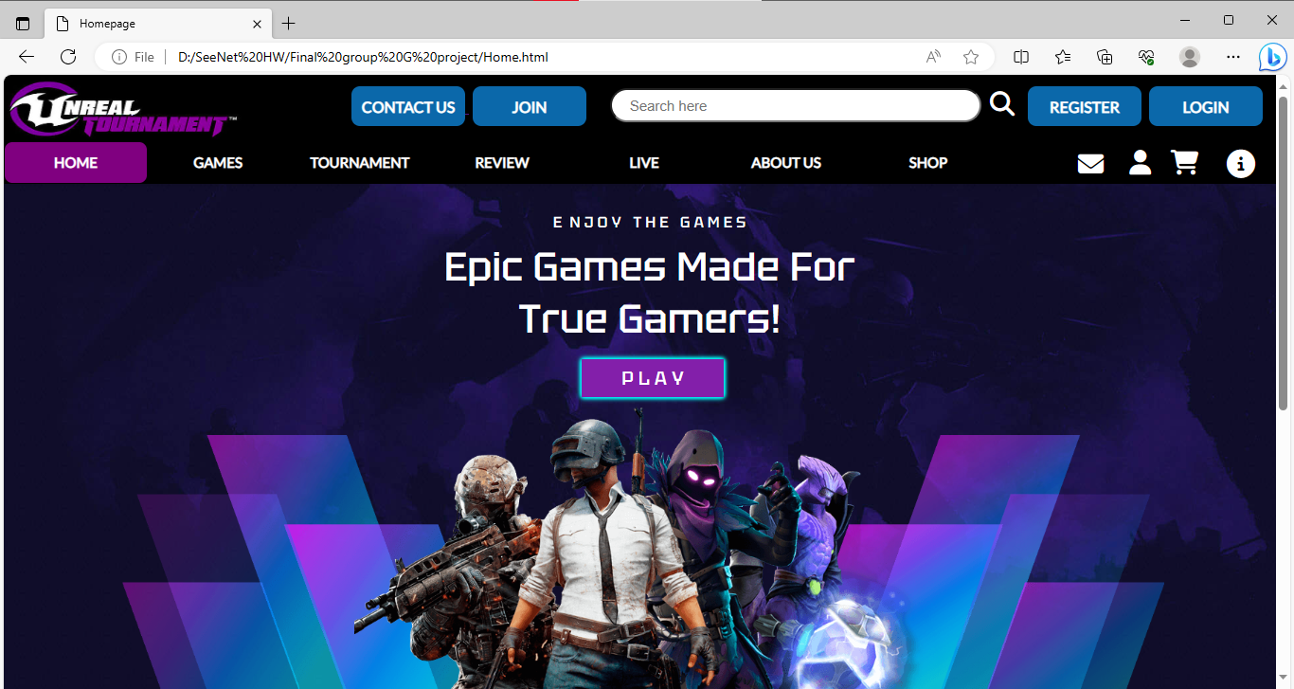

**Home.2**

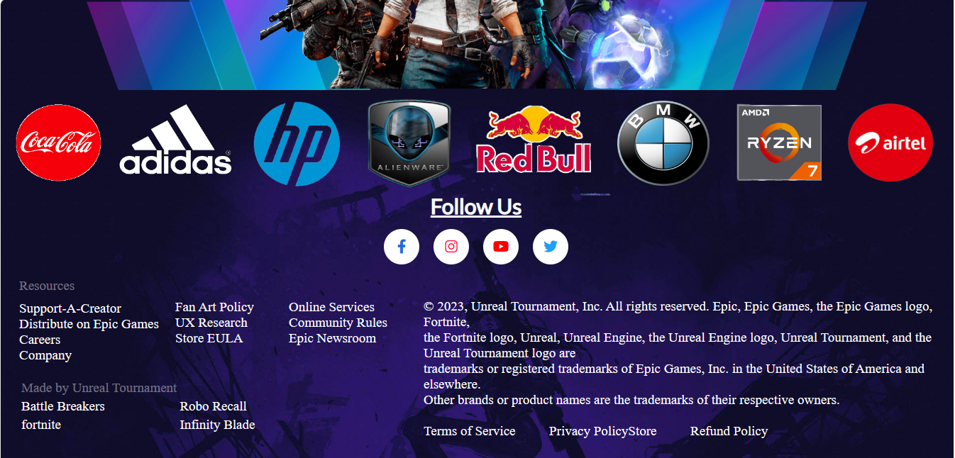

**Games.1**

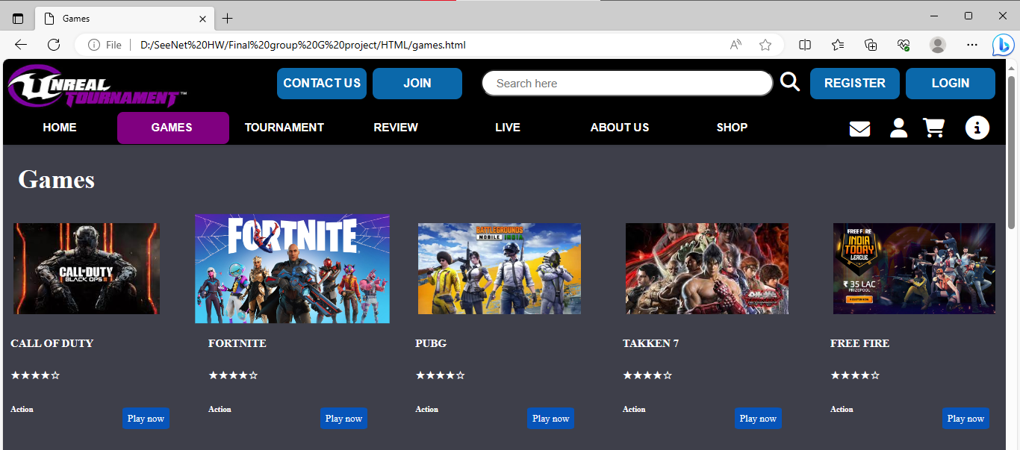

**Games.2**

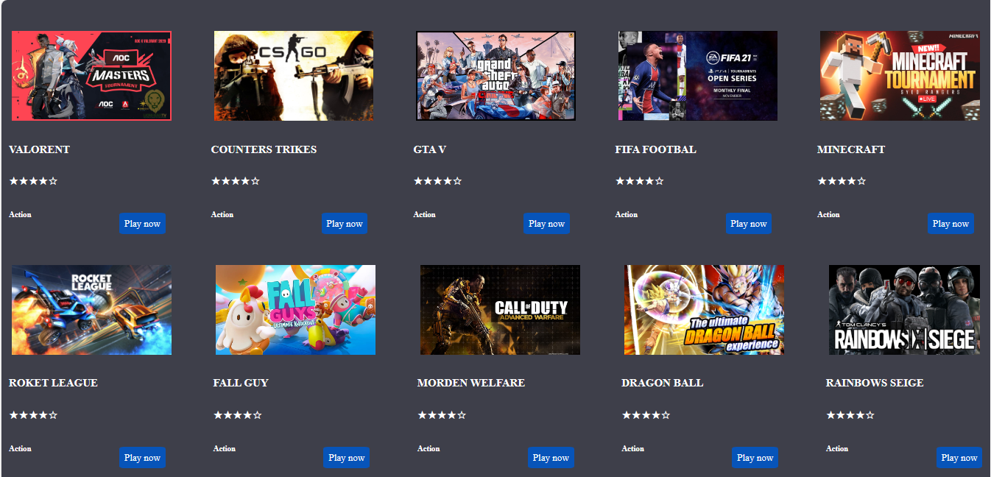

**Games.3**

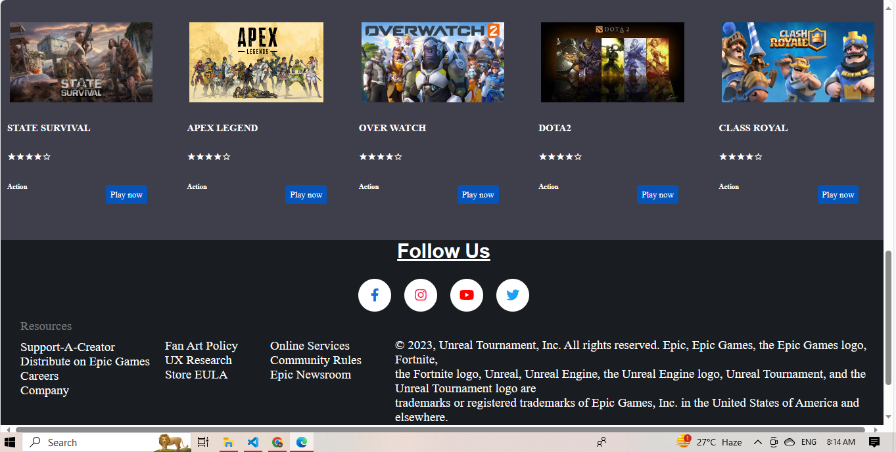

**Tournament.1**

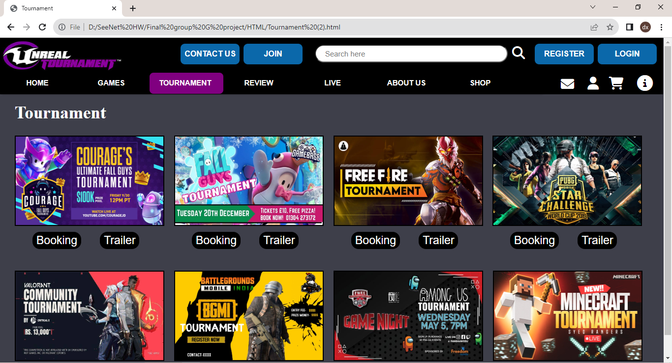

**Tournament.2**

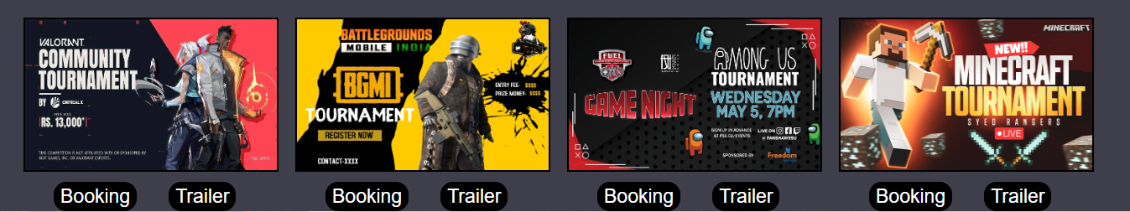

**Booking**

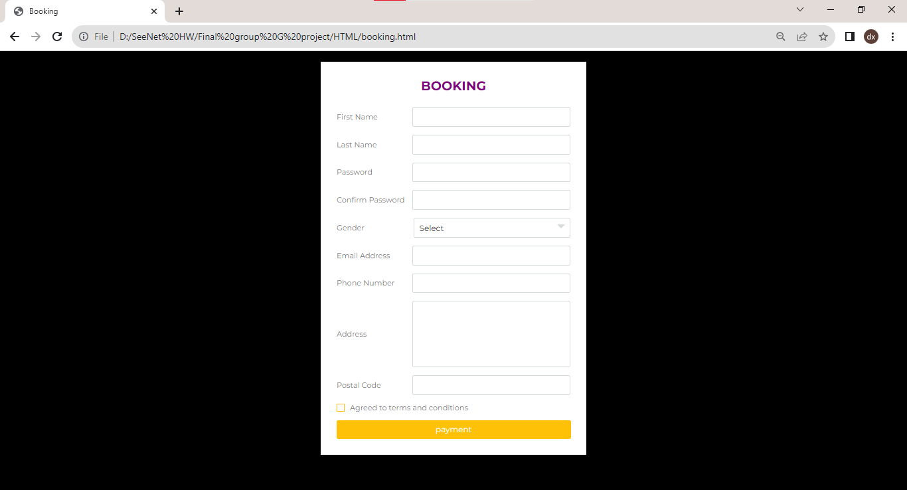

**Payment**

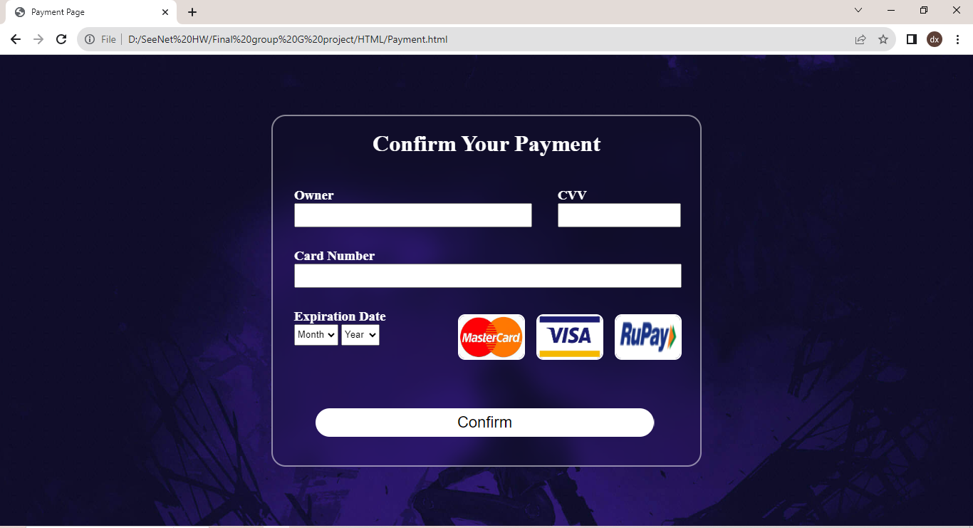

**Payment Successful**

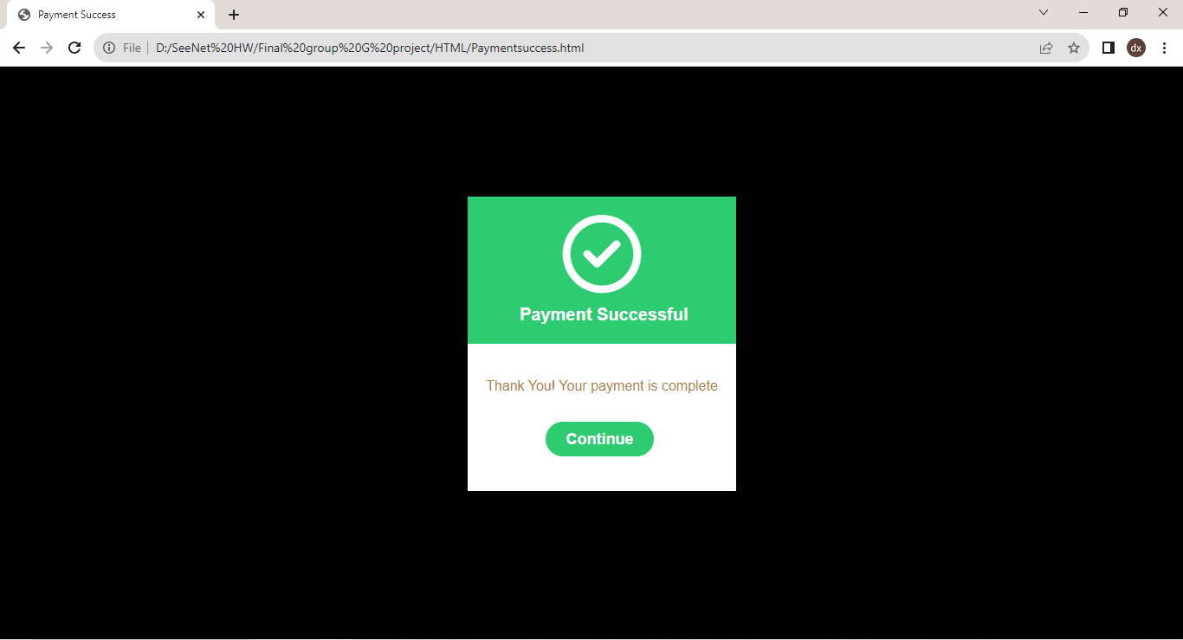

**Review**

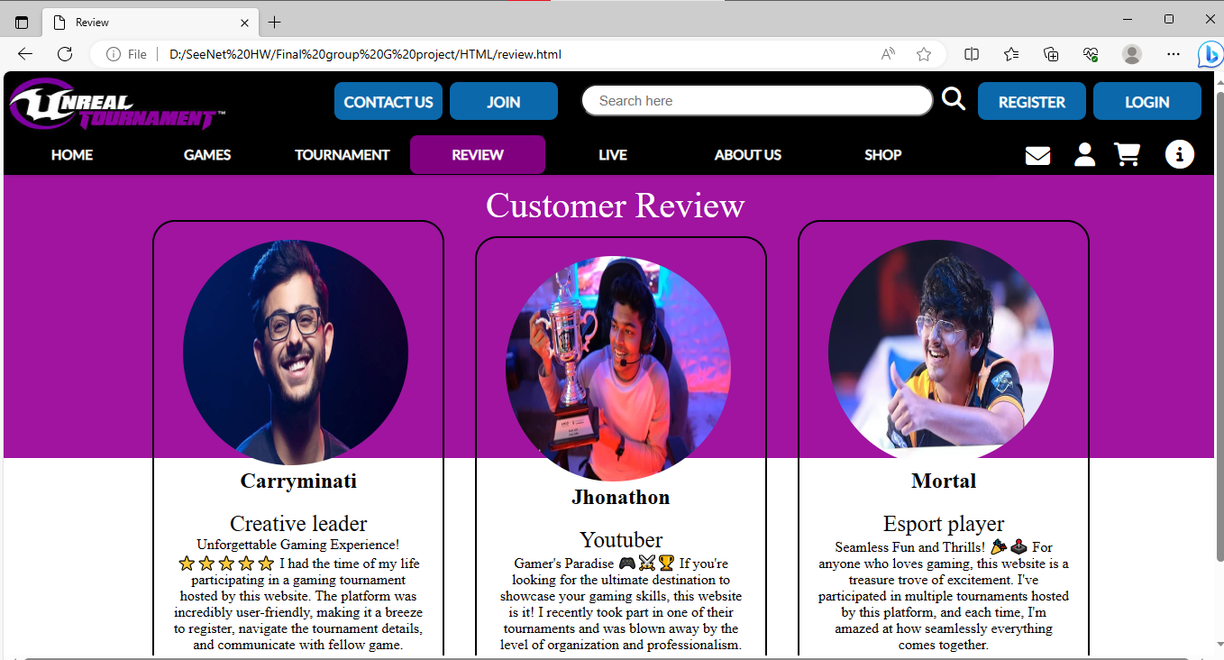

**Live**

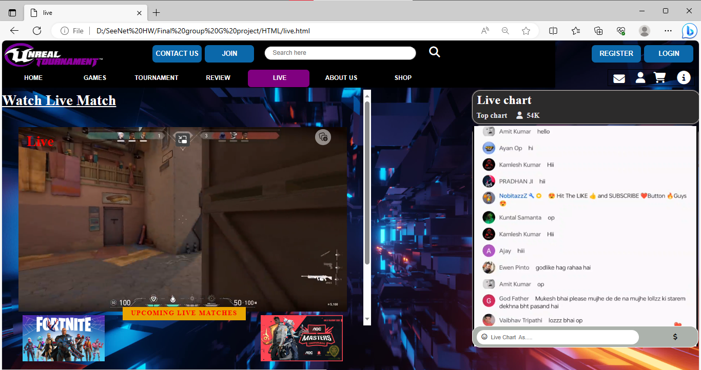

**About Us.1**

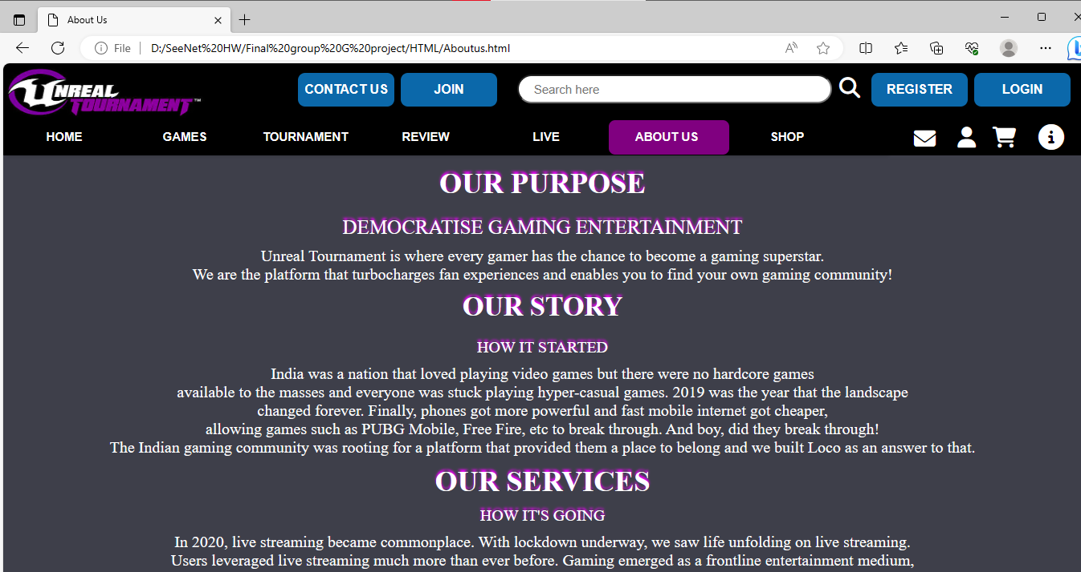

**About Us.2**

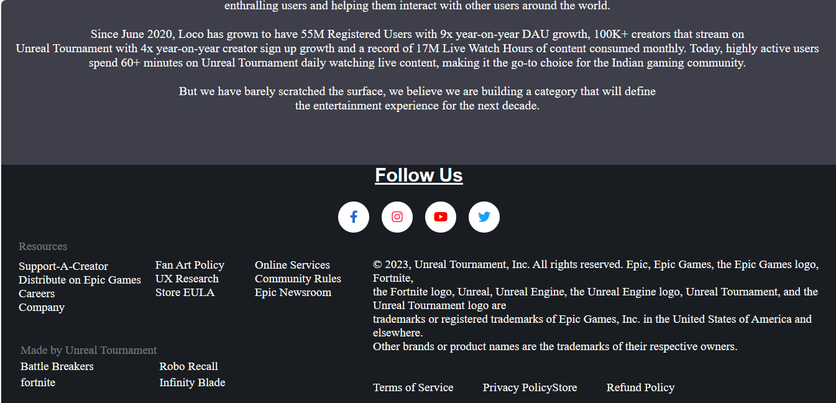

**Shop.1**

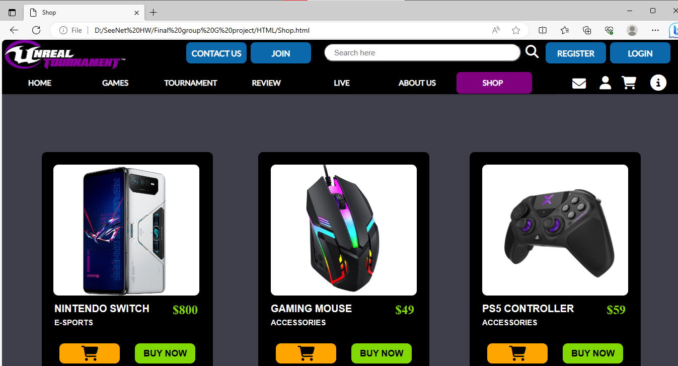

**Shop.2**

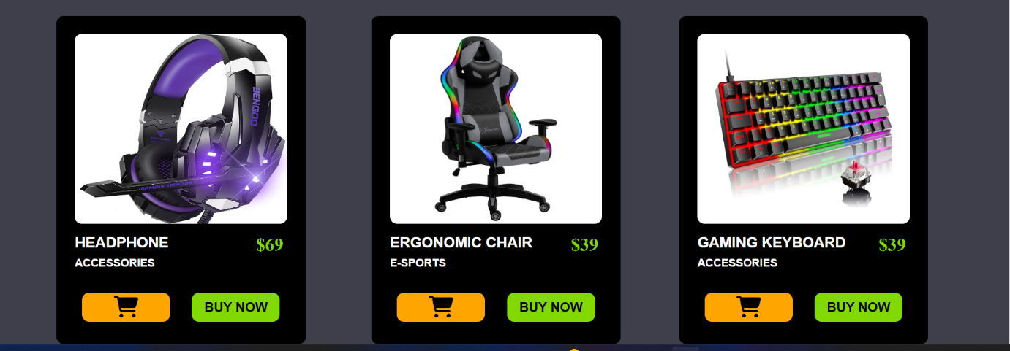

**Contact Us**

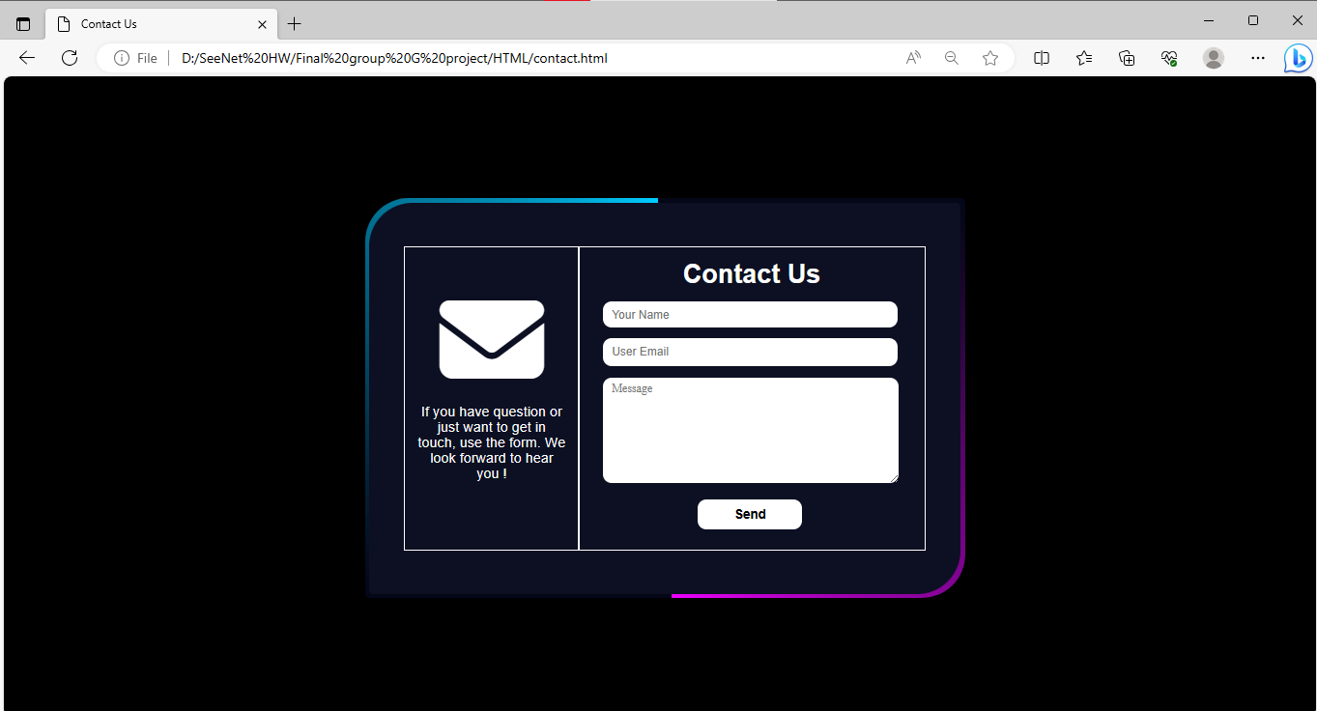

**Sent Success**

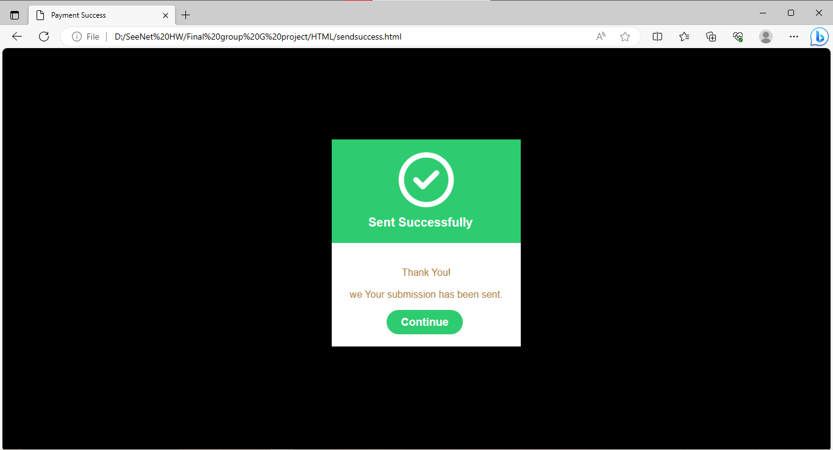

**Join.1**

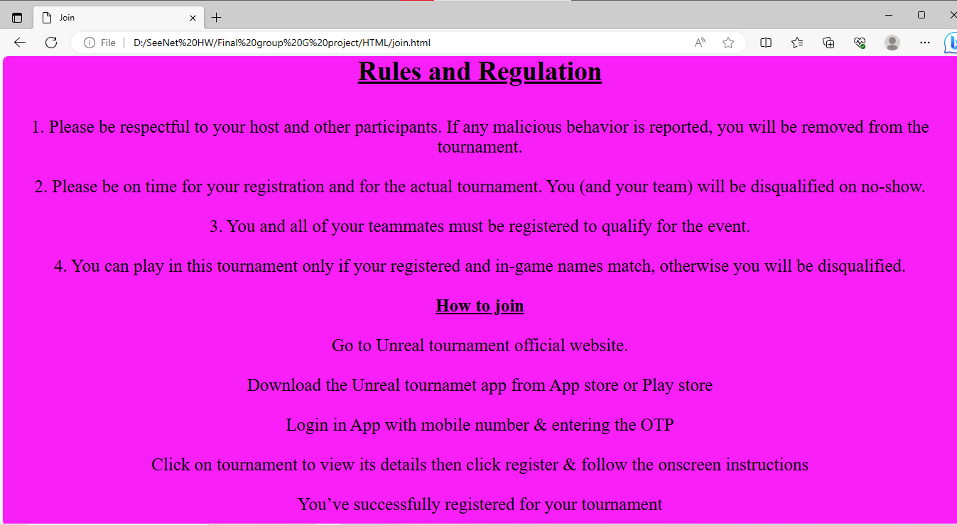

**Join.2**

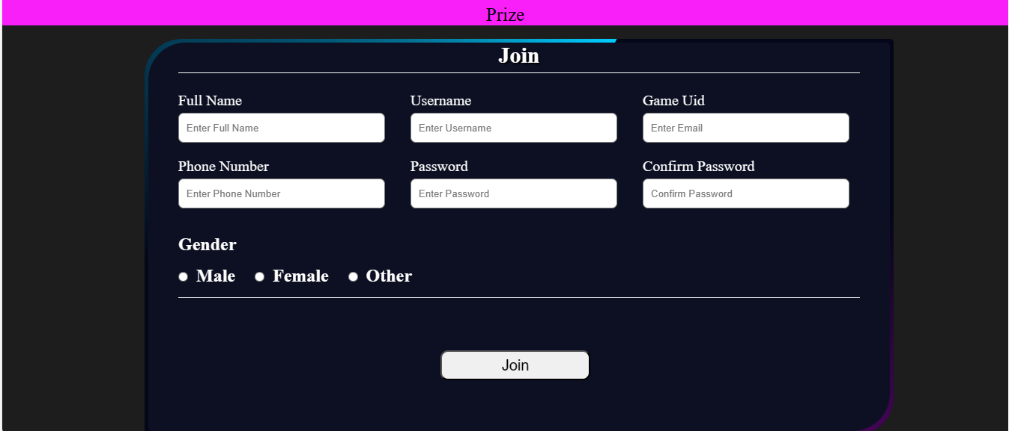

**Joined**

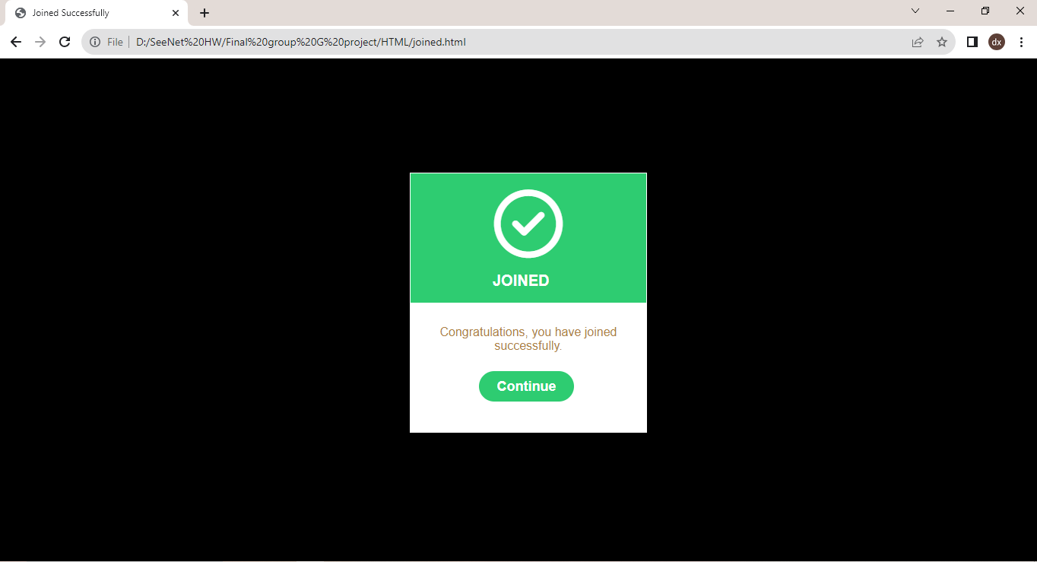

**Registration**

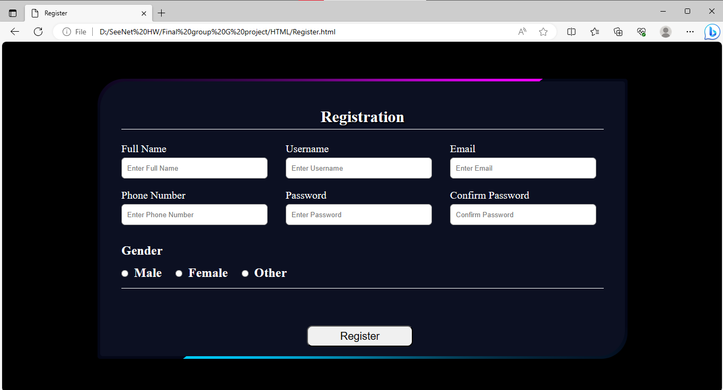

**Register Success**

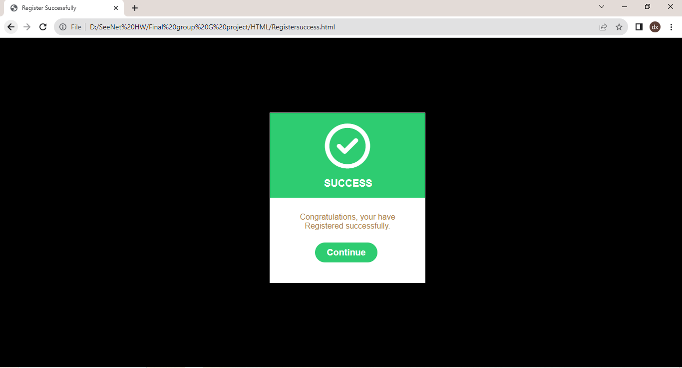

**Login.**

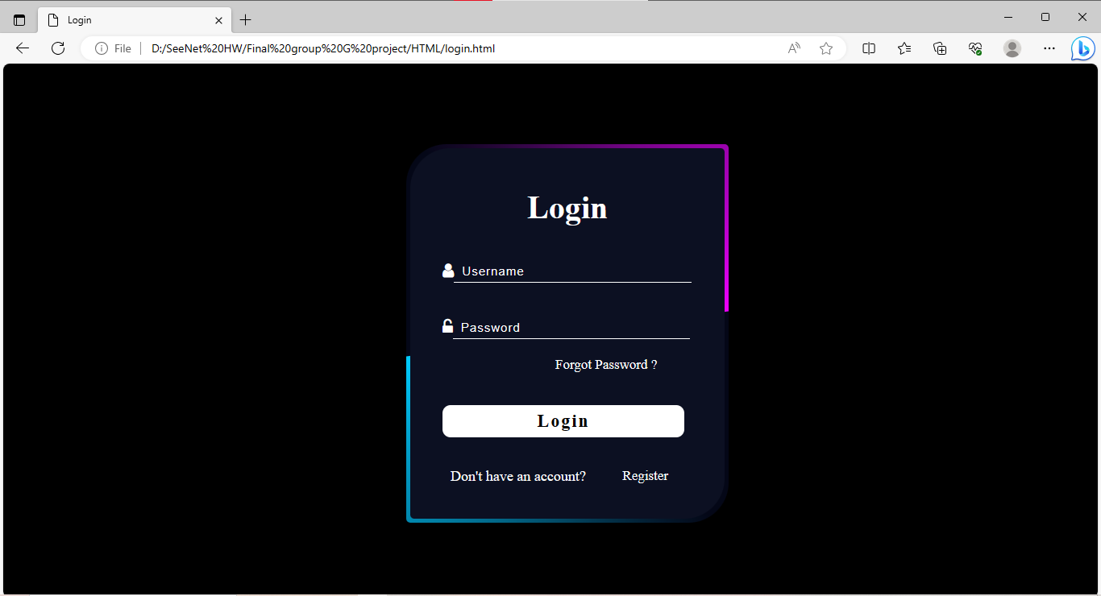

**Notification.**

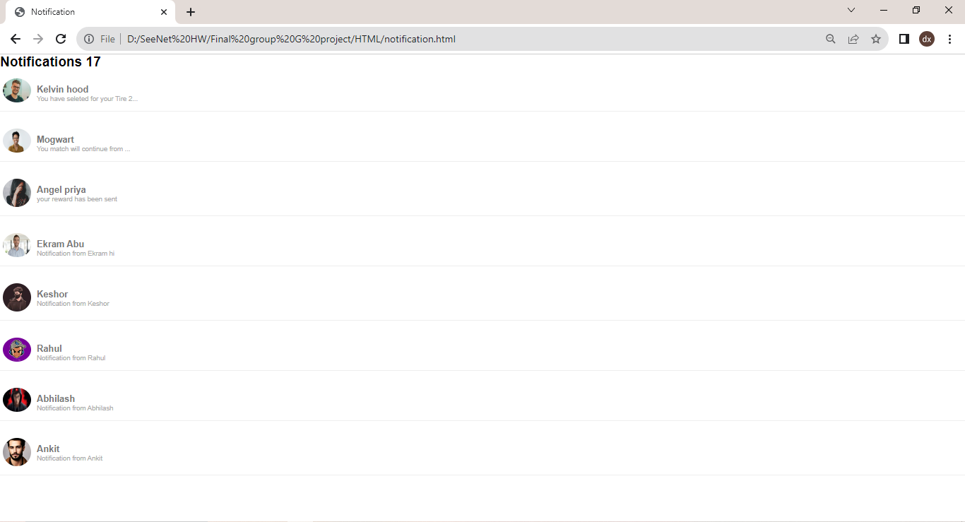

**Profile**

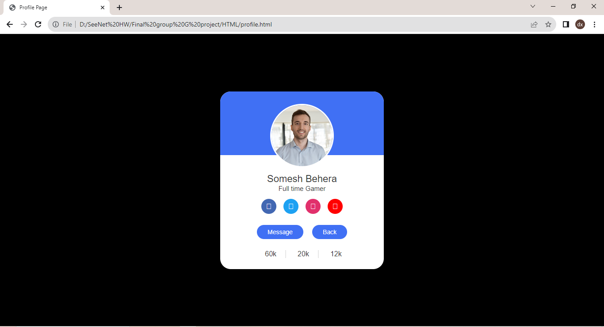

**Cart.1**

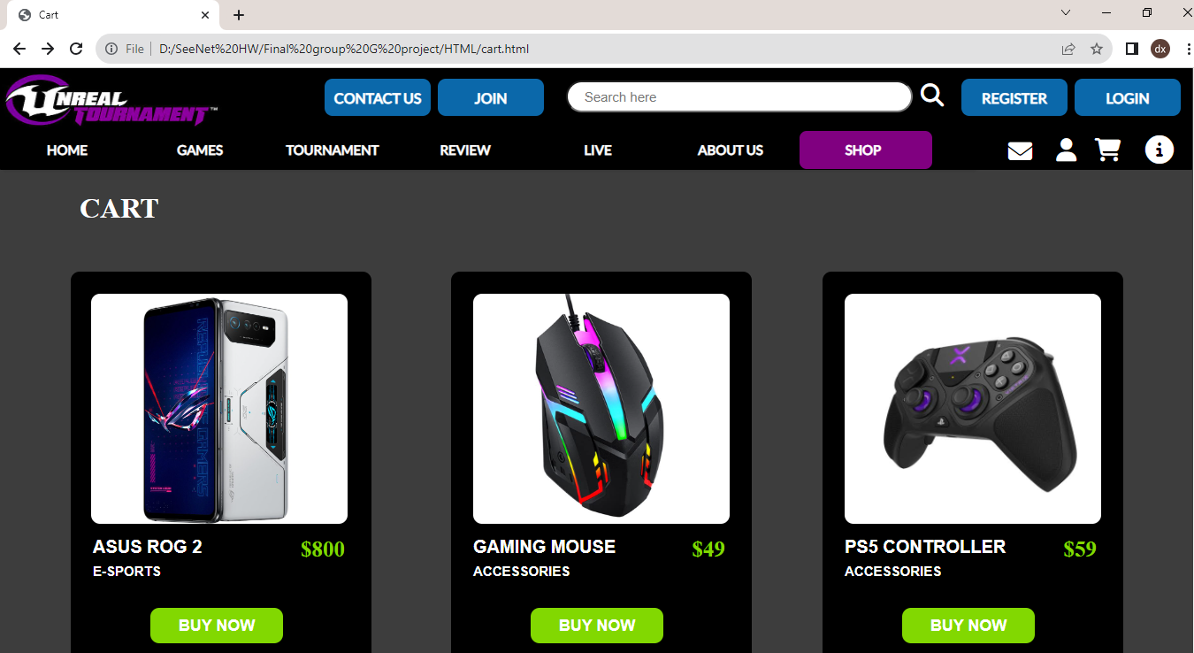

**Cart.2**

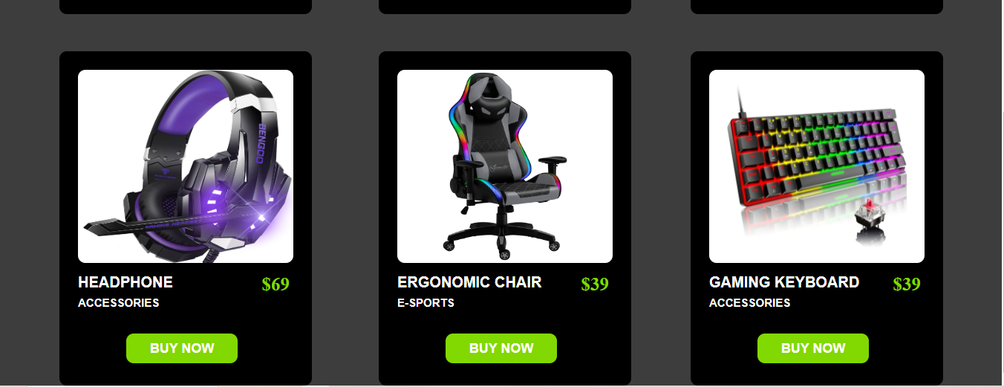

**Payment Gateway**

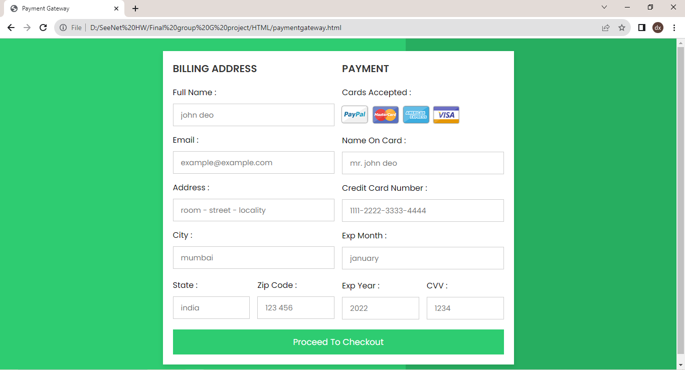

**Payment Success**

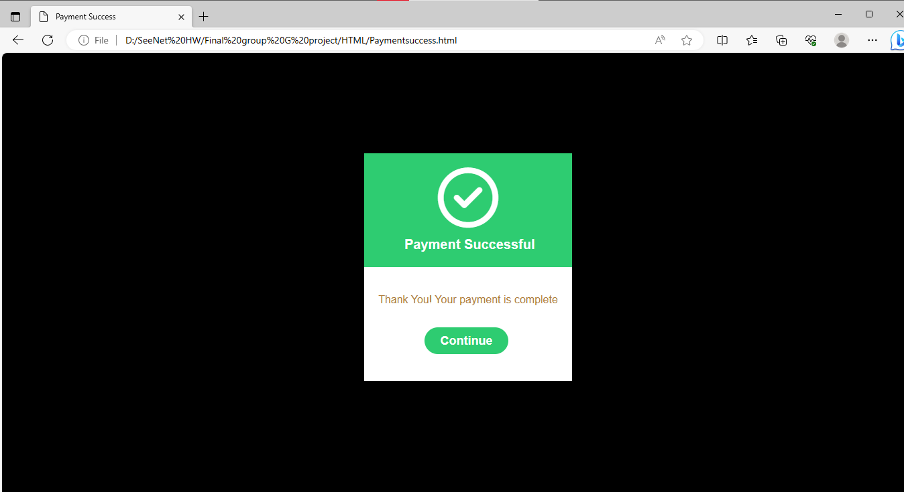

**Play video**

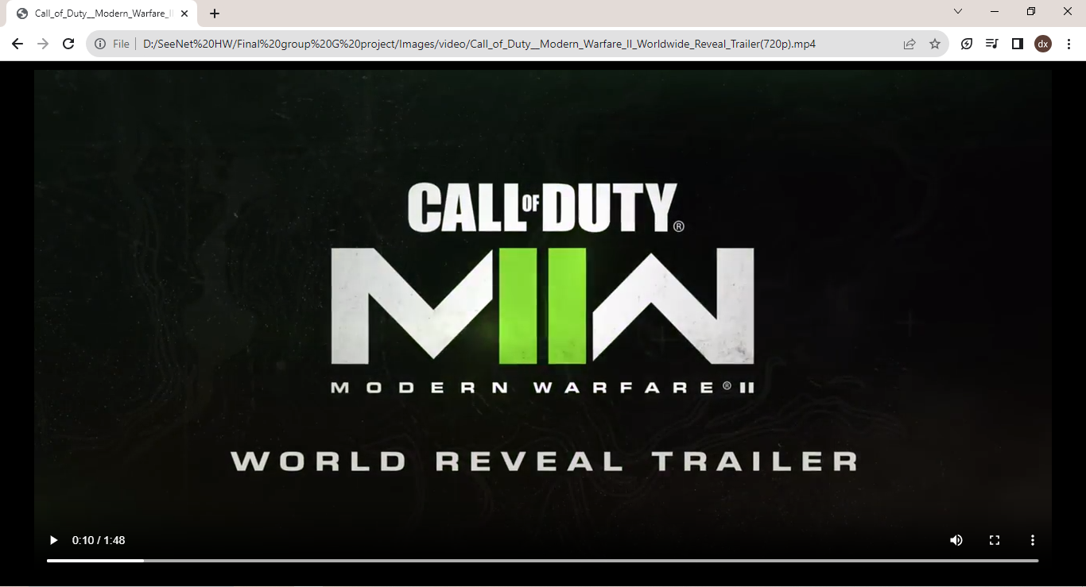

**Info.1**

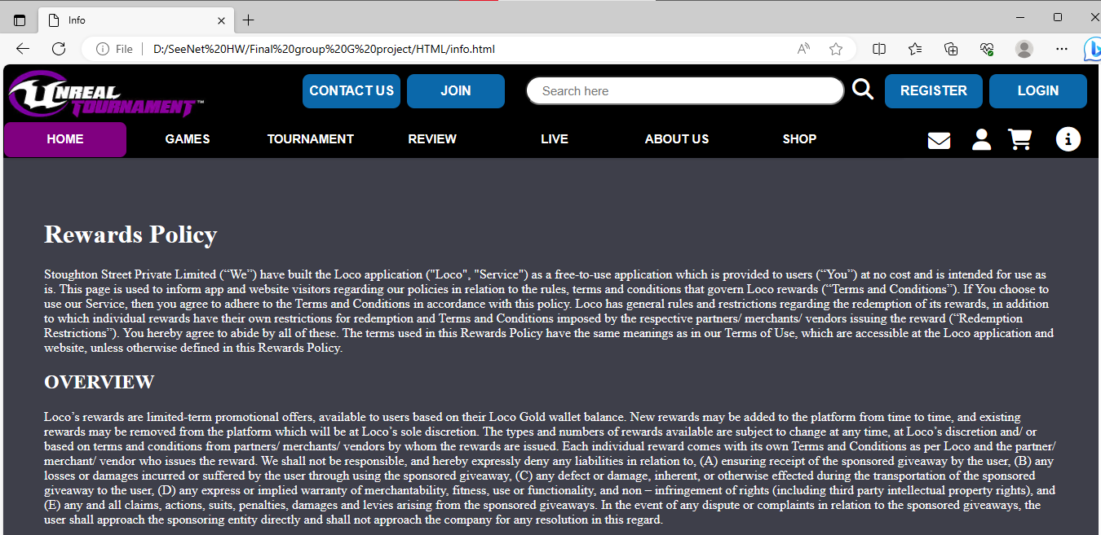

**Info.2**

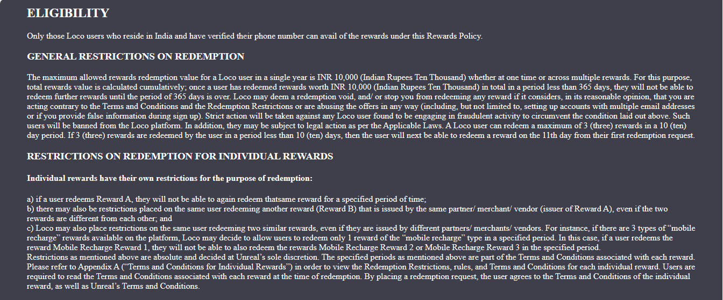

**Info.3**

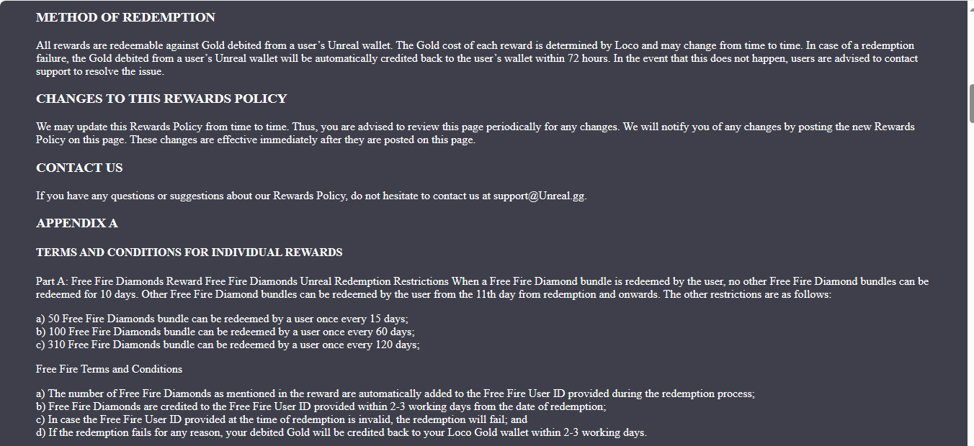

**Info.4**

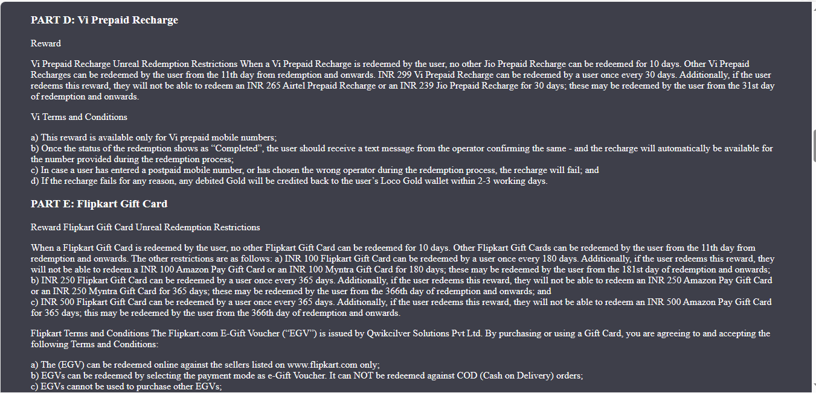

**Info.5**

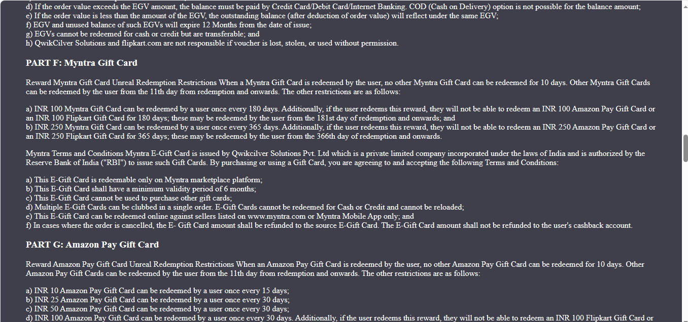

**Info.6**

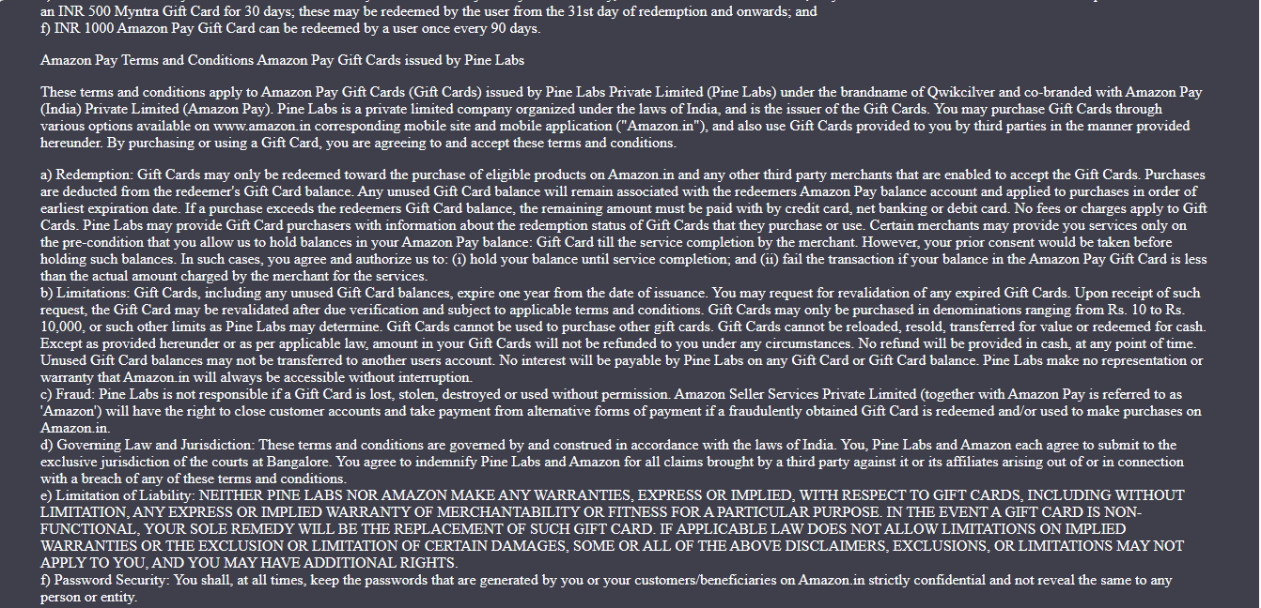

**Info.7**

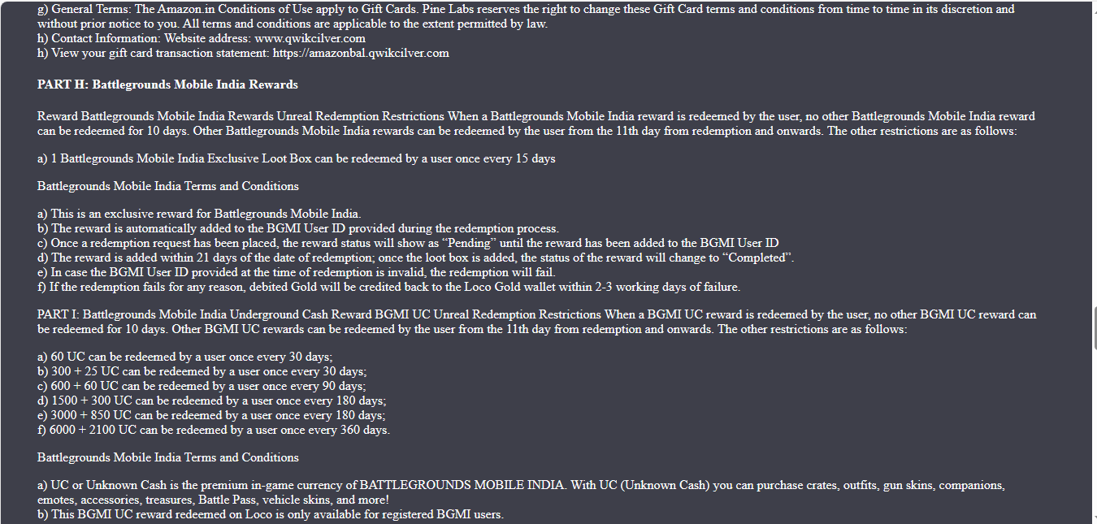

**Info.8**

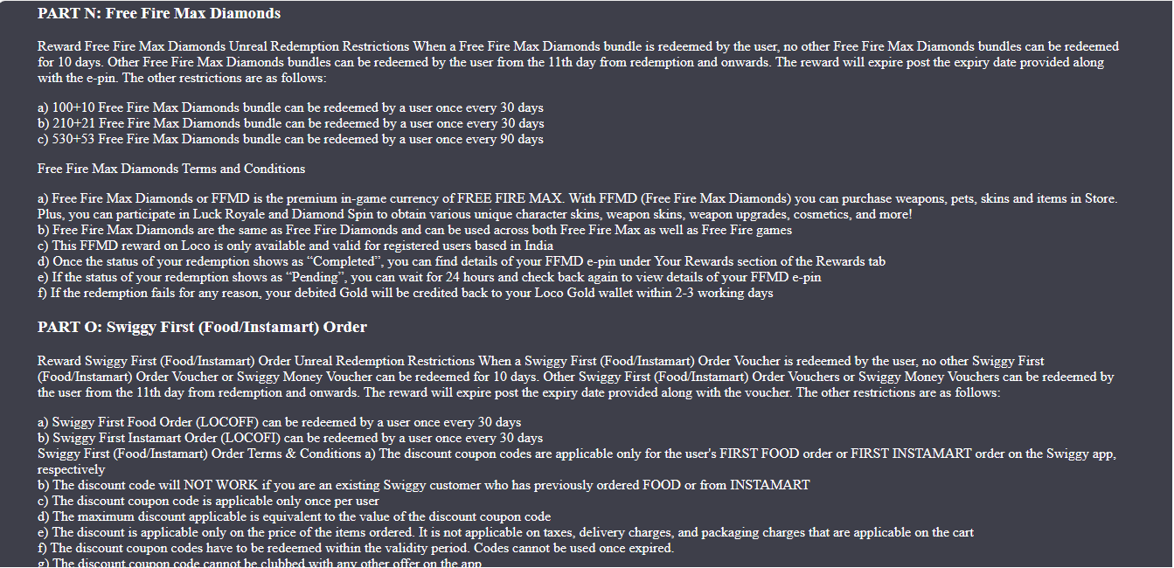

**CONCLUSION**

It has been a matter of immense pleasure, honor, and challenge to have this opportunity to take up this project and complete it successfully.

While developing this project we learned a lot about a online E-Sports site and also how to make it user-friendly, engaging and eye catching by hiding complicated parts of it from the users. During the development process, we carefully studied and understood the criteria for making web pages. We also realized the importance of maintaining a minimum margin of error through this project.

This project will be very much helpful for the student to make their static website using markup language.

With help of this project we learned various tags, attributes, style concepts etc. This project was helpful to enhance our knowledge about this topic.

Thus, our project on “Online E-Sports Site” is here with submitted.

**BIBLIOGRAPHY**

While working on this project, we got to know more about HTML & CSS from various sources.

**Sources used for project:**

* [www.w3shools.com](http://www.w3shools.com)
* Internet
* HTML & CSS notes provided by Seenet
* MS Word
* Notepad
* Google
* Youtube
* Font Awsome
* Snipping Tool

**System Used:**

* Operating System : Window10,7,11,11.
* Processor : Intel i3, 64bit/
* Memory : 4GB,512GB/4GB,64/8GB,512GB.
* Platform : VS Code, Notepad, MSWord, Adobe Photoshop, Chrome ., Snipping tool, etc.